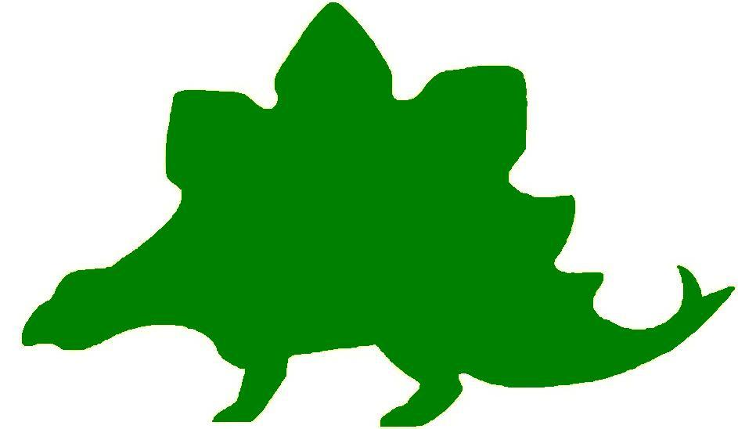
theHoustonMuseumofnaturalscience

Kindergarten Knowledge Hunt
Dear Educator,
Thank you for downloading the free, online curriculum available at HMNS! We’re thrilled to see that you are including the world-renowned Houston Museum of Natural Science in your educational toolkit.
Here at HMNS our mission has always been to provide exemplary educational opportunities for the community. Providing educators like you with free, fully editable curriculum is just one of many ways we are fulfilling that mission.
Thank you again, and we hope you enjoy your field trip to HMNS!
Best,
The HMNS Staff

How to use this guide:
- Feel free to edit the questions as needed to suit your student group.
- The Knowledge Hunt is structured to begin at the top of the Museum (floor three) and work its way down to the lower level.
- Visitor services and security staff are posted around the Museum and will be happy to assist you in finding any of the locations mentioned.
- Please ensure that one chaperone is with every group of ten students at all times as they complete these activities.
- Don’t forget to download our extension activities for use in the classroom when you return from your trip!

Please direct any and all questions to curriculum@hmns.org

Kindergarten TEKS Objectives

Each of the following TEKS Objectives are met as students explore the various exhibit halls and complete the Knowledge Hunt:

Science: K.1 (A, C), K.2 (A, B, C, D, E), K.3 (B, C), K.4 (A, B), K.5 (A), K.6 (A, C, D), K.7 (C), K.9 (A, B), K.10 (A, B)
Social Studies: K.2 (B), K.3 (A, B), K.4 (A), K.5 (A,B), K.6 (A, B), K.7(A, B), K.9(A, B), K.11(B), K.12 (A,B), K.15 (A, B,C, D), K.16(A, B), K.17(A,B)

ELA: K.1 (A,B,C,D), K.2 (A), K.3 (C), K.7 (A), K.8 (A,B,C), K.9(B), K.10 (A,D), K.12 (A,B,C), K.13 (A), K.15 (A,B), K.16 (A,B)
Math: K.1 (A,B,C), K.2 (A,B), K.3 (A,B), K.4, K.5, K.6 (A,B), K.7 (A,B), K.8 (A,B), K.9 (A,C), K.10 (A,B,D), K.11 (A,B), K.12 (A,B), K.13 B,C,D)

McGovern Hall of the Americas

Third Floor

Vocabulary:
natural resources, totem pole, moccasin, tipi, parfleche, transformation, Inuit, caribou, kiva

Origins and Diversity

Clothing and Culture
Show the students the case displaying clothing from different cultures. Tell students that the type of clothing people wear is determined by the climate in which they live and the natural resources available to make the clothing. Ask the students which clothing would not be suitable to wear in our hot, humid summer climate.

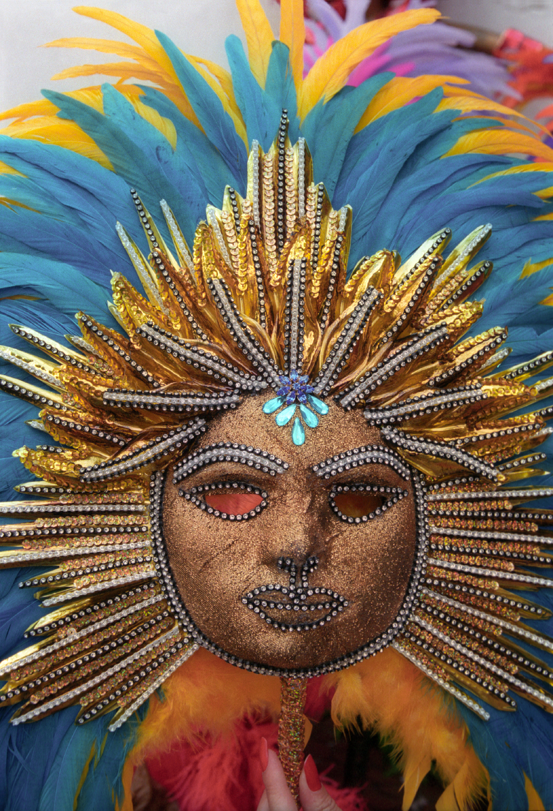

Rituals and Religion
Show the students the display of masks. Explain to the students that when performers want an audience to think of them as something or someone different, they often wear a mask or costume. Ask the students if they have ever worn a mask. Allow students time to look at the masks and think of what they might represent. What animal does #6 look like?

The Arctic

Seal Gut Parka
Read the text panel to the students to explain how the parka was made. Ask the students if they think it would make a good raincoat. Ask the students if they remember what a natural resource is. Explain that many seals lived in the Arctic Region when this parka was made. They did not have plastic, rubber, or any other waterproof material to make a raincoat from, so they used what they had available. That is called a natural resource.

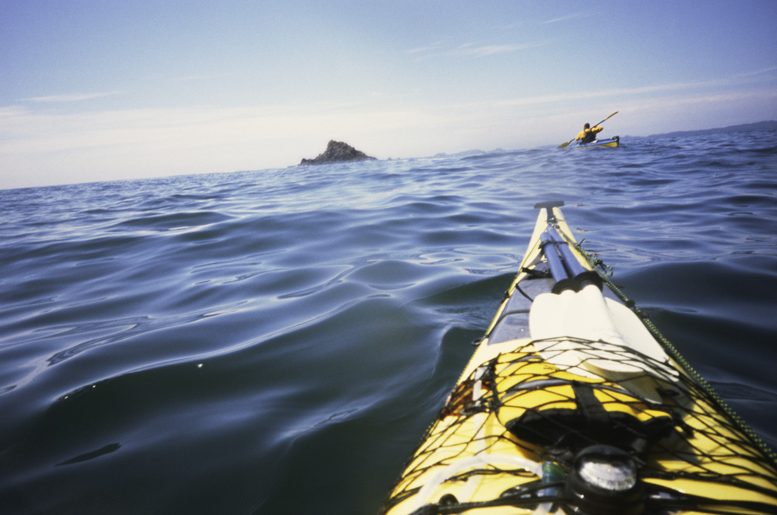

Kayak with Paddle
Tell the students that the kayak was one of the only forms of transportation people that lived in the Arctic Region had for hundreds of years. It was also made from sealskin because it was waterproof. What other forms of transportation do students know of that people use in snowy or cold regions?

Inuit Children
Show the students the toys played with by Inuit children. Explain that the toys were used so that children could learn about things they would need to know later in life. Can they suggest toys they play with that are like things they will use as adults? For example: cars, airplanes, trucks, plastic food, toy kitchen, dolls, etc. Ask the students why they think playing with toy objects that represent items they will use in later life is a good idea.

Parka and Women’s Items
Point out the parka. Tell the students this parka is made from seal skin. The fur keeps the person wearing it very warm. Coats were also made from caribou, polar bear, wolf, and fox because they were plentiful in the Arctic Region. Ask the students if they have ever put on a fur jacket. How did it feel?

Northwest Coast

Transformation Mask
Explain to the students that the transformation mask was used in traditional dances where one person had to play the part of more than one animal. The dancer could begin as one animal and change into another one by simply pulling a string. Ask the students if they can guess which two animals are portrayed in this mask.

House Post
Explain that a house post is located at the back of a house. Animals are important to the people of this region, so they honor the animals by carving them on their house posts. Ask the students if they know the two animals honored in this one. There is a thunderbird at the top and a bear at the bottom. The thunderbird was a magical bird created by the people of this region that could make thunder by flapping its wings and lightning by blinking its eyes. It was the most powerful of all creatures. The bear was important because it was believed to have taught people how to fish and hunt for berries so they would not starve.

The Southwest

The Kiva
Show the students the kiva. Explain that its thick walls are made of mud so it will be cool in the summer and warm in the winter. There is a place for a fire in the center and an opening at the top for the smoke to go through. There are also places built into the wall to display important objects. Ask the students why this might have been a good place to live in the hot, dry desert.

The Tipi
Show the students the tipi. Explain that it was meant to be taken down and moved every time the tribe moved. Point out the main poles and the buffalo hide that is wrapped around it. Explain that the fire was built in the center so the smoke could escape the hole at the top of the tipi. Tell the students that these Native Americans moved a lot because they followed the buffalo herds, so everything they owned had to be packed in small containers made of buffalo hide. Point them out in the exhibit. Ask the students if they could pack up their room in just the number of containers they see.

Feather Poncho
Take the students into the Aztec temple. Allow them to look at all the artifacts that represent their civilization. Point out the poncho decorated with colorful bird feathers. Ask them to look at the feathers and guess what kinds of bird feathers were used to make the poncho.

Hall of Ancient Egypt

Third Floor

Vocabulary:
hieroglyphs, Pharaoh, ancestry, sarcophagus, mummy, coffin, civilization, agricultural, society, erode

Egypt, Gift of the Nile
Read the text panel and give the students a few seconds to look at the map. Ask the student if they know which river runs through Egypt. Tell them that the Nile River is the backbone of Egypt. The river floods each year and deposits rich dirt so that the Egyptian farmers can plant their crops. Ask the students if they can list another very important formation in Egypt. Give them clues so that they guess the desert. Explain to the students that the desert acted as natural boundaries from enemies.

Timeline of Egyptian History
Ask the students to look at the timeline on the wall to answer the following question. Which time period came 1st, 2nd, and 3rd? New Kingdom, Old Kingdom, and Middle Kingdom.

1st: ______________________________

2nd: ______________________________

3rd: ______________________________

The Pillar Room
Tell the students to look closely at the large pillars in the room. What do they notice about their color and design? Explain that the pillars represent the passage of time in one of Egypt’s Temples. As time passes the pillars have eroded or worn down and that once they were beautiful and vibrant like at the beginning of the room.

Dressing for Eternity
Read the description on the text panel about how ancient Egyptians like to be shown at their best appearance. Ask the students if they ever dress to impress. Can they name times that they have dressed up for special occasions?

Pharaoh – Lord of the Two Lands
After reading the panel to the students, ask them to tell you who was the most important person in Egypt. What types of things do they think the King/pharaoh did? As ruler of the land it would be up to the King to set rules for his/her people. Ask the students if the know of any modern day Kings or Queens.

Temples
Before you read the text panel to the students, ask them if they know who might have lived in the ancient Egyptian temples. Read the panel to them, where they correct?

Why were the temples made of stone? Ask the students if they can think of large government building made of stone in their state. Give them clues so that they guess the Texas state capitol which is made up of pink granite. Remind the students that our capitol building is very important to us as laws are made there to help govern our state!

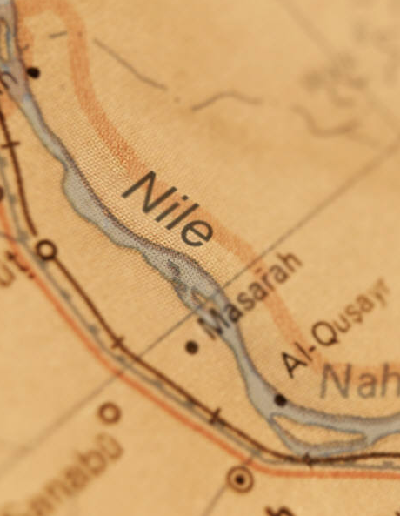 The Old Kingdom (Dynasties 3 – 6, 2682 – 2181 BC)
Ask the students to look at the map on the text panel. Is Lower Egypt above (north) of Upper Egypt or is it below (south) of Upper Egypt?

Explain to the students that the areas called upper and lower Egypt are opposite of what we would normally list them because they are labeled based on the flow of the Nile River. The Nile flows from south to north of from the bottom of the continent to the top, unlike the Mississippi River in the United States. This means what we think is up is really down!

Giant Coffin with Green Face vs. Coffin of Tjefut
Ask the students to look at both coffins across from each other. Have them give you two examples of who they are they same and how they are different.

Dollar Bill
Point out the dollar bill in the case. Ask the students to look at it closely and see if they can fine anything that reminds them of Egypt. They should notice the pyramid and the eye above it. Explain to the students that the unfinished pyramid symbolizes that the United States is still far from a finished product. Our government and our daily lives change all the time. The “all seeing eye” can trace its ancestry back to the Eye of Horus Amulet Popular thought out Egyptian history.

The Rosetta Stone
Point out the Rosetta Stone to the students. Ask them if they can tell how many different languages are on the stone. Explain to them that this stone was the “code breaker” to the ancient Egyptian writing of hieroglyphs. Because this stone shows the same information in three different languages historians were able to figure out what each letter or word the hieroglyphs represented.

Strake Hall of Malacology

Second Floor

Vocabulary:
mollusks, squid, herbivore, carnivore, omnivore, gastropod, trade

Gastropods
Explain that gastropods are one of the largest species of animals on Earth. They can live in the water or on land. Ask the students if they have ever seen snails in their garden. Tell them they are gastropods. Show the model of a gastropod to the students so they can see how the shell protects its body. Point out all of the parts of its body. Tell students that the foot allows it to smoothly glide along a surface.
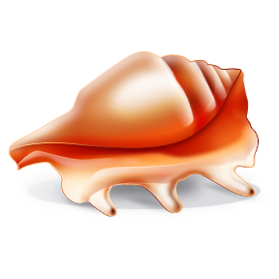

Mollusks of Texas and Gulf of Mexico
Allow the students an opportunity to look at the display of some mollusks that can be found on the Texas coast. Ask the students if they have ever found any of these types of shells in Galveston, Padre Island, or on the beaches of Mexico. Did they look like any of the shells in the display? If so, ask the students to point to that shell.

Squid Video
Watch the video narrated by a cute little girl squid to learn about the body parts of the squid, how it moves, and how it avoids predators. Then watch the video of a real giant squid moving in the ocean. Ask the students if they would like to be able to swim like a squid.
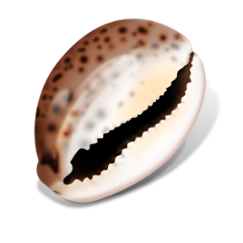

Family Cypraeidae (Cowrie)
Allow the students to gather around the case where the cowrie shells are displayed. See if the students can find the one that looks like a mouse (#17). Then point out #6. Explain to the students that this cowrie was once used by early cultures to trade for things they needed that they could not grow or make themselves. Ask the students if they think shells used for money is better or worse than the money system we use today.

Fossil Mollusks
This group of animals lived 500 million years ago. Point out the giant ammonites in the mural on the left. There are also fossilized shells of giant ammonites in the Hall of Paleontology for the students to see. Use the mural to point out the animals that once lived in the shells.

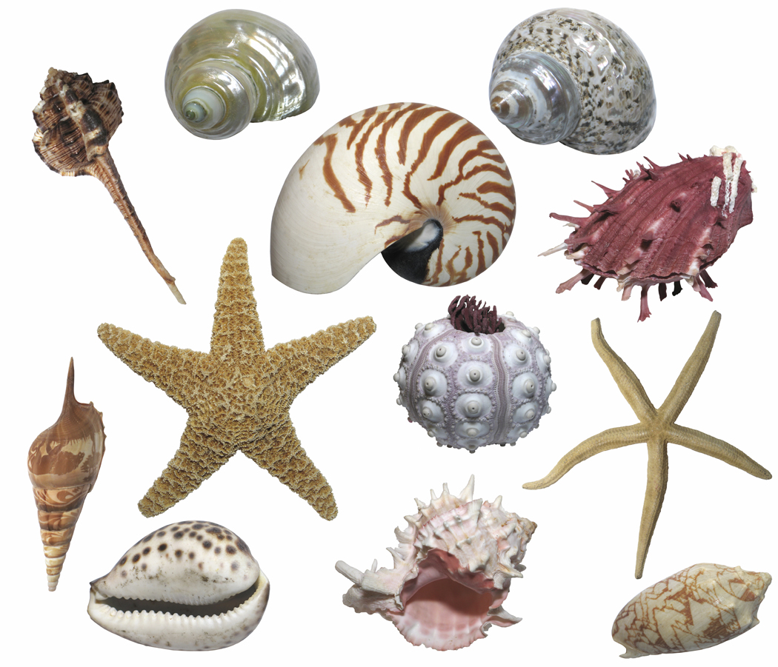

Classics
Allow students time to look at these familiar shells and tell about their favorites.

Snail’s Teeth
Show the magnified photographs of snail’s teeth. Explain that snail’s teeth are on the tip of something like a tongue that snails stick out to find food then transfer it to their mouth. This is similar to what elephants do when they pick up hay with their trunk and place it in their mouth. Tell the students snails are carnivores, herbivores, and omnivores. Ask the students if they know what each of those terms means. Carnivores eat other animals, herbivores eat plants, and omnivores eat both meat and plants.

Family Pectinidae (Scallops)
These may be the most familiar shell shapes to the students. Point out that the shell is actually made of two parts that are hinged in the middle so it can open and close. Show the students the opened shells. Remind them that an animal once lived inside.

World’s Largest Snail Shell
Show the students the picture of the living snail with its large yellow foot extended. Ask them if they remember that this foot helps the snail move, just like snails students see in their gardens. Ask the students what it would be like if they came outside one morning and saw a snail this large in their garden.

Cullen Hall of Gems and Minerals

Second Floor

Vocabulary:
mineral, gem, geometric, attributes

I Spy Something Geometric
Divide the students into four small groups. Assign each group a geometric figure to look for as they tour the Hall of Gems and Minerals. Review the characteristics of a circle, rectangle, square, and triangle before the groups begin their hunt. After completing their visit to the Hall, ask the students to report the number they counted.
Shape | Number
Circle
Rectangle
Square
Triangle



I Spy
Stand in front of a case that has more than one mineral displayed. Play “I Spy” with
the students. Describe the attributes of one of the objects and see if the students can guess which one it is. Move to another case and let one of the students lead the game.

Case #16 and #42
Show the students the Galena in case #16 and the Pyrite in case #42. Ask the students what attributes the two share.

Case #33
Gather students around the case to look at the Cerussite. Ask the students to suggest what it reminds them of. Talk about the attributes that make it resemble a snowflake.

Case #125
As the students walk through the Hall, ask them if they see any minerals that remind them of food. At case #125, ask the students what the Rhodochrosite reminds them of. Let them talk about the attributes that the mineral and the food share.

Farish Hall of Texas Wildlife

Second Floor

Vocabulary:
adaptation, environment, predator, prey, protected, characteristics, organism, talons, webbed, rare, species, marine

Before entering the Farish Hall of Texas Wildlife, explain to students that they will be seeing examples of what Texas’ environment looked like before there were any people. Some of the animals within the hall are endangered and no longer exist in abundance.

High Plains
Lead students to the High Plains region of the hall. Ask them to describe the region. What kind of animals live here?
Point out the grazing Pronghorn herd. Lead a discussion about these creatures by asking the following questions:
- What does the Pronghorn remind you of?
- Do you think the Pronghorn are predator or prey animals? Why?
- Explain that Pronghorn cannot jump fences. Why would that be a problem?
- What do you think the Pronghorn eat? Why?
- Do you think the Pronghorn are fast or slow runners? Why?

Coastal Wetland and Marsh
Look across the hall at the Coastal Wetland and Marsh region. Ask students to explain what is different about this region from the High Plains region.
Point out the alligator. Lead a discussion with your students by asking the following questions:
- Do you think the alligator is a predator or prey animal? Why?
- Do you think the alligator is a better runner or swimmer? Why?
- What sound do you think the alligator makes?
- Do you think the alligator has any enemies? Why or why not?

Guadalupe Mountains
As students enter the Guadalupe Mountain region, point out the skunk. Explain to students that even small animals have ways to defend themselves.
Ask students whether they have ever smelled a skunk in real life. Did it smell good or bad? Why do they think skunks are able to make that smell?
Point out the elk with their heads lowered. What does it look like they are doing? Most students will probably say that they are fighting. Ask students to come up with theories about why two elk might fight.

Extinct and Vanishing Species
Bring students over to the Extinct & Vanishing Species case. Explain to students that the animals featured here used to exist in large numbers, but no longer do. Have students guess what may have changed.

Piney Woods
As you enter the Piney Woods region, remind students that animals have developed different adaptations to help them live within their environment. Give students a few minutes to point out different animals within the region that are well-adapted to their habitat. Have students list the different characteristics of these animals.

Rio Grande Dry Forest
As students look at the Rio Grande Dry Forest, remind them that an environment is comprised of both living organisms and non-living objects. Have students point out as many living organisms as possible. Remind them that trees, cacti and other plants are living, while rocks are not.

Coastal Oak Motte and Coastal Prairie
Within the last main regions of the exhibit, there are a number of different predator and prey species. Remind students that some animals are predators, others are prey, and still others are both. Point out several different animals within the exhibition and ask students if they think the animal is a predator animal, a prey animal, or both. Have students explain their reasoning.

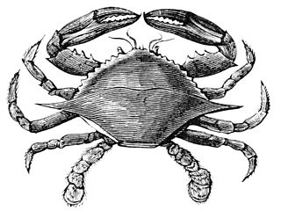

Hamman Hall of Texas Coastal Ecology

Second Floor

Vocabulary:
ecosystem, habitat, ecology, endangered, food chain, tidal, reef, bay. imprint

As you enter the Hamman Hall of Texas Coastal Ecology, adjacent to the Farish Hall of Texas Wildlife, explain that the Texas Coast is another important ecosystem in our state, important to many types of plants and animals (humans too!). Explain that ecology is the study of how organisms interact with their environment, and that a change in a habitat affecting one type of animal might affect other animals as well.

Upper Coast

Map of Coastal Region
Locate Harris County on the map of the Texas coast. Explain that this is where Houston is, where you and the students are standing at this very moment. How close are we to the ocean? Explain that Houston is part of Texas’ coastal plains. Have any of the students ever gone to the beach?

Oyster Reefs
Show students the display of an oyster reef (yes, these are real oyster shells!). Ask them what they see in the display, including any images in the background. As students describe the oyster reef in detail, have them classify each object as “natural” or “man-made”. Oysters are living creatures that can only survive in certain conditions. Discuss with students how some man-made objects, like trash or motor boats, might affect oysters.

Middle Coast

Brown Pelican
The Brown pelican was listed as an endangered species. Show students the maps of Brown pelican populations (larger circles represent larger numbers of pelicans in the area) over time. Explain that when there are very few of a type of plant/animal left, it is listed as “endangered,” or in danger of becoming extinct. Based on the maps, how has the number of Brown pelicans changed over time? Point out that pelicans are growing as a result of humans trying to preserve this amazing bird.

Video
Watch the video at the end of the Middle Coast section with your students. Have students watch the short clip from beginning to end and challenge them to estimate the number of empty milk jugs they see. How many are there? Too many to count! The narrator talks about a “never ending cycle” of picking up trash. Brainstorm with students about a way to stop this cycle and stop trash from ending up in the ocean where it harms wildlife.

Lower Coast

Kemp’s Ridley Sea Turtle
As you round the corner of the Lower Coast section, you will see a large turtle. What is she doing? How many eggs does she have? Explain that sea turtles like this will bury their eggs in the sand to protect them.
When the baby sea turtles hatch, they will imprint, or “mark” the beach they are on as their home. In what ways do we “belong” to a certain area and call it home?
Can students find the baby sea turtles in this exhibit? In what ways do they resemble their mother?

Frensley Hall of African Wildlife

Second Floor

Vocabulary:
ecosystem, characteristics, unique, Serengeti

Before entering the Hall of African Wildlife, explain to students that they will see animals exhibited in the unique environments in which they live in Africa. Tell the students to notice that the plants and animals are different depending on where they live in Africa. Encourage the students to make connections between animals and their habitats. Tell students that an ecosystem is a place where plants, animals, and the environment all interact together.

Congo
Tell the students that the Congo is a rainforest. Ask them what they see in the exhibit that might be found in a rainforest. Point out the Okapi that lives there. Ask the students if they know what kind of animal it is. Tell them that it actually has parts that look like three different animals. Point out the head and ask them if it looks like a giraffe. Ask them to look at the legs and tell the animal it reminds them of. See what the body reminds them of. Ask the students if they think there is really an animal like this one (there is an Okapi at the Houston Zoo). Remind them that the animals in these exhibits represent real animals.

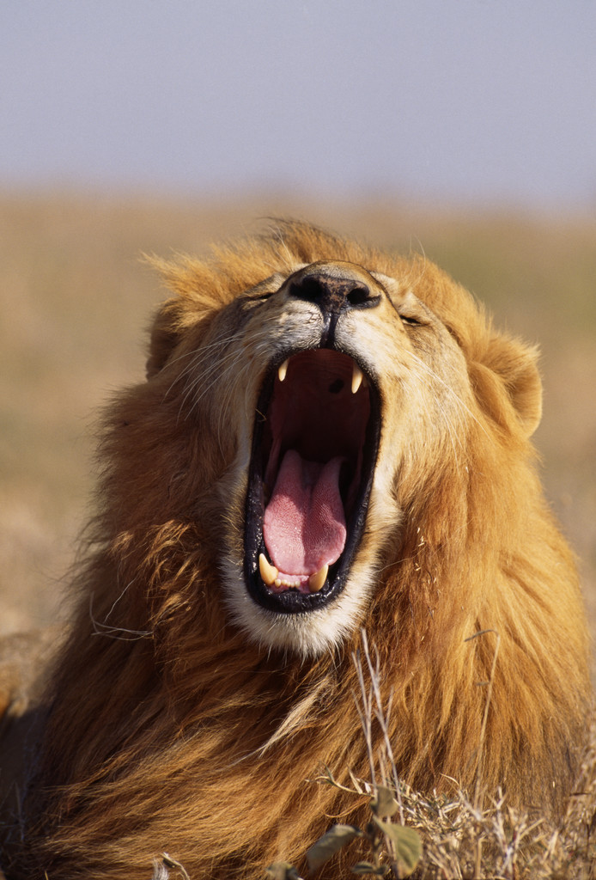

Serengeti
As the students look at the exhibit, remind them that organisms such as plants and animals are classified as living and while other objects are classified as nonliving. Animals need air, water, and food to live, while plants need air, water, nutrients from the soil, and light to survive. Ask the students to name everything in the exhibit they see that represents something living. Point out the lion. Ask the students how the color of its fur helps it survive in this environment. See if the students can find anything else in the exhibit that helps the lion survive.

Okavango
Ask the students what animals they see in this exhibit that they have not seen in any of the others. Ask them what is different about this ecosystem that allows the hippopotamus and the crocodile to live there. Ask the students if they think the lion could live here. Be sure they can explain their answer.

Morian Hall of Paleontology

First Floor

Vocabulary:
dinosaurs, fossils, paleontology, predators, physical traits, carnivore, herbivore

Complex Life
As you enter the Hall of Paleontology you will start at the beginning of time and work your way to modern times.

Ask your students to stop at the first set of objects. Give the students a few minutes to look at the first four stromatolites to the right. Ask the students to name all the colors they see.

Once you have discussed the colors of the first four stromatolites, tell the students to look at the last one on display to the left, titled “Banded Iron”. Now, ask them what color they see on this object. Explain to the students that most rocks contain iron minerals and when iron is exposed to oxygen it begins to rust. Ask the students to describe the color of rust. Tell them that when scientists studied this object and discovered that oxygen was now abundant on Earth they knew that many types of life were possible.

Trilobites
Starting in the Cambrian area, ask the students to walk down and observe the row of trilobites. Ask students to describe the different trilobites on display (big, bumpy, spikey, big eyes, small eyes, antenna, etc.). Explain to the students that when trilobites first occurred on the timeline they were large and their eyes focused on the ground, but once predators emerged they became smaller with intricate spokes and eyes that looked up so that they could protect themselves if necessary. Now ask the students to look at the largest trilobites on display. Do they have several spikes on their bodies? Why or why not? Ask them to explain their answers.

Plesiosaur
Stop at the Plesiosaur on display. Ask the students to think about a penguin. Have them describe what a penguin looks like, specifically their wings, and how they used them. Now, look at the Plesiosaur on display and in the mural. Ask the students if they think the Plesiosaur would swim faster or slower than a penguin. Why? Ask them to explain their answers. Tell them that it was possible that a Plesiosaur swam faster than a penguin because it had an extra set of flippers which acted like the penguin’s wings. This means some Plesiosaur could be very fast in the water.

Late Jurassic
When you enter the Late Jurassic period you will see an Allosaurus, a Stegosaurus and a Diplodocus. Ask the students the following questions:
1. Which one has the longest tail?
2. Which dinosaur has the most spikes?
3. Which dinosaur has the sharpest claws?
Explain to the students that these physical traits all helped the dinosaurs survive and live during their time period. See if they can guess what each feature was used for? Answer: All three were used for protection.

Lane
Ask the students to observe the Triceratops mummy named “Lane”. Point out that all of Lane’s bones are braced in order to protect his fossil. This is a good indication that this is an actual dinosaur fossil and not a cast of a real dinosaur fossil. Tell the students that you want to know how many of them it takes to stretch from Lane’s nose to the tip of his tail. Ask the students to measure it by standing shoulder to shoulder. If you have a small group you might have to get the kids to count as they go then ask the person in the front to move to the end and count again. Do this until you have counted all the way across Lane’s body.

Wyrex and the Denversaurus
Look at “Wyrex” the Bobtailed Tyrannosaurus rex. Ask the students to look at Wyrex’s teeth. Ask the students if they are sharp or flat. Now look at the Denversaurus’ teeth. Ask the students the same question: are they sharp or flat? Tell the students that most meat eaters or carnivores have sharp teeth so they can chew into the meat, while herbivores or plant eaters have flat teeth so they can grind down leaves and vegetables. Ask the students which animal ate meat and which one ate vegetables.

“The North American Cretaceous Inland Ocean”
Ask the students to look at the mural titled “The North American Cretaceous Inland Ocean”. Point out the “panzer squid” (Baculites) in the mural. Ask the students to guess why the panzer squid is shooting ink at the fish heading in his direction. Ask the students if they can name another animal that shoots ink at predators to protect themselves.

“A Green River Lake”
Ask the students to look at the mural, “A Green River Lake”. Point out the large bat chasing the dragonfly. Explain to the students that this is the first known bat. Ask the students to think about modern bats and describe how they look different from the one in the mural. Next, ask the students to describe how modern day bats and this earliest known bat look alike.

Megalodon
Ask the students to take a look at the Megalodon jaw on display. Tell them to look at the teeth from the front of the jaw and the back. Now ask the students to guess what happens when a shark loses his tooth. Do they think it grows back like our teeth? Explain to the students that when a shark loses his teeth the row behind moves forward to fill in the gap. Sharks continue to grow rows of teeth throughout their lifetime.

Mastodons vs. Humans
Point out the mastodons and humans interacting. Tell the students to observe the mastodon’s teeth. Ask them if the mastodon is a carnivore or an herbivore. The students should notice that the mastodon’s teeth are flat, indicating they ate plants. Now ask the students if the mastodon is hunting the humans or if the humans are hunting the mastodon. Explain to the students that humans of the time period hunted mastodon not only for the large quantity of food product but also for their fur for clothing and their bones for tools.

Wiess Energy Hall

First Floor

Vocabulary:
alternative, fossil fuels, energy, renewable, nonrenewable, organisms, sediment, transformation, porous, permeable, geothermal, fuel

Formation
Allow the students to sit on the floor and watch the video showing the origin of energy 13 million years ago. Tell the students that the Solar System, with its stars and planets, was created 13 billion years ago during a burst of energy called “The Big Bang”. The Sun formed and radiated energy. On Earth, plants and animals developed the ability to capture and store energy from the Sun. In the ocean, organisms so tiny that they can only be seen with a microscope absorbed energy from the Sun. When they died, they were covered with mud and rock sediment and began their transformation into oil and gas. These are called fossil fuels because they were created by fossils 600 million years ago. Since the organisms have all died out, no more fossil fuels will be created. These are called nonrenewable energy sources.

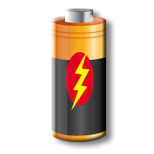

“Energy Is”
Before going into the small theater, tell the students that they will see a film about energy. Ask if anyone knows what energy is and why we need it. When they emerge from the film, see if they can remember the four kinds of energy they learned about in the film. Ask if they know how gasoline, electricity, and natural gas are all used in everyday life.

Geovator
Take the students on a “ride” in the Geovator to see what it is like to be deep underground, inside an oil well.

Porosity and Permeability
Explain to the students that the glass beads represent holes in the rocks deep inside the Earth where oil is trapped. Push the button and tell the students to watch what happens. Which side does the oil move through faster? Explain that because there is more space between the large marbles, oil can flow faster through it.

Crude Oil Samples
Allow the students to look at the different kinds of oil found all over the world. Tell them to notice the different colors and thicknesses of oil. Point out the one from Texas. Ask the students how it is different from the other kinds of oil in the exhibit.

“Energy Excursion Theater”
Before going into the theater, tell the students that they are going to see a film about an alien named Blackout Bart that is trying to steal our energy. The Wizard chases it through many of the alternative forms of energy that we are developing to provide energy when oil and coal are used up. After seeing the film, ask students if they can name at least three of the six alternative energy sources presented in the film.

Alternative Energy Sources
Take the students on a tour of the alternative energy sources displayed at the end of the Energy Hall. Tell the students that “alternative” means other choices. These energy sources are other choices for energy, beyond nonrenewable sources, that will never be used up.

Solar energy changes heat from the sun into electricity. Wind is constantly moving, so it can turn the blades on a windmill to create energy. Geothermal heat is inside the Earth, but ways are being found to bring that heat up to the surface of the Earth to create energy. The tides in the ocean never stop moving, so tidal energy is always available. The water on the top of the ocean is warmer than the water at the bottom of the ocean, so the warm water can be used to create energy. There are fuel cells in cars that do not need gas to run. Ask the students if they have ever heard of any of these alternative forms of energy.

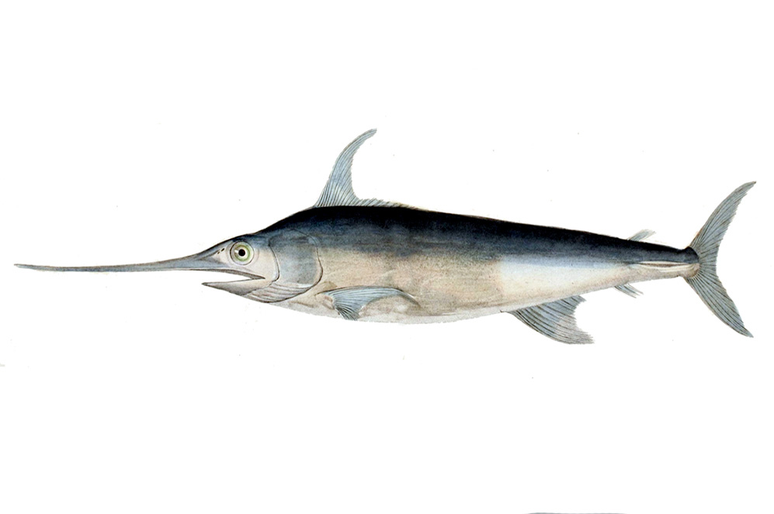
Alfred C. Glassell Jr. Hall

First Floor, Main Entrance

Vocabulary:
adaptation, environment, predator, prey, protected, characteristics, organism, fish, shark, dolphin, mammal, marine

As you guide students through the main hall, tell them to look up. Point out the various fish hanging from the ceiling, and ask students to count how many fish they see.

Bring students over to the marlin hanging on the wall. Ask students to compare this fish to those hanging from the ceiling. How are they similar? How are they different?

Give students an opportunity to share what they know about animals that live in the ocean. Ask them what the biggest animal they know of is. What about the smallest? How many different ocean animals can they name?
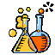

The Welch Chemistry Hall

Lower Level

Vocabulary:
light, heat, sound, solid, liquid, gas, metal

Patterns
Have students observe the ceiling lights. Ask them if they can notice any patterns in the lights. Explain that the lights represent what is in the air they breathe. Have students predict why there is so much more of one color than the others.

States of Matter
Encourage students to observe the ping pong balls at the Matter in Motion station. Have students predict what will happen with each when air flow is introduced to the tubes. Press the button and allow students to observe what happens. Ask them why they think the ping pong balls reacted differently in each tube.

Slime Polymer
Show students the slime tubes and explain to them that each one is made of slightly different materials. Ask them what is similar and different about each tube, just by observing. Have them predict which tube will go the fastest. Then, after racing the slime, students will discuss whether their predictions came true or not, and why.

Self Assembly
Bring students to the self-assembly station. Show them each of the three tubes and explain that they are each filled with different liquids. Look at the first tube, which has just oil and water in it. Encourage students to use their directional words as they explain what is happening in the tube (over, under, on top of, beneath).

Solar System

Outside Main Entrance

Vocabulary:
planets, dwarf planet, Solar System

Allow the students to step on the Sun and all of the planets in front of the Museum. Tell the students the names of the planets and give a little information about them. Be sure they know where the Earth is located in relation to the Sun.

