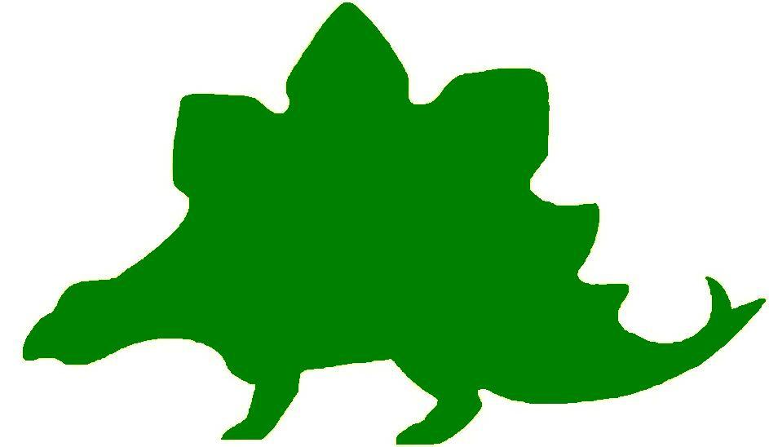

theHoustonMuseumofnaturalscience

High School Knowledge Hunt
Dear Educator,
Thank you for downloading the free, online curriculum available at HMNS! We’re thrilled to see that you are including the world-renowned Houston Museum of Natural Science in your educational toolkit.
Here at HMNS our mission has always been to provide exemplary educational opportunities for the community. Providing educators like you with free, fully editable curriculum is just one of many ways we are fulfilling that mission.
Thank you again, and we hope you enjoy your field trip to HMNS!
Best,
The HMNS Staff

How to use this guide:
- Feel free to edit the questions as needed to suit your student group.
- The Knowledge Hunt is structured to begin at the top of the Museum (floor three) and work its way down to the lower level.
- Visitor services and security staff are posted around the Museum and will be happy to assist you in finding any of the locations mentioned.
- Please ensure that one chaperone is with every group of ten students at all times as they complete these activities.
- Don’t forget to download our extension activities for use in the classroom when you return from your trip!

Please direct any and all questions to curriculum@hmns.org

Hall of the Americas

Third Floor

Locate the text panel “Introduction to Archaeology”
Define “archaeology.”

Name two ways archaeologists can date an object:

1.
2.

Read the text panel in front of the clothing (specifically #6). What is the purpose of the traditional dances and social events?

Look at the sand painting and find the title “What does this Sand Painting Mean?”
List the four sacred plants:

You will see a replica of the Wilson-Leonard Site. Read the text panel to answer the questions that follow.
What was an important food item to the Paleo-Indians 11,000 years ago? How is this represented in the replica?

How long ago was the highest rock pit created?

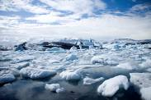

The Arctic
List the three things that the Arctic peoples depended on completely until the twentieth century.

Find the child’s seal gut parka. How are the rows of gut held together?

Name three swift forms of transportation.

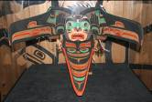

The Northwest Coast
What is the name of the ceremony that reinforces clan ties and affirms a family’s right to privileges and prestige?

How does a transformation mask work?

What does the transformation mask on display represent?

The Southwest
Describe how the stone and mud plaster construction of the walls of Pueblo village structures provided natural insulation.

What is a kiva?

Use the touch screen computer under the doll case and press “Farming.”
What made the Pueblo corn special? Where did it originate?

The Plains
When the Spanish introduced the horse to the Plains, the way of life of the Native Americans changed forever. How did the horse positively impact the daily lives of these people? How did the interaction with outsiders negatively impact the tribes and their way of life?

Look at the display of the tipi. Which direction does a door of a tipi face? Why?

The Southeast
What types of crops did the Mississippian people farm?

Look at the film “Spiro Mounds.”
Why did the Oklahoma government pass an antiquities preservation law in 1936?

Go to the computer touch screen next to the Luxury Objects and click on “Tobacco.” What did the natives believe tobacco was good for?

The Maya
Find the touch screen titled “Jaguar: Protector of the Fields and Forest” and click on chocolate. What did the Mayas call the chocolate trees?

Who or what is the patron of cacao?

Enter the room to the right and find the Temple of Hochob. What is the door shaped like? Why?

The Aztecs
Find the “god” that was used to teach their children obedience. What is the name of the “god” figure? What did it do?

Find the model of the “ball game” to answer the next question.
When is it believed the first ball game occurred?

The Incas
How long did it take the Incas to build over 14,000 miles of roads?

Hall of Ancient Egypt

Third Floor

Egypt: Gift of the Nile
What continent is Egypt located?

What is the name of the river that runs south to north through Egypt?

Timeline of Egyptian History
What famous Queen ruled Egypt during the Ptolemaic Egypt (332 – 30 BC)?

Map: Egypt
Label the map with the 12 places listed below and include a compass rose. Use the text panels throughout the exhibit to help you locate the areas listed.

Lower Egypt Upper Egypt Nile River Red Sea
Mediterranean Sea Alexandria Thebes Memphis
Rome Italy Greece Jerusalem



Egypt’s Ancient Roots
What natural occurrence encouraged ancient Egyptians to leave the desert and move to the Nile flood plain?

The Predynastic Period (6000 – 3100 BC)
What artifacts suggest that upper and lower Egypt were culturally distinct?

Scripts and Writing in Egypt
What kinds of text were written in hieratic?

What were scribal schools?

Who was allowed to attend scribal schools?

Did you know? Naming Egypt
Why do you think the ancient Egyptians named their country Kemet to honor the Nile River?

Ramses II
Look at the large stone bust in the case. How do you think they transported this bust from where it was made to its final pace of honor?

Pharaoh: Lord of the Two Lands
What was maat?

To whom would the king offer the “spoils of war”? How do we know?

Temples
Who had access to the temples?

What would happen to older temples?

Mummification
List two types of protection that was important in the mummification process.
1.
2.

The Old Kingdom (Dynasties 3 – 6, 2682 – 2181 BC)
Where was the Great Pyramid built?

Who was the Great Pyramid built to honor?

The Late Period (Dynasties 26 – 31, 664 – 332 BC)
What technical disadvantage did the Egyptians suffer from during this time period? Who was better at it?

Third Intermediate Period (Dynasties 21 – 25, 1069 – 664 BC)
Why do you think historians believe the Nubian Pharaohs were more Egyptian than Egyptians?

List two innovations the Intermediate Period was known for.
1.
2.

Coffins became the main focus during the Intermediate period. What was painted of the coffins?

Did you know? Sarcophagus
Are all coffins sarcophagi? Why or why not?

Roman and Byzantine Egypt (30 BC – 641 AD)
When did Egypt become a province of the Roman Empire?
What religious belief became popular during the 3rd century AD? How did this affect the burial process?

Mallets and Masons: Egypt’s Mystic Pseudo-Heritage
What does the unfinished pyramid, on the US dollar bill, possibly mean?

The Rosetta Stone
Which three scripts are on the Rosetta Stone?

How did historians learn to “decode” hieroglyphics using the Rosetta Stone?

Hall of Malacology

Second Floor
Read the front of the display.
“What are Mollusks?”

Explain the process of a mollusk forming a shell. (See “How do gastropods make their shells”)

Look at the back of this display. What is the difference between malacology and conchology?

Gastropods and Bivalves
Identify the physical characteristics of gastropods and bivalves by check the appropriate box.

Physical Characteristics | Gastropod | Bivalve
no head
carnivorous and herbivorous
shell, spirally coiled
head, foot, visceral mass
hatchet-shaped foot for burrowing
filter feeder/predator
eyes on head
has teeth

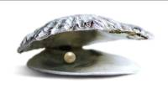Natural vs. Cultured Pearls
What is the difference between natural and cultured pearls?

After viewing the film, complete the flow chart by adding enough boxes and arrows to show how a pearl is formed.

Hall of Gems and Minerals

Second Floor

Each text panel contains a number on the bottom right. We will use these to identify the case.

Case 4: What is the name of the object that looks like a cluster of blueberries?

Look at the Azurite, how many surfaces can you count?

Case 9: Find the Gold Dragon, what type of mineral does the dragon sit on?

Case 38: What is the name of the object and where is it from?

How many cylinders can you count on this object?

Case 46: Where is the cavansite from? What color is it?

Case 58: What is the name of the blue item? Where is it from?

What is in case 78?

What is the name of the green object in case 96?

Case 117: Compare and contrast the four cylinder crystals you see in this case.

What stands in case 149?

There are three opals in the Gems and Minerals/Sue and Lester Smith Vault. One opal can be found in case 87, another just outside of the back door of the vault, and the last one inside the actual vault. Take some time to look at these three opals. List three differences and similarities between them.

Compare | Contrast
1. | 1.
2. | 2.
3. | 3.

While visiting the Hall of Gems and Minerals locate examples of at least five different geometric shapes. Use the chart below to help you.

Case Number | Geometric Shape | Object Name | Place of Origin

Farish Hall of Texas Wildlife
Second Floor

Vocabulary:
aquatic, biodiversity, niche, environment, estuary, ecosystem, species, deforestation, biome, non-sustainable, biotic, abiotic, prey, predator, herbivore, migrate, consumers, scavengers

Changes in Population
View the video at the start of the population. Choose three different animals discussed, and identify what region they are from and how their numbers have changed over the years. Then, predict how the population change may have impacted the ecosystem as a whole.
Animal | Region | Population Change | Impact

Aberrantly Colored Animals
Examine the case just outside of the exhibit. What challenges do you think aberrantly colored animals faced?

How do you think the aberrantly colored animals adapted to survive?

Invasive Species
Use the video to respond to the following questions:
What invasive species have made their presence known in Texas?

What are the different ways in which invasive species arrive?

Are invasive species always bad? Why or why not?

Regional Comparison
Choose three different ecosystems and use the Venn diagram below to compare and contrast them.

Animal Relationships
As you look through the exhibit, identify at least one predator/prey relationship and one producer/consumer relationship in each ecosystem.
Ecosystem | Predator/Prey | Producer/Consumer
High Plains
Coastal Wetland and Marsh
Guadalupe Mountains
Piney Woods
Rio Grande Dry Forest
Coastal Oak Motte
Coastal Prairie

Competition
For each of the animals listed below, find one additional animal within its ecosystem that is in direct competition with it for a biotic or abiotic factor. Identify the animal and the factor that they are competing for.
Animal | Competitor | Factor (Biotic/Abiotic)
Alligator
Coyote
Skunk
Pine Tree
Rattlesnake
Turkey
Barn Owl

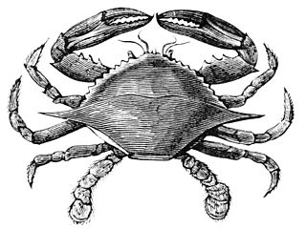

Hamman Hall of Texas Coastal Ecology

Second Floor

Vocabulary:
ecosystem, ecology, tidal zone, population density, salinity, hypersalinity, debris

What is ecology and why might coastal ecology be important to us?

Upper Coast

Oyster Reefs
What is the economic importance of an oyster reef?

What other economic activities do you see represented in the oyster reef display?

What is the difference between salinity and hypersalinity?

Marine Debris
Use the tabletop touch display to find out more about marine debris. What is it?

Who is threatened by marine debris?

Middle Coast

Tides
What causes tides?

Draw a beach in the space below and label the three tidal zones.

Brown Pelican
Observe the series of maps that tracks Brown pelican populations over time. Estimate the number of Brown pelican breeding pairs on the most recent map. How has the number increased or decreased from previous years?

Lower Coast

Texas Coast by the Numbers
What is the current human population in the 18 Texas coastal counties?
What is this population expected to be in the year 2050?
The human population is expected to increase by approximately what percentage in the next 35 years? Show your work.

Seagrass Species
Use the text panel to determine a distinguishing feature of each of the three species of seagrass.
Species | Feature

Kemp’s Ridley Sea Turtle
As you round the corner of the Lower Coast section, you will see a large sea turtle laying her eggs in the sand.
Using the information given about the sea turtle’s needs, as well as the table touch screen titled “Recreation on the Texas Coast,” explain how human activities may or may not affect the life and breeding habits of these turtles.

Hall of African Wildlife

Second Floor
In the Hall of African Wildlife, find the map of Africa and label each of the regions on the map below.

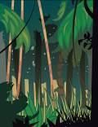

Congo – “Congo Exploration”
How large is the rainforest region in the Congo Basin?

Why did it take until 1900 before the Okapi were discovered?

Look at the Okapi in the scene, describe what it looks like. (Draw a picture)

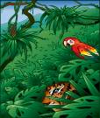

West Africa Tropical Forest – “Living Together in Harmony”
Describe the environment of the West Africa Tropical Forest:

What areas of Africa does the West African Tropical Forest cover?

Serengeti – “Feast or Famine”
What are two types of resources? Define each.

Write an example of each type of resource

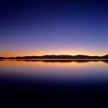

Ethiopian Realm – “Living together in Harmony”
Describe the environment of the Ethiopian Realm:

List the areas the Ethiopian Realm covers.

What is a niche? Give an example.



Okavango – “Life Needs Water to Survive”
Why is the Okavango Delta called the “Jewel of Africa”?

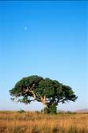

Lowveld – “What is an Ecosystem?”
Define ecosystem

Give examples of Producers, Consumers, and Scavengers that are shown in this scene.
Producer:

Consumers:

Scavengers:

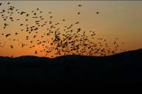

Sahara – “Perilous Migrations”
How long does it take a songbird to fly across the Sahara?

What happens to any bird who has not stored enough energy for the migration?

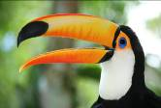

Bird beaks
Observe the birds in the Hall of African Wildlife. There is a great deal of variation among the birds in the Hall. If we look at a bird’s beak, we can often tell what it eats. Find and name a bird in the African exhibit that has the following type of beak:
Bird Name | Description | Purpose
 | Flat beak | Filters food from water
 | sharp, hooked beak | to eat other animals
 | thick short beak | to crack seeds
 | short, thin beak | to eat insects
 | long, thin beak | to get nectar from flowers
 | straight, sharp beak | to spear food
 | long, curved beak | to dig in the mud for food

Bird feet
Now, look at the birds’ feet. Feet also serve specific purposes. Find and name a bird in the African exhibit that has:
Bird Name | Description | Purpose
 | webbed feet | swimming
 | large, curved claws | grasping
 | long back toe | perching

The Morian Hall of Paleontology

First Floor

Precambrian
Look at the four stromatolites on display. Notice the absence of red or rust. Now look at the banded iron and notice the large amount of red or rust. Keep in mind that most rocks contain iron, but the iron in the first four specimens didn’t “rust” like the iron in the fifth specimen. What can we now assume was in the atmosphere that allowed the iron to rust and was necessary for more complex life forms to live on Earth?

Aquarium
Watch the scenes that flow by on the aquarium screens. List four of the different adaptations you see on any of the sea creatures that float by. How do these adaptations help them to survive?
1.

2.

3.

4.

Trilobite
Look at the second window of trilobites on the Cambrian wall. Notice that this shows a parent and offspring. Compare and contrast the offspring with the parent.
 | Parent | Offspring
Compare
Contrast

Boomerang-headed Amphibian
Look at the model of the Boomerang-headed amphibian. How do his feet help him in the water? If he is meant to stay close to the bottom, how does his head shape help him survive?

Jurassic Motherhood
Examine the ichthyosaurs on display paying special attention to her stomach. Can you find all eight of her pups? Note the large head size. Why do you think these babies would need a large head at the start of their lives?

Gyrodus Circularis
Look at the round wide sharp-finned gyrodus circularis. Notice he has harp pointy teeth. This fish thrived on coral. How do his body, his teeth, and his fins help him to thrive on a coral diet? (*Hint: he is thin and flat so he can get between coral structures).

Stegosaurus vs. Allosaurus
Compare and contrast the Stegosaurus and the Allosaurus. Which one do you think could run faster? Based on your observation of the bone structure which one would be more adapt to muddy terrain? Which animal was a carnivore and which was an herbivore?

Compare/Contrast | Stegosaurus | Allosaurus
Run Faster? Why?
Better on muddy Terrain? How do you know?
Carnivore/Herbivore. Evidence?

The Late Cretaceous
Complete the food chain using the options below:

Sun triceratops magnolia
decay/nutrients tyrannosaurus rex

“Stan” vs. “Lane”
Based on their physical appearance, which one is hunting the other, Stan the Tyrannosaurus rex or Lane the Triceratops? Explain your answer.

Quetzalcoatlus
Does this animal give live birth like “Jurassic Mom”?

Which baby (Jurassic Mom or Quetzalcoatlus) do you think would be most dependant on mom after birth?

Fight or Flight
Compare the two scenes on display. One includes a t.-rex and a denversaurus and the other includes a t.-rex and a set of three quetzalcoatlus. Which scene shows a “fight” to survive and which scene shows a “flight” to survive?

Action | Scene
Fight

Flight

The End of the Ice Age
By the end of the Ice Age the mammoth, mastodons and giant slots like “slothzilla” became extinct. List two reasons why you think this happened.

1.

2.

The Wiess Energy Hall

First Floor

At the entrance to the Energy Hall, watch the movie Formation. The movie states there was, “a super thermal radiation of unimaginable scale.” What is this theory called?

 What is the origin of all energy on Earth?

As you enter the Hall go to the right, enter the theatre and watch the movie “Energy Is…” How do they find pockets of oil?

What three things are going to get used up?

List three renewable sources of energy.

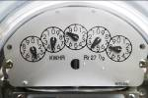 Electricity is the constant flow of ….

What two things does natural gas make?

Sedimentation
Observe the particles as they flow into the water. Which will settle to the bottom – the heavier or lighter particles?

Watch the movie Birth of a Reservoir.
What causes the heat which “cooks” the organic matter and forms oil and gas?

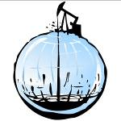

Hydrocarbon Traps
Use the computer screen to see the different kinds of rock on the wall. Read “What Kinds of Rock are Here?” List the four types of rocks.

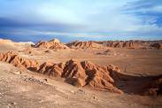

Exploration
In the exploration section you will see a diorama of two geologists in a remote mountainous area. Press the red button to see what they have to say. Describe the job of a geologist.

List three sources of oil deposits.

Seismic Section
What is a “bright spot?”

Geovator
Ride the Geovator to experience what it would be like to be a drill bit. How deep does the bit go into the Earth?
What is the “pay zone”?



Energy Excursions Theater
Watch the movie and list the main sources of energy.

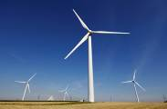 List the types of alternative energies covered.

Choose two sources of energy and describe which of the two has the greater economic/environmental impact. Use at least three reasons in your argument.

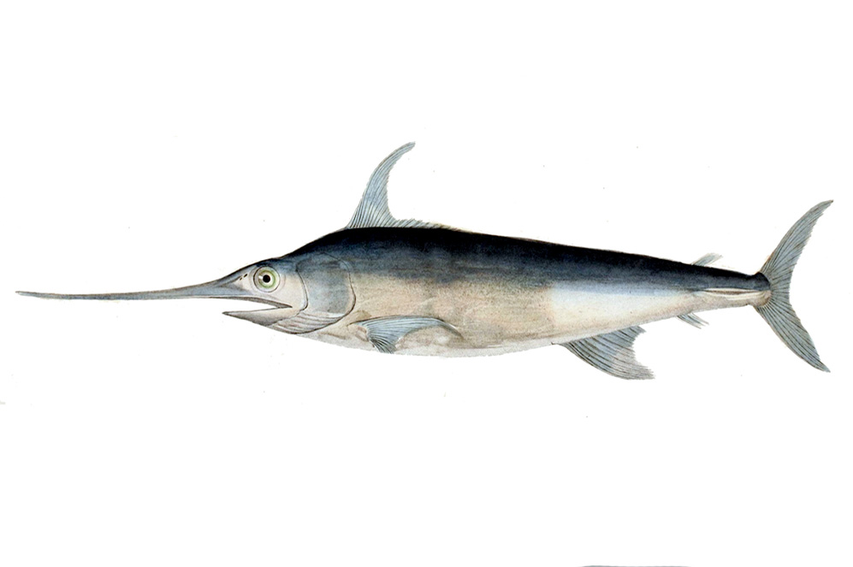
Alfred C. Glassell Jr. Hall

First Floor, Main Entrance

As you enter the hall, observe the various marine animals on the ceiling. Choose three different animals, using the text panel on the pillar as a guide, and compare and contrast their physical features in the Venn Diagram below.

Look at the marlin mounted on the wall. Observe its physical characteristics, and use the chart below to determine the purpose of each of these physical features, as well as how it helps the creature survive.
Feature | Purpose | How it Helps Survival
Dorsal Fin
Teeth
Upper Jaw/Snout
Gills
Tail
Pectoral Fin

In the space below, sketch one of the animals in the exhibit and label its different body parts, as well as its uses.

Move over to the touch screen by the stairwell and choose one of the available topics. In the space below, list the claims within the video, the reasoning behind each claim, and the evidence used to support the claim.
Video Choice: _________________________________________________________
Claim | Reasoning | Evidence
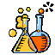

Welch Chemistry Hall

Lower Level
Power of 10 (+) Scale
Write out 10^11. Be sure to include commas in their appropriate places.

Periodic Table
Write out the atomic number and name of the element that each of the atomic symbols below represents. Give an example of each element.
- Hg:
- Bi:
- Na:
- Cu:
- Cl:
- K:

Instruct students to use the touchscreen Periodic Table of Elements to complete the following questions:

How many families are represented in the Periodic Table?

Which elements make up the halogens?

Which elements make up transition metals?

Students will use the Periodic Table of Elements to fill out the following chart:
Elemental Symbol | Element Name | Family | Atomic Number | Atomic Weight | # of Valence Electrons
 |  |  |  | 87.62 | 2
 |  |  | 53
 |  |  |  | 28.0855

Heavy Metal
At the Heavy Metal station, various types of metal are represented. Students will choose two of these metals and use the Periodic Table of Elements to answer the following questions.

Metal #1: _______________________ Metal #2: ________________________

Which of the two metals has the greatest atomic radii?

Which of the two metals is the most electromagnetic?

DNA
Observe the DNA model in the center of the room. Its structure is a double helix. What does it contain?

Super Metals
Is an alloy a compound, element, or mixture? Explain your answer.

