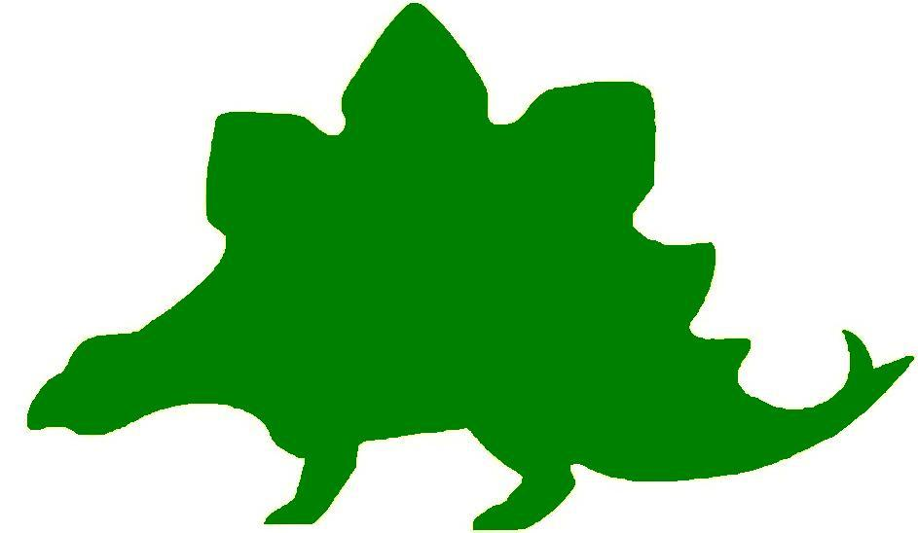

theHoustonMuseumofnaturalscience

8th Grade Knowledge Hunt
Dear Educator,
Thank you for downloading the free, online curriculum available at HMNS! We’re thrilled to see that you are including the world-renowned Houston Museum of Natural Science in your educational toolkit.
Here at HMNS our mission has always been to provide exemplary educational opportunities for the community. Providing educators like you with free, fully editable curriculum is just one of many ways we are fulfilling that mission.
Thank you again, and we hope you enjoy your field trip to HMNS!
Best,
The HMNS Staff

How to use this guide:
- Feel free to edit the questions as needed to suit your student group.
- The Knowledge Hunt is structured to begin at the top of the Museum (floor three) and work its way down to the lower level.
- Visitor services and security staff are posted around the Museum and will be happy to assist you in finding any of the locations mentioned.
- Please ensure that one chaperone is with every group of ten students at all times as they complete these activities.
- Don’t forget to download our extension activities for use in the classroom when you return from your trip!

Please direct any and all questions to curriculum@hmns.org

8th Grade TEKS Objectives
Each of the following TEKS Objectives are met as students explore the various exhibit halls and complete the Knowledge Hunt:

Science: 8.1 (A), 8.2 (A, B, C, D, E), 8.3 (B, C), 8.4 (A), 8.5 (A, B, C, D, E, F), 8.9 (A, B), 8.11 (A, B, C, D)
Social Studies: 8.11 (A), 8.12 (B). 8.16(D), 8.17(C),8.30(A, B, C), 8.31(D)

ELA: 8.2 (A, B, C, E), 8.13 (B, D), 8.14 (A, B, C, D, E), 8.15 (A), 8.16, 8.17 (A, B), 8.18 (A, B, C), 8.20 (A, B (i-ii)), 8.21 (A), 8.22 (A, B), 8.23 (A, B, C, D), 8.24 (A, B), 8.25 (A, B, C, D), 8.26 (A, C), 8.27 (A), 8.28
Math: 8.1 (A), 8.4, 8.5, 8.7 (A, C), 8.8 (A, B, C, D), 8.9 (A), 8.14 (A, C)

McGovern Hall of the Americas

Third Floor

Vocabulary:
kiva, prehistoric, archaeologist, kachina, pueblo, extinction, ornamental, tipi, agriculture, horticulture, cacao, deity

Read the text panel in front of the clothing (specifically #6). What is the purpose of traditional dances and social events?

You will see a replica of the Wilson-Leonard Site. Read the text panel to answer the questions that follow.
What was an important food item to the Paleo-Indians 11,000 years ago? How is this represented in the replica?

How long ago was the highest rock pit created?

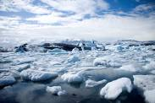

The Arctic
List the three things that the Arctic peoples depended on completely until the twentieth century.

Find the child’s seal gut parka. How are the rows of gut-lining held together?

Name three swift forms of transportation.

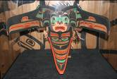

The Northwest Coast
What is the name of the ceremony that reinforces clan ties and affirms a family’s right to privileges and prestige?

How does a transformation mask work?

What does the transformation mask on display represent?

The Southwest
Describe how the stone and mud plaster construction of the walls of Pueblo village structures provided natural insulation.

What is a kiva?

Look at all of the kachinas in the display and read the information that explains their importance. What was their purpose in this society?

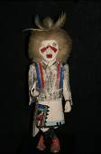
Ancient cultures often created physical representations of their ideals or beliefs.
Use the information about kachinas and the Aztec skeleton (located in the Aztec area) representing the god, Tlahuizcalpantecuhtli, to compare and contrast the beliefs of two different cultures.

Use the touch screen computer under the doll case and press “Farming.”
What made the Pueblo corn special? Where did it originate?

The Plains
When the Spanish introduced the horse to the Plains, the way of life of the Native Americans changed forever. How did the horse positively impact the daily lives of these people? How did the interaction with outsiders negatively impact the tribes and their way of life?

The Southeast
What types of crops did the Mississippian people farm?

Go to the computer touch screen next to the Luxury Objects and click on “Tobacco.” What did the natives believe tobacco was good for?

The Maya
Find the touch screen titled “Jaguar: Protector of the Fields and Forest” and click on chocolate. What did the Mayas call the chocolate trees?

Who or what is the patron of cacao?

The Aztec
Find the deity that was used to teach children obedience. What is the name of the “god” figure? What did it do?

Find the model of the “ball game” to answer the next question.
When is it believed the first ball game occurred?

The Inca
How long did it take the Incas to build over 14,000 miles of roads?

Hall of Ancient Egypt

Third Floor

Vocabulary:
ancient, civilization, ruins, temples, pyramids, pharaoh, branches of government, capital, capitol, drought

Egypt Gift of the Nile
What river runs through Egypt?

Fact: Did you know that the Nile River runs south to north unlike our Mississippi River that runs north to south. This is why Upper Egypt is south of Lower Egypt.

Timeline of Egyptian History
What culture surfaced in North America during Ptolemaic Egypt?

Egypt’s Ancient Roots
When did cows become domesticated?

Fact: Did you know that The Texas Longhorn is a cross between an English and Mexican breed of cattle (by way of Spain).

Scripts and Writing in Egypt
How long was the Egyptian “alphabet” made of unilateral signs? How long is our alphabet?

Did you know? Naming Egypt
How did ancient Egyptians refer to their country?

Why do you think our founding fathers named our country The United States of America?

Pharaoh: Lord of the Two Lands
What three things was the king responsible for?

Which branch of our government makes the laws?

Temples
Why were temples made of stone?

What major building in our capital is made of stone?

Mallets and Masons: Egypt’s Mystic Pseudo-Heritage
Look at the U.S. dollar bill, what do you see that reminds you of Egypt?

Fact: It is believed that the unfinished pyramid is a symbol that the United States is still unfinished.

The Rosetta Stone
What three languages are written on the Rosetta Stone?

Which of these three languages did historians use to unlock the mystery of Egyptian writing?

Strake Hall of Malacology
Second Floor

Vocabulary:
mollusk, gastropod, carnivorous, marine, bivalve, cultured pearl

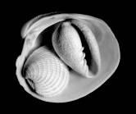

Mollusks
What are Mollusks?

On the map below, label the areas where mollusks can be found
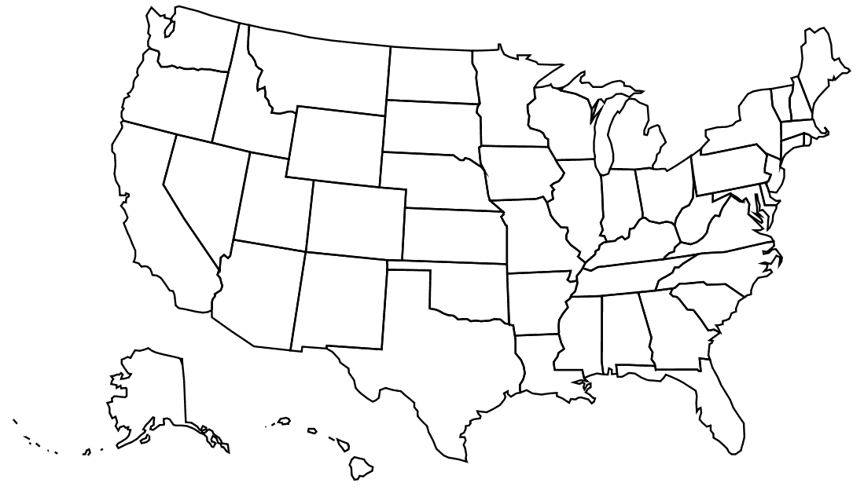

Why do you think Texas has a state shell and Arizona does not?

Look at the back of this display. What is the difference between Malacology and Conchology?

Gastropods and Bivalves
Identify the physical characteristics of gastropods and bivalves by checking the appropriate box.
Physical Characteristics | Gastropod | Bivalve
no head
carnivorous and herbivorous
shell, spirally coiled
head, foot, visceral mass
hatchet-shaped foot for burrowing
filter feeder/predator
eyes on head
has teeth

List the five Mollusks that are native to Texas.
1.
2.
3.
4.
5.

Cullen Hall of Gems and Minerals
Second Floor

Vocabulary:
reflection, refraction, prism, surfaces, angles, geometric shape, Gold Rush

Circumference  Circle: C = 2πr  Area  Square: A = 4s  Rectangle: A = lw or A = bh  Triangle: A = ½ bh or A = bh/2  Circle: A = πr² | Volume  Cylinder: V = Bh*  Cone: V = 1/3 Bh*  Surface Area  Cube: S = 6s²  Cylinder (total): S = 2πrh + 2π  *B represents the area of the Base of a solid figure.

Each text panel contains a number on the bottom right. We will use these to identify the cases.

Case 16 - # 1 Galena on Dolomite
Solve the area of this rectangle if h = 2.5 inches and b = 3 inches. Show your work.

Case 31 – Quartz
Looking at the quartz in this case, the top section makes a cone shape. Assuming r = 2 and h = 3, find the volume. Round to the nearest whole number.

Case 42 – Pyrite
Find the area of one side of this mineral, assuming it is a square, if s = 3 inches. Next, find the surface area of the pyrite cube if s = 3 inches.

Case 76 – Hydxorylherderite
Find the area of the top triangle in this mineral if b = 2 inches and h = 1.5 inches.

Case 83 – Elbaite
Look at the Elbaite in the case. Picture a regular cylinder of similar size. Its radius is 1.5 inches and its height is 8 inches. Find the volume of the cylinder. Round your answers to the nearest whole number and include all unit of measure. Show your work.

Now picture the same cylinder and find the surface area using the same information given above.
r = 1.5 inches and h = 8 inches

Case 125 – # 1 Rhodochrosite
Find the circumference of the top circle if r = 3 inches.

There are a couple of opals in the Hall of Gems and Minerals. Take some time to look at these opals. List three similarities and three differences between them.

Compare | Contrast
1. | 1.
2. | 2.
3. | 3.

While visiting the Hall of Gems and Minerals, locate examples of at least five different geometric shapes. Use the chart below to help you organize your information.

Case Number | Geometric Shape | Object Name | Place of Origin

Chose one of the geometric shapes you listed above and draw the shape from two different angles.

Word Problems
Each student should pick a display case in the Hall of Gems and Minerals. Ask the students to come up with two word problems about the gem, mineral, or the display case itself. (Think angles, percentage, scale, etc.) Write these problems below; you will share them when you get back to class.

1.

2.

Farish Hall of Texas Wildlife
Second Floor

Vocabulary:
biodiversity, niche, environment, estuary, ecosystem, species, deforestation, biome, non-sustainable, biotic, abiotic, prey, predator, herbivore, migrate, consumers, scavengers

Changes in Population
View the video at the start of the exhibit. Choose three different animals discussed, and identify what region they are from and how their numbers have changed over the years. Then, predict how the population change may have impacted the ecosystem as a whole.
Animal | Region | Population Change | Impact

Estuaries
What is an estuary and why is it important?

In what ecosystem do estuaries exist?

What biotic and abiotic features dominate estuaries?

Animal Relationships
As you look through the exhibit, identify at least one predator/prey relationship and one producer/consumer relationship in each ecosystem.
Ecosystem | Predator/Prey | Producer/Consumer
High Plains
Coastal Wetland and Marsh
Guadalupe Mountains
Piney Woods
Rio Grande Dry Forest
Coastal Oak Motte
Coastal Prairie

Competition
For each of the animals listed below, find one additional animal within its ecosystem that is in direct competition with it for a biotic or abiotic factor. Identify the animal and the factor that they are competing for.
Animal | Competitor | Factor (Biotic/Abiotic)
Bald Eagle
Pronghorn
Porcupine
Three-Toed Box Turtle
Cactus
Turkey
American Bison

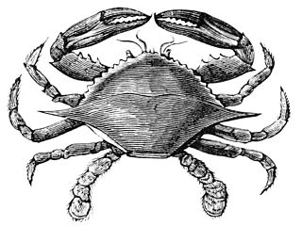

Hamman Hall of Texas Coastal Ecology

Second Floor

Vocabulary:
ecosystem, ecology, tidal zone, population density, salinity, hypersalinity, debris

As you enter the Hamman Hall of Texas Coastal Ecology, find Houston (Harris County) on the map of Texas. What is ecology and why might coastal ecology be important to us?

Upper Coast

Oyster Reefs
What is the economic importance of an oyster reef?

What other economic activities do you see represented in the oyster reef display?

What is the difference between salinity and hypersalinity?

Marine Debris
Use the tabletop touch display to find out more about marine debris. What is it?

Who is threatened by marine debris?

Middle Coast

Tides
What causes tides?

Brown Pelican
Observe the series of maps that tracks Brown pelican populations over time. Estimate the number of Brown pelican breeding pairs on the most recent map. How has the number increased or decreased from previous years?

Lower Coast

Texas Coast by the Numbers
What is the current human population in the 18 Texas coastal counties?
What is this population expected to be in the year 2050?
The human population is expected to increase by approximately what percentage in the next 35 years? Show your work.

Take a look at the sample of laws passed over time to protect our bays and estuaries. How have these laws changed over time? Why do you think this change has occurred?

Kemp’s Ridley Sea Turtle
As you round the corner of the Lower Coast section, you will see a large sea turtle laying her eggs in the sand.
Based on what you have seen so far in this exhibit, list at least three things the turtle requires for survival, and three things that could present a danger to it.
Needs for Survival | Dangers

Frensley Hall of African Wildlife
Second Floor

Vocabulary:
aquatic, tropical, biodiversity, niche, environment, primates, ecosystem, species, deforestation, biome, non-sustainable, biotic, abiotic, prey, drought, predator, herbivore, reservoir, migrate, consumers, scavengers

In the Hall of African Wildlife, find the map of Africa and label each of the regions on the map below.

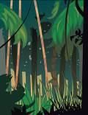

Congo – “Congo Exploration”
How large is the rainforest region in the Congo Basin?

Why did it take until 1900 before the Okapi were discovered?

Look at the Okapi in the scene, describe what it looks like. (Draw a picture)

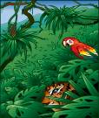

West Africa Tropical Forest – “Living Together in Harmony”
Describe the environment of the West Africa Tropical Forest:

What areas of Africa does the West African Tropical Forest cover?

Serengeti – “Feast or Famine”
What are two types of resources? Define each.

Write an example of each type of resource.

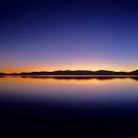

Ethiopian Realm – “Living together in Harmony”
Describe the environment of the Ethiopian Realm:

What is a niche? Give an example.



Okavango – “Life Needs Water to Survive”
Why is the Okavango Delta called the “Jewel of Africa”?

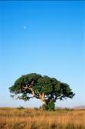

Lowveld – “What is an Ecosystem?”
Define ecosystem:

Give examples of a producer, consumer, and scavenger being shown in this scene.
Producer:

Consumers:

Scavengers:

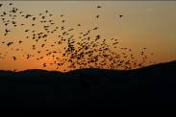

Sahara – “Perilous Migrations”
How long does it take a songbird to fly across the Sahara?

What happens to any bird who has not stored enough energy for the migration?

Comparing Ecosystems
Pick two African regions. List at least one example of the following for each:

Region | 1. | 2.
Predator
Prey
Consumer
Producer
Scavenger
Biotic Component
Abiotic Component

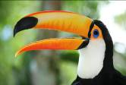

Bird beaks
Observe the birds in the Hall of African Wildlife. There is a great deal of variation among the birds in the Hall. If we look at a bird’s beak, we can often tell what it eats. Find and name a bird in the African exhibit that has the following type of beak:

Bird Name | Description | Purpose
 | Flat beak | Filters food from water
 | sharp, hooked beak | to eat other animals
 | thick short beak | to crack seeds
 | short, thin beak | to eat insects
 | long, thin beak | to get nectar from flowers
 | straight, sharp beak | to spear food
 | long, curved beak | to dig in the mud for food

Bird feet
Now, look at the birds’ feet. Feet also serve specific purposes. Find and name a bird in the African exhibit that has:

Bird Name | Description | Purpose
 | webbed feet | swimming
 | large, curved claws | grasping
 | long back toe | perching

The Morian Hall of Paleontology

First Floor

Vocabulary:
paleontology, fossils, extinction, predator, prey, carnivore, herbivore, mastodon, mammoths, consumer, producer, extinct, environment, deprived

Trilobites Reveal the Lost Kingdom of Avalonia
What theory as given about why shallow water trilobites (Paradoxides) were found in Massachusetts, Georgia, Wales, Morocco, but not in Ohio, Nevada, Russia or China? What proof did scientists find to support the theory? Do you agree? Why or why not?

Draw and label the four views, showing what scientists believe happened to the lost island of Avalonia. Shade in the island through each step.

Jurassic Oceans
List two predator/prey relationships in this mural.

Mesolimulus walchi
Follow the footsteps of the horseshoe crab. As he continues across the floor he is being deprived of more and more oxygen. How is this affecting his movement? What happens to the horseshoe crab once he is completely deprived of oxygen?

A Jurassic Watering Hole During the Tithonian Age
Look at the mural and list the producer/consumer relationship you see. List at least one predator/prey relationship on display.

- producer/consumer

- predator/prey

“Lane” the Triceratops vs. “Stan” the Tyrannasaurs rex
In this scene between Lane and Stan, which one is the predator? The prey? Explain how you came to your conclusions.

Predator =

Prey =

Explanation:

The North American Cretaceous Inland Ocean
In the mural, what would happen to the environment if the coral was suddenly removed? What would happen if the temperature of the water dropped 10 degrees? Explain your answers.

Why is it important for each species to exist in this underwater environment?

The End of the Ice Age
By the end of the Ice Age the mammoth, mastodons and giant sloths like “slothzilla” became extinct. List two reasons why you think this happened.

Foucault Pendulum

First Floor

Go to the touch screen at the Foucault Pendulum to learn more about how this device works.

Wiess Energy Hall

First Floor

Vocabulary:
energy, sedimentary, electricity, hydrocarbons, reservoirs, geologist, explorations, subsurface, seismic, borehole, molecule, consumer, nuclear, hydroelectric, conductor, current, generators, turbine, alternative, deplete, non-renewable, renewable, conservation

At the entrance to the Energy Hall, watch the movie Formation. The movie states there was, “a super thermal radiation of unimaginable scale.” What is this theory called?


What is the origin of all energy on Earth?

As you enter the Hall go to the right, enter the theatre and watch the movie “Energy Is…” How do they find pockets of oil?

What three things are going to get used up?

List three renewable sources of energy.

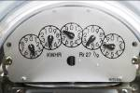
Electricity is the constant flow of…

What two things does natural gas make?

Watch the movie Birth of a Reservoir.

What causes the heat which “cooks” organic matter and forms oil and gas?

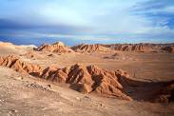

Exploration
In the exploration section you will see a diorama of two geologists in a remote mountainous area. Press the red button to see what they have to say. Describe the job of a geologist.

Seismic Section
What is a “bright spot?”

Geovator
Ride the Geovator to experience what it would be like to be a drill bit. How deep does the bit go into the Earth?

What is the “pay zone”?



Energy Excursions Theater
Watch the movie and list the main sources of energy.

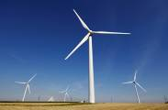
List the types of alternative energies covered.



Persuasion with Evidence
Choose two sources of energy and write down any information you can find about them. You will use this information when you are back in the classroom. You will work in groups in a debate persuading your classmates that your chosen source of energy has a greater economic/environmental impact on your city. Use at least three reasons in your argument.

Count the number of pins around half of the pendulum. If all of the pins are knocked down in a 24-hour period, how long does it take for the pendulum to knock over five pins? Show your work.

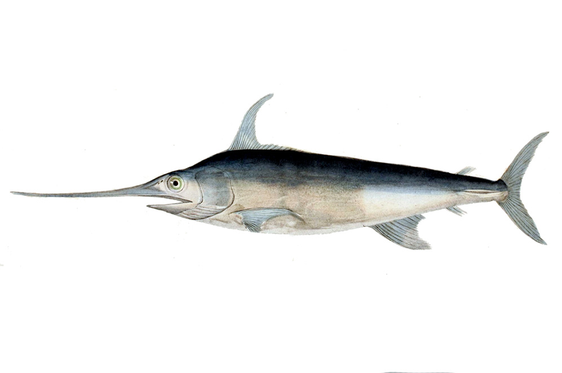
Alfred C. Glassell Jr. Hall

First Floor, Main Entrance

Vocabulary:
biodiversity, niche, environment, estuary, ecosystem, species, biome, non-sustainable, biotic, abiotic, prey, predator, herbivore, migrate, consumers, scavengers, producer, consumer, resources

Use the chart below to identify whether each organism is a producer or a consumer and whether it is a predator, prey, or both.
Organism | Producer/Consumer | Predator/Prey
Black Marlin
Dusky dolphin
Manta ray
Wahoo
Algae
Hammerhead Shark
Roosterfish

Do you think plants, such as algae, can be considered prey? Explain your answer.

Examine the mounted marlin against the far wall. What abiotic and biotic factors does this animal depend on to survive? Fill out the chart below
Biotic Factors | Abiotic Factors

Touch Screen
Move over to the touch screen by the stairwell and explore its various options. What different factors do humans depend on within the ocean?

How have humans modified these resources?

In what ways are these resources at risk?

How can we help to ensure that stability is returned to coral reefs, beaches, and other ocean habitats?

The Welch Chemistry Hall
Lower Level

Vocabulary:
solar system, gravity, orbit, revolve, rotation period

Periodic Table of Elements
Instruct students to use the touchscreen Periodic Table of Elements to complete the following questions:
How many families are represented in the Periodic Table?

Which elements make up the noble gases?

Which elements make up alkali metals?

Students will use the Periodic Table of Elements to fill out the following chart:

Symbol | Element Name | Family | Atomic Number | Atomic Weight
Hg
 | Potassium
 |  |  | 53
Xe |  | Noble Gases

Heavy Metal
At the Heavy Metal station, various types of metal are represented. Students will choose two of these metals and use the space below to sketch and label the element, including its protons, neurons and electrons.

Metal #1: _________________________________ | Metal #2: __________________________________



Weather Center

Lower Level

In groups of four or five, students should rotate the roles of weather person (meteorologist), camera person, and audience. While reporting the weather and operating the camera, students will experiment with lighting, sound, camera angle, posture, voice level, and delivery skills. The audience will listen and view the presentation and critique both performances. The audience will rank the skills of each person on a scale of 1 – 5 with 5 being “very skilled”.

Meteorologist
 | 1 | 2 | 3 | 4 | 5
Posture
Voice Level
Delivery Skills

Camera Operator
 | 1 | 2 | 3 | 4 | 5
Ability to frame the subject

Solar System

Outside Main Entrance

Vocabulary:
Periodic Table, elements, molecule, atom, atomic number, atomic weight, family, group, noble gas, alkali metals, ions, protons, neutrons, crystal, matter, conductor, density, insulator, polymer, acid, base, pollutant, conductivity, superconductors, synthetic, natural, insulator, gravity, coefficients

Saturn
Using the statistics provided, calculate how many Earths would fit between Saturn and the Sun.

Mercury
Extrapolate the percent Mercury is of Jupiter (size) using the statistics given for both.

Neptune
Using the length of a Neptune year and its rotation period, find the number of hours in a year on Neptune. How many times longer is it than an Earth year?

Additional Questions
Count the number of steps between Jupiter and Neptune:

How many of the planets are named after mythological deities?

Gathering Information
Fill in the charts for each listed planet using their plaques. You will use this information later:

Terrestrial Planets
Planet | Mercury | Venus | Earth | Mars
Distance from Sun (AU) |  |  | 1
Rotation Period (hrs) |  |  | 24
Year Length (Earth yrs) |  |  | 365.26 days
Mass (Earth masses) |  |  | 6,600 billion billion tons
Temp. Range (deg C) |  |  | -90 to 58
# Moons |  |  | 1
Diameter (# Earths) |  |  | 12,756 km

Gas Giants
Planet | Jupiter | Saturn | Uranus | Neptune
Distance from Sun (AU)
Rotation Period (hrs)
Year Length (Earth yrs)
Mass (Earth masses)
Temp. Range (deg C)
# Moons
Diameter (# Earths)
*AU stands for Astronomical Unit and is equal to the distance between the Sun and the Earth, which is about 149, 597, 870 km.

