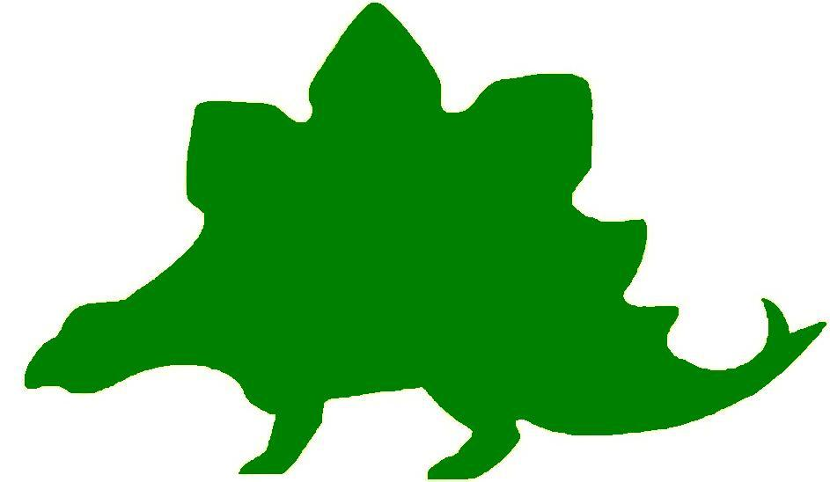
theHoustonMuseumofnaturalscience

8th Grade Extension Activities

McGovern Hall of the Americas

Third Floor
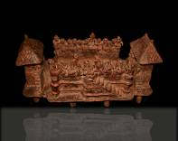

Play Ball!
In the Hall of Americas students saw a sculpture called the Ball Game, dated around 200 BC. This game was obviously important to the culture, because a sculpture of it was made. Ask the students to write a story about the game, describing how it was played and why it was so important. Alternatively, students can create a list of ten rules that explain how the game was played.

Decisions Decisions!
Ask the students what they would do if they were on the opposite team of their best friend and they knew that the winners of the game were going to be sacrificed and the losers would live in disgrace? Tell the students to write a story about how you could make a plan to save both of their lives.

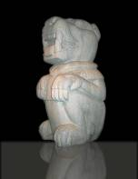

Jaguar – Protector of Cacao!
The Pre-Columbian Jaguar statue the students saw at the Museum was discovered in a Guatemala cacao orchard. Ask the students why they think that, of all the animals that could have been chosen to sculpt, the jaguar was chosen by this culture? Ask them why they think the natives decided to make it so large? Tell the students to create a clay model of an animal of their choice. They should think about where it might be displayed in their community. What will it represent? Will it be fierce or friendly? How will the community celebrate its importance? Assign the students to write a story about their special animal.

Funny Faces
Tell the students to look at the picture above and take note of the expression of the Jaguar sculpture. Discuss whether it was a mean or friendly creature. Students should support their opinion with details from the sculpture. Ask the students to redraw the sculpture, changing its expression to evoke a different emotion.

Yummy Math
For the Maya, the Jaguar was the protector of the valuable cacao orchards. The cacao tree is the plant from which chocolate is made. Chocolate had many uses in ancient societies. It was used as medicine, food, and even as a form of currency. For a modern day use of chocolate, use M&M’s to sharpen students’ math skills: probability, estimation, fractions, percents, graphing, etc.

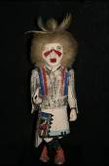

A New Kind of Kachina
While visiting the Museum students had a chance to see real kachinas in the Hall of the Americas. Tell the students to remember that kachinas represented deities that controlled an event or were used to explain an act of nature. Ask the student to choose an event or an act of nature and create a new kachina. They should draw or create a model of the new kachina. When they are finished, ask them to write a short story that explains the role of their new figure. Present the kachinas to the class and display them around the room.

Hall of Ancient Egypt

Third Floor

The Capitol
While visiting the Hall of Ancient Egypt you learned that the Egyptians built their temples out of stone so that they could last forever. Think about the capital of Texas. In Austin, our state’s capital we have a large pink granite building as our Capitol, sitting in the middle of Congress Avenue. We used pink granite that can be found in the Texas hill country as a nod to our Texas pride. Conduct some research on other capitol buildings in the United States. What are they made of? How do they give a “nod” to their state?

Branches of Government
Divide the class into three groups. Each group should be assigned a branch of government. Ask the groups to research their branch. Find out what they do and who is responsible for their branch. Have a friendly class debate where each branch argues that their branch is the most important. Lead the group into understanding that each branch is actually dependent on another and that this is our system of checks and balances. Explain that in ancient Egypt they did not have a system like this in place. Whatever the Pharaoh said was law. Ask the students how they would feel about living under a Pharaoh’s rule.

Strake Hall of Malacology

Second Floor
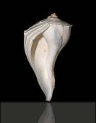

State Shells
Fourteen states have a “State Shell”. Divide the class into small groups and ask each group to choose one of the fourteen states to research. Ask the groups to find out as much information as possible at their state’s shell. They should create a drawing to represent the shell and make a list of fun facts about it. Ask the groups to present their shell to the class along with their list of fun facts.

Gastropods and Bivalves
Tell the students to use the chart they filled out during their trip to the Museum to create their own gastropod or bivalve. Students should be sure to include the correct physical traits they checked off on their chart. They may design their gastropod or bivalve anyway they like. Display their work around the classroom.

Cullen Hall of Gems and Minerals

Second Floor
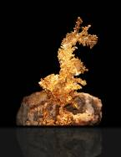

Gold Dragon – Gold Rush
While in the Hall of Gems and Minerals, students saw our “gold dragon”; this fascinating specimen is naturally occurring and has not been molded or shaped in any way! Gold has always captivated humans, and has played a major role in shaping our history, especially in the formative days of the United States as it was expanding and extending its boundaries. One major point of westward expansion in U.S. history took place in 1849 during the California Gold Rush. It was a very difficult time for many; one in five people died trying to pan for their fortune. When you begin talking about westward expansion, begin a class discussion about the ‘49ers. Discuss how they arrived in California, what they did while they were there, what it was like to live in the mining towns, and who became wealthy and who didn’t.

On the board, list the facts that students already know about the Gold Rush. Divide the class into two groups. One group will be arguing that it was a good idea for the ‘49ers to rush to California while the other group argues that it was a bad idea to head west. Ask students to conduct additional research about that time period in California. Hold a class debate in which both sides use facts they have learned to make their arguments.

Word Problems
At the Museum, every student came up with two word problems about a Gems and Minerals case of their choosing. Divide the class into three equal groups and have each compile their problems, making sure all of the information necessary to solve their problems is provided. Every group must also make a solutions sheet to go along with their problem set. Switch and solve the other groups’ word problem sets.

Farish Hall of Texas Wildlife
Second Floor

Competitors
Assign students an animal to research. Have them use the internet and other resources to identify the different competitors the animal must deal with on a daily basis. Students should then indicate which adaptations the animal has made to cope with this competition. Finally, students will think about how the animal could adapt further to be even more well-suited to its environment. What changes in behavior would it need to make? How would that impact the ecosystem overall?

Students can then write a persuasive piece where they argue that their animal is the most well-suited to its environment.

Changes in the Ecosystem
Assign students a particular ecosystem within Texas. Then, assign a different change to each one. For example: the coastal wetlands could experience a drought, or the Piney Woods could experience a forest fire. You can include all natural changes or man-made changes (such as deforestation). Students will have to predict how the ecosystem will change, and how the wildlife will be impacted in the long term. Additionally, students will need to create an action plan for revitalizing any major losses to the ecosystem.
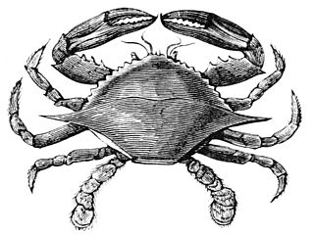

Hamman Hall of Texas Coastal Ecology

Second Floor

Marine Debris Begone
Have students research methods used to clean up tricky marine debris (think trash that has floated far out to sea or particles so small they can’t be caught in a net). After choosing a method to focus on or brainstorming one of their own, have students create a story about the problem of pollution. They could have villains, superheros, double-crossers, etc. Encourage them to get creative with solving the crisis.
Bonus: Team up with another class to share stories.

Salinity
Review the concept of salinity with students. Remind them that, in the exhibit, they read about hypersalinity as well as brackish water. Explain that different spots in the ocean may have different concentrations of salt (the ocean is not homogenous), and that these concentrations can be so different that they actually form distinct layers in the water.
You will need: large beaker or clear glass, small glass, spoon, water, salt, food coloring for each group of students
Fill the large beaker about 1/3 full of water. Add in salt, stirring to dissolve the salt in the water. Keep adding in salt until you can’t add any more (if you stir for 5 min. and the salt isn’t dissolved, you are there!). This is a hypersaline solution.
In the small glass filled with water, add a small quantity of salt- a spoonful should do. Add a few drops of food coloring to this glass so that this solution is clearly different.
Carefully and slowly add a small amount of the colored solution to the hypersaline solution in the large beaker. Do not stir. What happens?

Frensley Hall of African Wildlife

Second Floor

Ecosystems and the Domino Effect
Tell the students to refer to the ecosystem chart they filled in during their trip. Ask the students to choose one of the two African regions and, in essay form, describe what they believe would happen if they took out all of the scavengers within that system. Would anything change? Why or why not? What would happen to the plants in the ecosystem? Would any changes spill over into other ecosystems? What would happen to each of the other animals/components that you listed? Be specific.

The Morian Hall of Paleontology

First Floor

Grid the Dig
Scientists know that dinosaurs are found in certain parts of the world for many reasons, and have learned to recognize specific rock formations. When parts of a dinosaur are discovered, scientists take every precaution to protect the potential paleontological site. One such precaution includes making a grid using rope and stakes over the top of the site. To determine where to make the grid, first, scientists identify the bone and the dinosaur to which it belongs. Then, they measure out the grid based on the estimated size of the identified dinosaur and the location of the bone in the skeleton.

Tell students to pretend they are walking in an area where dinosaurs have previously been found when they see a partially exposed bone fragment, such as a rib bone, a tail bone, jaw bone, etc. Ask the students to create a grid map of the site where this dinosaur might be uncovered. Then, tell the students to draw the grid covering the area where the dinosaur is buried. Students should research the size of the dinosaur for use in making their scale. On their map, students need to include a key to show the scale of each square and a compass rose. Label the quadrants of their grid using letters across the top and numbers down the side. Give the coordinates identifying where the part of your dinosaur was exposed above the ground.

Meet the Press
Give the students a list of the kinds of scientists that work on a dinosaur dig. Some suggestions are geologist, paleontologist, paleolife artist, paleobotanist, geochemist, cartographer, etc. After researching one of these scientists, have the students write a job description of that scientist and explain why they are important to the dig. Next, students will present their scientist to the class. They may dress as the scientist and carry objects that might be necessary for them to be successful on the dig. Students should be prepared to field questions as if they are being interviewed by the press.

Round up the Pterosaur Eggs!
As the students saw at the Museum, Pterosaur used their wings to fly from one place to another. Ask the students to pretend that a mother Pterosaur has lost her eggs. One egg is 25 ft. in front of her while the other egg is 40 ft. to her right. Tell the students to illustrate their positions. For more advanced students, draw a picture of a pterosaur with two eggs in other positions. Calculate the distance between the eggs.
Use a² + b² = c² (the Pythagorean Theorem) to solve for the distance. Round your answer to the nearest tenth.
90º



Drifting Away
While visiting the Museum, the students learned that the Trilobite was important to the theory of continental drift because they have found fossilized remains on different continents that scientists believe were attached at one point. Ask the students to break into pairs to conduct research to find out if there are any other fossils that were found on two different continents. Students should be prepared to report their findings to the class.

Wiess Energy Hall

First Floor

Energy Conservation
Below are a few ideas to promote the conservation of energy and natural resources in local neighborhoods. Challenge each student to come up with at least two new ideas.

- Observe the bicycle racks at the school. Are there enough? If not, implement a program to create more. Make posters, videos, etc. to encourage students to ride their bikes to school. Create an award procedure for those who walk or ride their bikes instead of taking the bus. Design posters to show the personal health benefits of biking and hang them in the school’s hallways.

- Encourage teachers and students to use both sides of their paper. Do research and create a visual to show the benefits.

Nighttime Energy
What would the effect be of a reversal of our times of activity from day to night (i.e. sleep all day and do everything we need to at night, like school and grocery shopping)? Have the students write stories on their take of this new way of life. How far reaching would this reversal be? Would society become more efficient? Less efficient? Would it cost more for the world to be up at night? Why or why not?

Persuasion with Evidence (cont.)
One of the most important conclusions the students may reach from their visit to the Energy Hall is that the world desperately needs to develop renewable energy sources.

In a class discussion, create a list of different kind of energy sources. Narrow the list down to two kinds of energy. Divide the class into two groups and assign each an alternative energy source. Each group will conduct research and create a presentation, including a visual display, to convince the class that their type of energy would be best for the city.

The format of the class presentation should be a debate; each group needs to be aware of their energy’s pros and cons, and must be prepared to answer, with supporting evidence, questions from the other group.

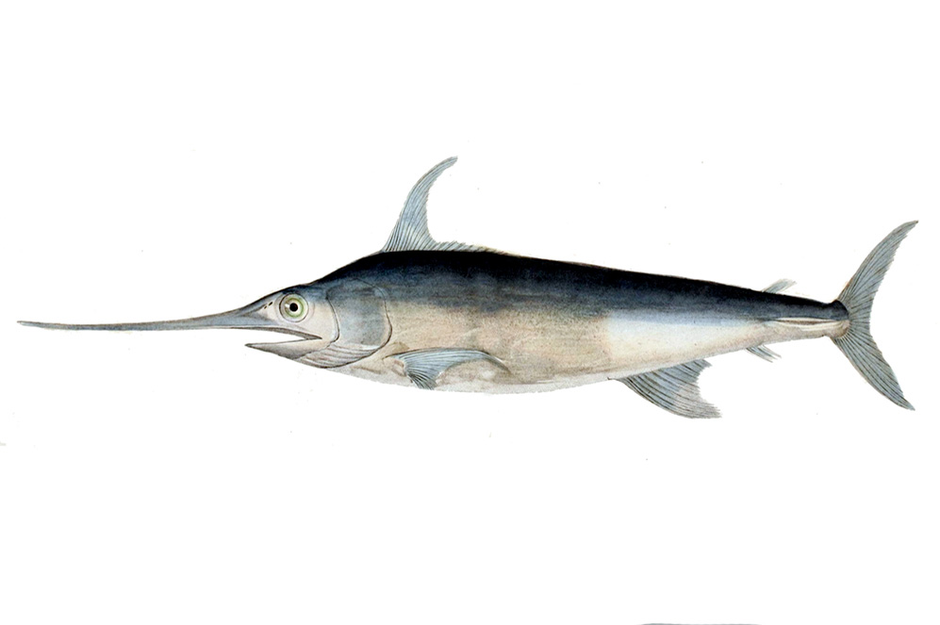
Alfred C. Glassell Jr. Hall

First Floor, Main Entrance

Changes Over Time
Remind students that while animals are well-suited for their environment, environments do change. Sometimes they change quickly and sometimes there are slow changes over time. Have students choose one marine animal they encountered in the exhibit and research its natural environment. Then, have then investigate what changes its environment may face and predict how it may impact the animal. How will the animal have to adapt to these changes?

Updating Ecosystems
Humans are well-known for making modifications to ecosystems, and this is no exception in the marine world. Have students research different man-made modifications such as artificial reefs, runoff, the building of dams, or the use of natural resources and its lasting impact on the ecosystem. Students should develop a persuasive speech in which they argue either for or against the necessity of this human activity, providing evidence to support their claim.

Food Webs
Assign each student a different marine ecosystem and have them create a detailed food web. Tell students to label each organism on the web as predator/prey and producer/consumer as appropriate.
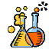

The Welch Chemistry Hall

Lower Level

Balancing Chemical Equations
Explain to students that while they were at the Museum, they used the Periodic Table of Elements to investigate the properties of different elements. Show them that a balanced chemical equation is one where there is the same number of each kind of atom present on either side of the arrow (same number in the reactants and the products). See the example below:

UNBALANCED: _Mg + O₂ ⬄ _MgO
(one Mg and two O) ⬄ (one Mg and one O)

BALANCED: 2Mg + O₂ ⬄ 2MgO
(two Mg and two O) ⬄ (two Mg and two O)

Fill in the correct coefficients needed to balance each of the following equations (Remember, you cannot change subscripts, you cannot place coefficients in the middle of a formula, and you must use the least common multiple that will work, i.e. the smallest coefficients possible):

_Al + _O₂ ⬄ _Al₂O₃ _H₂ + _N₂ ⬄ _NH₃

_H₂ + _O₂ ⬄ _H₂O _Fe + _Cl₂ ⬄ _FeCl₃

_C₂H₆ +_O₂ ⬄ _CO₂ + _H₂O _Zn + _HCl ⬄ _ZnCl₂ + _H₂

Atom Matching
Assign each student an element and tell them that they must create a model of the element, with the correct number of protons, neutrons and electrons. Once students have created their elements, place groups of elements in different locations around the room. Students will circulate from one station to the next, trying to identify as many elements as possible, using the Periodic Table of Elements as their guide.

Solar System

Outside Main Entrance

Planetary Math
Ask the students to answer the following questions using the information they gathered at the Museum. They should write out their work and answers, being sure to include correct units of measurement for all answers.

1. Starting with their relative distances from the Sun, how much farther is Earth from Uranus than Earth from Venus?

2. We already know that one day on Earth, or its rotation period, is 24 hours long. With this information, calculate in hours how long one year on Saturn lasts.

3. By what percent is Jupiter’s diameter larger than Mercury’s?

4. How many planet Mars’ could fit into planet Neptune?

5. Find the planet with the most moons. How long is one NIGHT on that planet?

6. Write out the given mass of the Earth using the power of ten format.

7. Using the number of steps you found between Jupiter and Neptune, calculate how many steps it would take to get from the Sun to Uranus.

8. How much colder is the average temperature on Neptune than Venus?

9. What, in degrees Celsius, is the difference in the average temperature of Earth than Mars?

