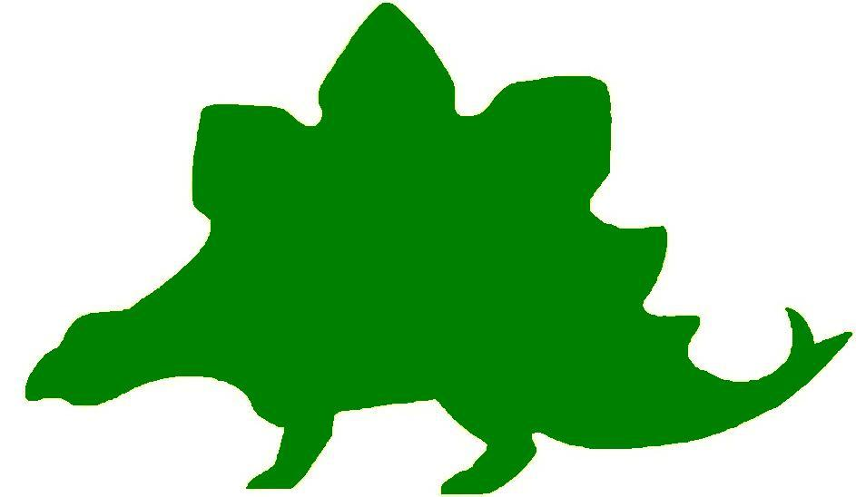
theHoustonMuseumofnaturalscience

7th Grade Knowledge Hunt
Dear Educator,
Thank you for downloading the free, online curriculum available at HMNS! We’re thrilled to see that you are including the world-renowned Houston Museum of Natural Science in your educational toolkit.
Here at HMNS our mission has always been to provide exemplary educational opportunities for the community. Providing educators like you with free, fully editable curriculum is just one of many ways we are fulfilling that mission.
Thank you again, and we hope you enjoy your field trip to HMNS!
Best,
The HMNS Staff

How to use this guide:
- Feel free to edit the questions as needed to suit your student group.
- The Knowledge Hunt is structured to begin at the top of the Museum (floor three) and work its way down to the lower level.
- Visitor services and security staff are posted around the Museum and will be happy to assist you in finding any of the locations mentioned.
- Please ensure that one chaperone is with every group of ten students at all times as they complete these activities.
- Don’t forget to download our extension activities for use in the classroom when you return from your trip!

Please direct any and all questions to curriculum@hmns.org

7th Grade TEKS Objectives

Each of the following TEKS Objectives are met as students explore the various exhibit halls and complete the Knowledge Hunt:

Science: 7.1 (A, B), 7.2 (A, B, C, D, E), 7.3 (A, B, C, D), 7.4 (A), 7.5 (A, C), 7.6 (A), 7.8 (A, B), 7.9 (A), 7.10 (A, B, C), 7.11 (A, B, C), 7.12 (A, B, C, D, E, F), 7.13 (A), 7.14 (A, B, C)
Social Studies: 7.1 (A, B, C), 7.2 (A, B), 7.4 (A, B), 7.6 (A, B), 7.7 (A), 7.8 (A, B), 7.9 (A, B, C), 7.10 (A, B), 7.11 (A, B, C, D), 7.12 (A, B, C), 7.19 (A, B, C), 7.21 (A, B, C, H), 7.22 (A, B, C, D), 7.23 (A, B)
ELA: 7.2 (A, B, E), 7.9, 7.13 (B, C, D), 7.14 (A, B, C, D, E), 7.16, 7.17 (A (i – v), B, D),
7.18 (A, B, C), 7.19 (A (i – viii), B, C), 7.20 (A, B (i – ii)), 7.21, 7.22 (A, B), 7.23 (A, B, C, D), 7.24 (A, B), 7.25 (A, B, C, D), 7.26 (A, B, C), 7.27, 7.28
Math: 7.1 (B), 7.2 (B, D), 7.4 (A), 7.6 (B, C), 7.8 (A), 7.9 (B, C)

McGovern Hall of the Americas

Third Floor

Vocabulary:
archaeologist, ceremonialism, counting coups, descendants, kiva, Mesoamerica, migration, temple

The Southwest
List the descendants of the Pueblo.

What two objects are considered to show the Pueblo’s connection with the earth?

Kiva – Pueblo Architecture
How did these houses stay warm during the winter and cool in the summer?

What activities took place in the plaza of the Pueblo village?

List two interesting facts about the kiva.

Kiva, A.D. 1250; Room Block 500, Sand Canyon Pueblo
How were scientists able to discover the use of this room?

What was this room used for?

About the Kiva
What objects are left out of the scene? Why?

Read the quote below, from the exhibit, and answer the questions that follow.

“Being a Pueblo person, I wonder if the people who lived at Sand Canyon Pueblo would have left so many things in view if they had known that 700 years later strangers (archaeologists) would be visiting their home.”
- Peter Pino, Pueblo Zia

What do you think happened to the Pueblo of Sand Canyon?

What can you conclude about the way the Pueblo feel regarding their ritual objects? What led you to this conclusion?

Who are the Pueblo?
Define Pueblo.

Do the Pueblo have a unified language?

Do you think that a language can unite groups of people? Why or why not?

Mesoamerican Connections
How do we know that kachina ceremonialism was fully developed throughout the Pueblo world long before Europeans came to the Americas?

What types of items were exchanged through extensive trade networks between the Pueblo and Mesoamerica?

What evidence do we have that proves these exchanges took place?

Turn the corner to view the map of the Pueblo migration. Answer the two questions that follow using this map.

Locate the Sand Canyon Pueblo. Estimate, using the scale at the bottom, how far away this settlement was from the Texas tribe Albuquerque.

In which direction did the Pueblo migrate?

Stone and Shell
Who did the Navajo learn silversmithing from?

How did this help the Navajo during an exchange for goods?

Draw a flow chart to show how the Zuni learned silversmithing, starting from the Spanish.

Zuni

The Hopi
What are central elements of Hopi life?

Hopi Kachinas
What needs are addressed to the kachina dolls by Hopi men dressed to impersonate them?

Are the kachina dolls gods?

What is the job of the kachina doll?

Choose your favorite kachina doll and sketch it. What do you think it was a representation of?

Pottery making at Zuni
How did the Zuni get their name?

What are four uses for the Zuni pottery?

Zuni Pottery Designs
List three facts about the pottery designs.

The Plains
List the areas that were covered by fertile plains.

Horse Culture
What group was responsible for introducing horses to the Native American tribes?

Why were the Southern Plains tribes able to gain early access to the horses?

Why was the buffalo important?

What happened to the buffalo during westward expansion of European Americans?

Plains Life
How did the Plains tribes connect with the spiritual world?

How did tobacco connect the earth and the sky?

Warfare
What is counting coups?

American Flag Designs
Give three reasons why American flag designs were used in some Plains Indian’s objects.

What’s in a (Tribal) name?
How did tribes get the names we know them as today?

Complete the name chart below.
European Name | Indian Name
Cheyenne
 | Inuna – ina
Kiowa
 | Siksika

Tipi
List five facts about the Tipi.

The Buffalo
List all the ways the Buffalo were used.

List some causes of the destruction of the large buffalo populations.

Plains Peoples in Texas
Name the tribe that was most dominant in Texas.

What two major events caused major clashes between the Comanche and Americans?

What area of Texas was set aside for the Comanche?

What made Spiro so Important?
How did the Spiro tribe earn so much of its power?

The Aztecs and their neighbors
Describe the Templo Mayor (the Great Temple).

What happened to the temple?

Why do you think it was a good idea to include objects from all the people of Central America in the temple’s construction?

Hall of Ancient Egypt

Third Floor

Vocabulary:
ancient, civilization, capital, capitol, archeologists, pyramids

Egypt Gift of the Nile
What was the first great African Civilization?

Timeline of Egyptian History
During which period were the great pyramids constructed?

Egypt’s Ancient Roots
What did archeologists find along the Nile River that gave them evidence of early humans?

Scripts and Writing in Egypt
Define hieroglyphic

Pharaoh: Lord of the Two Lands
Which “two lands” is the title to this text panel alluding to?

Temples
What were temples made of? Why?

What important building in Austin is made of stone?

Mummification
What class of people would be fully mummified?

Mallets and Masons: Egypt’s Mystic Pseudo-Heritage
What might the “all-seeing eye” on the one dollar bill represent?

Strake Hall of Malacology

Second Floor

Vocabulary:
algae, bivalves, carnivore, cephalopod, herbivore, mantle tissue, mollusks, symbiosis, torsion

Why is the tissue of Giant Clams so colorful?

What lives within the mantle tissue of all giant clams?

What is the name of the algae?

Define symbiosis.

How does the giant clam benefit from its partnership with the algae? How does the algae benefit? What is this mutually beneficial partnership called?

Gastropods
Write down what you believe is the most likely hypothesis for the adaptive significance of torsion.

What do gastropods eat?

Compare the teeth of an herbivore and a carnivore. List two differences and similarities.

Differences | Similarities

Where do bivalves live?

How do bivalves attach to their surroundings to ensure stability in their environment?

Texas Mollusks
List the five Mollusks that are native to Texas.
1.
2.
3.
4.
5.

Class Cephalopoda
Choose one part of the cephalopod’s body you think help it escape its enemies. Defend your answer.

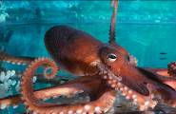

Cephalopod Shells and Egg Cases
What does an argonauta do to ensure her young/eggs are protected until they hatch?

Choose an egg case and draw it below. Describe what it looks like.

Cullen Hall of Gems and Minerals

Second Floor

Vocabulary:
area, circumference, cone, cubes, cylinder, gem, geometric figure, mineral, prism, pyramid, rectangle, trapezoid, triangle, volume

Below is a list of formulas you will need to help you solve some of the problems in this Hall.

Circumference  Circle: C = 2πr  Area  Square: A = 4s  Rectangle: A = lw or A = bh  Triangle: A = ½ bh or A = bh/2  Circle: A = πr² | Volume  Cube: V = s³  Cylinder: V = πr ² h

Complete the chart below as you walk through the Hall of Gems and Minerals. Find the minerals that include the geometric shapes listed in the chart. Write down the name of the mineral and the case number you find the mineral in.

Name of Mineral | Case Number | Geometric Shape
 |  | Pyramid
 |  | Cone
 |  | Rectangular Prism
 |  | Cylinder
 |  | Parallelogram
 |  | Rectangle
 |  | Cube
 |  | Circle
 |  | Square
 |  | Triangle

Case 11 – Gold Dragon
Look at the gold dragon and take detailed notes about its appearance. You will use this information when you return to class. Sketch the gold dragon below.

Case 25 - #1 Cerussite
Make a 3D sketch of this mineral. Be sure to view the mineral from the top, side, and front. Is this a trapezoid? Why or why not?

Case 16 - # 1 Galena on Dolomite
Solve the area of this rectangle if h = 3 inches and b = 4 inches. Show your work.

Case 31 – Quartz
Find the area of one of the triangles by estimating the base and height. Sketch your triangle and add labels.

Case 42 – Pyrite
Find the volume of the cube if s = 14 centimeters. Convert centimeters to inches before you work your problem.

Case 41 - #3 Fluorapophyllite on Stilbite
Estimate the number of cubes in this mineral. Assume one of the cubes sides is 3 centimeters. Find the area of one side. Make a 2D sketch of the side.

Case 76 – Hydroxylherderite
Find the area of the main triangle if h = 1.5 inches and b = 2 inches.

Case 83 – Elbaite
Find the circumference and the volume of this mineral if r = 2 inches and h = 8 inches.

Case 125 – Rhodochrosite
Find the area of the stop circle of this mineral if the diameter is 5 inches.

Farish Hall of Texas Wildlife

Second Floor

Vocabulary:
biodiversity, biomes, diversity, drought, endemic species, fauna, niche, predators, prey, food chain, food web, producer, consumer, competition, ecosystem, structure, adaptation, function

Biomes
On the map, label the different biomes of Texas covered in the exhibit and give three characteristics of each. Use the introductory video to guide you.
High Plains
Create a flow chart of a food chain evident in the Coastal Wetland & Marsh area.

Texas Predators
Use the chart below to identify how the animals listed have adapted to be successful in their environments.
Predator | Prey | Location | Adaptation
American Alligator
Coyote
Mountain Lion
Black Bear
Timber Rattlesnake
Barn Owl

Coastal Wetland and Marsh
Observe the complex ecosystem evident in the Coastal Wetland and Marsh area. Choose one of the animals that you see and imagine that it is removed from the ecosystem. Predict what will happen to the rest of the environment.

Guadalupe Mountains
For each of the animals listed below, identify one structure (feet, mouth, eyes, etc.) that helps it survive and explain its function. The first one is done for you as an example.
Animal | Structure | Function(s)
Mountain Lion | Claws | Gripping the dirt/rock and attacking prey.
Porcupine
Elk
Bighorn Sheep
Snake

Piney Woods
Find the flying squirrel. What kind of response do you think it would have if attacked by a predator? Why?

How is the woodpecker’s beak adapted to its environment?

What different defense mechanisms do you observe within this ecosystem?

Rio Grande Dry Forest
What characteristics make this region so different from the Piney Woods region before it?

In what ways have the animals below adapted to survive the environment they are in?
- Rattlesnake
- Jaguar
- Javelina

Coastal Oak Motte
Spend some time examining the migratory birds on display, both in the exhibit and through the touch screen. List at least four adaptations these birds have to help them survive, as well as four challenges they face while migrating.

Adaptations:

Challenges:

Coastal Prairie
Complete the Venn diagram below, comparing the survival techniques of any three animals within the ecosystem.

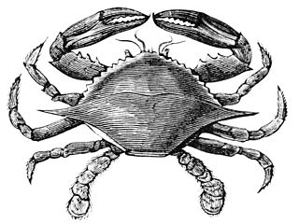

Hamman Hall of Texas Coastal Ecology

Second Floor

Vocabulary:
ecosystem, ecology, tidal zone, population density, salinity, hypersalinity, debris

As you enter the Hamman Hall of Texas Coastal Ecology, find Houston (Harris County) on the map of Texas. What is ecology and why might coastal ecology be important to us?

Upper Coast

Oyster Reefs
What is the economic importance of an oyster reef?

What other economic activities do you see represented in the oyster reef display?

What is the difference between salinity and hypersalinity?

Marine Debris
Use the tabletop touch display to find out more about marine debris. What is it?

Who is threatened by marine debris?

Middle Coast

Tides
What causes tides?

Brown Pelican
Observe the series of maps that tracks Brown pelican populations over time. Estimate the number of Brown pelican breeding pairs on the most recent map. How has the number increased or decreased from previous years?

Lower Coast

Texas Coast by the Numbers
What is the current human population in the 18 Texas coastal counties?
What is this population expected to be in the year 2050?
The human population is expected to increase by approximately what percentage in the next 35 years? Show your work.

Take a look at the sample of laws passed over time to protect our bays and estuaries. How have these laws changed over time? Why do you think this change has occurred?

Kemp’s Ridley Sea Turtle
As you round the corner of the Lower Coast section, you will see a large sea turtle laying her eggs in the sand.
Based on what you have seen so far in this exhibit, list at least three things the turtle requires for survival, and three things that could present a danger to it.
Needs for Survival | Dangers

Frensley Hall of African Wildlife

Second Floor

Vocabulary:
biodiversity, diversity, drought, endemic species, fauna, niche, predators, prey

Africa Map
Notice at the top of the Africa map that the area is dry and brown. Before the plates moved Africa away, this area was a dense rainforest. Make a hypothesis as to why this area’s ecosystem changed so dramatically over time?

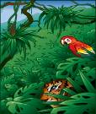

West African Tropical Forest – Living together in Harmony
How are the levels of biodiversity achieved in the tropics?

Give two examples of niches.

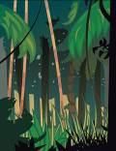

Congo
List three components of the Congo Basin ecosystem as seen in the display.
1.
2.
3.

Examine the okapi in the case. How many different features can you identify that could have come from other animals? List the animal next to its feature.

Equatorial Diversity
Why do you think species diversity is higher in the tropics than any other area of the world?

Rainforest – A Threatened Resource
List three things you can do, as a consumer, to help preserve the rainforest.

The Land of Sky – High Endemism
Define endemic species.

Why is it impossible for some species to leave the area?

What is the result of this restriction?

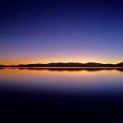

Ethiopian Realm
Compare and contrast the Ethiopian Realm with the West African Tropical Forest by using the Venn diagram below.

Serengeti – Feast or Famine
Predict what will happen to predators if their prey becomes reduced by drought, disease, or humans?

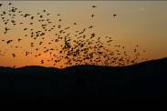

Sahara
Look at the hooves of the scimitar-horned oryx. How they are better suited to this hot environment than a lion’s wide paws?

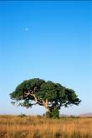

Lowveld – What is an Ecosystem?
Define ecosystem.

Give examples of producers, consumers, and scavengers that are shown in this scene.
Producer:

Consumers:

Scavengers:

What do you think would happen to each group if a drought hit the area and the grass dried up?



Okavango Delta
Where in Africa would you find the greatest concentration of wetland fauna?

Okavango
What three animals do you see in this display that you don’t see in any other scene from Africa?

Why are these animals only found in this region?

The Morian Hall of Paleontology

First Floor

Vocabulary:
atmosphere, extinction, fossil, paleontologist, specimen, inherited trait, organism, species, migrated, nutrients, biodiversity, environment

Precambrian
Look at the four stromatolites on display. Notice the absence of red colored rust. Now look at the banded iron and notice the large amount of red rust. Keep in mind that most rocks contain iron, but the iron in the first four specimens didn’t “rust” like the iron in the fifth specimen. What can we now assume was in the atmosphere that allowed the iron to rust and was necessary for more complex life forms to live on Earth?

Middle-Late Ordovician | 472 – 443 – Trilobite
Look at the 3rd case of trilobites on this wall and specifically the top specimen to the right. If you look very close you will see a baby swimming towards the adult. What traits did this baby inherit from the parent? List them below.

Jurassic Oceans
Look at the mural titled “The Early Jurassic Ocean”, how many different organisms can you find?

What would happen if the crinoids or sea lilies were removed? Would this environment be able to sustain its high biodiversity? Explain your answer.

The Late Cretaceous
Look at the mural of the Late Cretaceous. What are some common elements in the environment that sustain the diversity of life during this time period? Hint: Think basic needs.

Complete the food chain using the options below:

Sun Triceratops magnolia
decay/nutrients Tyrannosaurus rex

Fight or Flight
Compare the two scenes on display. One includes a T.rex and a Denversaurus and the other includes a T.rex and a set of three Quetzalcoatlus. Which scene shows a “fight” to survive and which scene shows a “flight” to survive?
Action | Scene
Fight

Flight

Quetzalcoatlus
Look at the large pterosaur on display. Keeping in mind that these creatures can soar above the Earth’s surface, how might his bones differ from that of a T.rex? Explain your answer.

Eocene – Maple Leaf
What do you think this leaf needed to survive?

How do you think it moved nutrients to all of its outer areas?

Mastodons and Mammoths
Why do you think the mastodons and the mammoths migrated to areas beyond where they originated? Hint: think basic needs.

Foucault Pendulum

First Floor

Go to the touch screen at the Foucault Pendulum to learn more about how this device works.

Count the number of pins around half of the pendulum. If all of the pins are knocked down in a 24-hour period, how long does it take for the pendulum to knock over five pins? (Show your work)

Wiess Energy Hall

First Floor

Vocabulary:
alternative energy, anticlines, basins, fault, geological event, hydrocarbon traps, natural gas, Pangaea, renewable sources, reservoir rock, seismic, thermal radiation, topography

At the entrance to the Energy Hall, watch the movie Formation. The movie states there was, “a super thermal radiation of unimaginable scale.” What is this theory called?


What is the origin of all energy on Earth?

As you enter the Energy Hall go to the right, enter the theatre and watch the movie “Energy Is…” Use the information from the movie to answer the following questions.

How do they find pockets of oil?

What three things are going to get used up?

List three renewable sources of energy.

Sedimentation
Observe the particles as they flow into the water. Which will settle to the bottom – the heavier or lighter particles?

Texas: The Underground Story
What is the name of the big oil discovery that started an oil boom in Texas that continues today?

What tore Pangaea apart?

What caused layers of salt to form?

How was the Gulf of Mexico created?

What created the oil and gas we pump today?

Name three professions that work together to figure out how to get to the oil and gas beneath the surface.

Earth from Above
What can faults near a riverbed tell us about what lies beneath?

On the computer screen, click on “Topograph”, then “Topography Faults”, and last on “More Information” to answer the following question.

Why can we sometimes “see” different layers of rock?

After clicking on “Topography Anticlines” and “Play Movie” answer the following questions.

What happens to the top layers of strata?

Why would this anticline be a good place to look for hydrocarbon traps?

Global Hydrocarbon Information Center
Click on “Where are the Sedimentary Basins?”

Explain how sedimentary basins form.

Seismic Section
Look at the “slice” of underground rock layers on the wall. How many faults can you find? How many salt domes?

Geovator
Why does limestone make an excellent reservoir rock for oil and natural gas?

How is sandstone formed?

Why does shale make an excellent source rock for the formation of oil and natural gas?



Energy Excursions Theater
Watch the movie and list the main sources of energy.

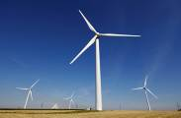
List the types of alternative energies covered.

Choose two sources of energy and describe which of the two has the greater economic/environmental impact. Use at least three reasons in your argument.

Alternative Energy Sources
List the eight types of alternative energy sources.

1.
2.
3.
4.
5.
6.
7.
8.

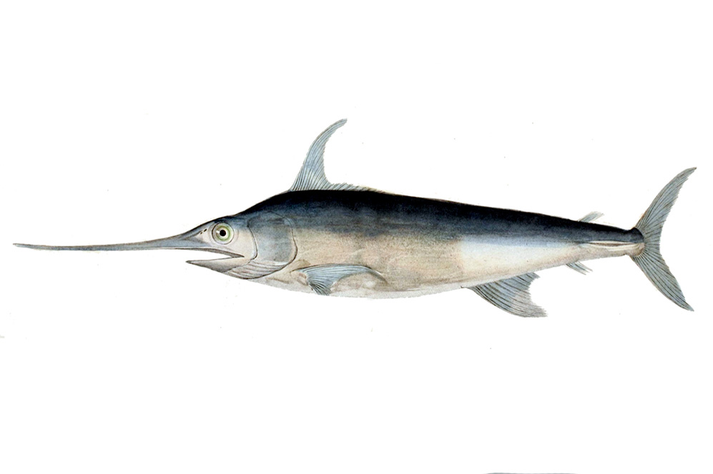
Alfred C. Glassell Jr. Hall

First Floor, Main Entrance

Vocabulary:
biodiversity, biomes, diversity, niche, predators, prey, food chain, food web, producer, consumer, competition, ecosystem, structure, adaptation, function
Look at the various marine animals around you. There are a wide array of animals represented throughout this hall, all of which live in a similar ecosystem. How do you think this biodiversity contributes to the sustainability of the ecosystem?

What would happen if one of the animals, for example the hammerhead shark, was removed from the ecosystem?

Examine the giant, mounted black marlin against the far wall. How do you think this creature would respond if it were attacked? Explain your answer.
Compare the physiology of the following animals within the Glassell Hall: Manta ray, blue marlin, roosterfish (hint: some may be located in the stairwells)

How do the following structures help the animals within the Glassell Hall survive?
Tail
Gills
Blowhole (on dolphin)
Dorsal fin



The Welch Chemistry Hall

Lower Level

Vocabulary:
acid rain, alloy, compound, elements, protons, neutrons, electrons, Periodic Table, oxygen, nitrogen, sulfur, hydrogen, phosphorous, argon, particles

Organic Compounds
Students will use the touchscreen Periodic Table of Elements to identify the following elements that make up organic compounds:
Symbol | Element | Characteristics
H
O
Ph
N
S

Atmospheric Observations
Using the ceiling lights and corresponding text panel as a guide, students will complete the following questions pertaining to Earth’s atmosphere:
What three elements make up the vast majority of Earth’s atmosphere?

If there are 100 particles of Oxygen, how many Nitrogen particles can you expect?

If there are 100 particles of Nitrogen, how many Oxygen particles can you expect?

What is the ratio of Oxygen particles to total particles, as expressed in fraction and decimal form?
Fraction:
Decimal:

Predict what would happen if you put more Oxygen in the air. What if you took away Oxygen?



Weather Center

Lower Level

In groups of four or five, students should rotate the roles of weather person (or meteorologist), camera person, and audience. While reporting the weather and operating the camera, students will experiment with lighting, sound, camera angle, posture, voice level, and delivery skills. The audience will listen and view the presentation, critiquing both performances. The audience will rank the skills of each person on a scale of 1 – 5 with 5 being “very skilled”.

Meteorologist
 | 1 | 2 | 3 | 4 | 5
Posture
Voice Level
Delivery Skills

Camera Operator
 | 1 | 2 | 3 | 4 | 5
Ability to “frame” the subject

Solar System

Outside Main Entrance

Vocabulary:
Moon Phases: first quarter, full moon, new moon, third quarter moon, waning crescent, waning gibbous, waxing crescent, waxing gibbous

Sketch the solar system and write down the information you see about the Earth. You will use this when you return to class.

