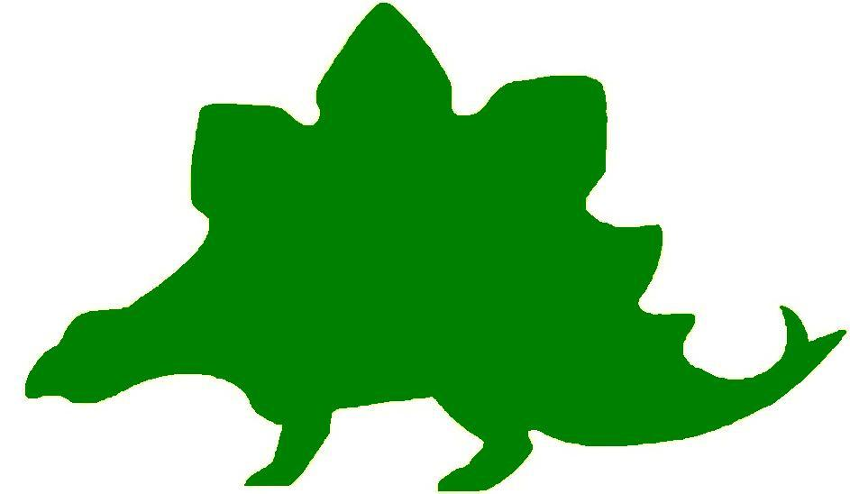
theHoustonMuseumofnaturalscience

7th Grade Extension Activities

McGovern Hall of the Americas

Third Floor

Did you know?
Ask the students to choose a descendant of the Pueblo from the list they created while visiting the Museum. Students will conduct research about their chosen group to find out more about their way of life, where they are located, and the types of structures they live in. Ask students to write a research paper about their chosen tribe and create a 3D model of a home in the style of their tribe. Tell the students they will give an oral report of their research and show off their model.

Zuni Art
While at the Museum the students learned about how Zuni pottery was created. They learned that each object was created for a particular use and that the designs were geometric in shape. Ask the students to use their two lists to create their own Zuni pottery. Students will present their object to the class, explaining its use and what the artwork means.

Peace Offering
While visiting the Hall of the Americas the students learned about the Templo Mayor (the Great Temple) of the Aztecs. Students learned that while the Aztecs constructed this temple they incorporated some objects of neighboring tribes to show good will towards them. Ask the students to create a “spirit” stick that includes their rival school’s mascot. The spirit stick should be a friendly sign of peace to their “neighboring” school.

Hall of Ancient Egypt

Third Floor

The Capitol
While visiting the Hall of Ancient Egypt you learned that the Egyptians built their Temples out of stone so that they could last forever. Think about the capital of Texas. In Austin, our state’s capital city, our capitol building is a large pink granite structure sitting in the middle of Congress Avenue. We used pink granite that can be found in the Texas hill country as a nod to our Texas pride. Conduct some research on other capitol buildings in the United States. What are they made of? How do they give a “nod” to their state?

Strake Hall of Malacology

Second Floor

Two is Better than One
While viewing the Giant Clams in the Hall of Malacology, students learned about symbiosis and how two different animals live together and each benefit from the other. Ask the students to research symbiosis and find out what other animals live this way. How does this help them adapt to their environment?

A New Kind of Cephalopod
Ask students to refer to their Knowledge Hunt to discover which part of the cephalopod’s body they chose to answer the question about escaping its enemies. Tell the students that they are to create a new cephalopod species. They should incorporate the feature they chose for defense. Students should be prepared to show a drawing or computer generated picture of their new species.

Cullen Hall of Gems and Minerals

Second Floor

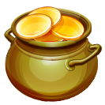

Of Course You Should Give Me the Gold.
When the students visited the Museum they saw a mineral titled “Gold Dragon”. To help students work on their persuasive skills, present them with the scenario below.

What if you came to the end of the rainbow and you found a dragon guarding the gold. Write a persuasive speech using five reasons why the dragon should give you the gold. Be sure to give examples to support your reasons.

Ask the student to role play using their speech with another student playing the part of the dragon. Have the class vote to see if the speech writer will get the gold or not.

Golden Shapes
Students may refer to their notes about the “Gold Dragon” that they took during their visit to the Hall of Gems and Minerals. Ask the students why we named this mineral “Gold Dragon”. Like looking at clouds, different people will see different shapes. Tell the students this is one of the most famous pieces of gold found. Give the students a sheet of foil and allow them to shape it into their own design. Have them name their new mineral and display it around the classroom.

No Two Snowflakes are Alike!
The students made a sketch of the mineral in case 22 while they were completing their Knowledge Hunt. Ask the students to look back at their sketch. How many different geometric shapes can they find? The shape of this mineral reminds us of a snowflake. Ask the students to make a snowflake including as many geometric shapes as possible.

I Can’t Find It!
Ask the students if they have ever looked at a Highlights® Magazine. Remind the students that they are famous for their Hidden Picture® puzzles. Tell the students to look back at all their sketches from the Gems and Mineral Hall. Instruct the students that they are to create their own hidden picture puzzle by including all the minerals they sketched in their Knowledge Hunt.

Farish Hall of Texas Wildlife

Second Floor

Travel Texas
When the students visited the Hall of Texas Wildlife they mapped out the different biomes covered in the exhibit. Divide the class into seven groups and ask each group to research one of the areas. They can create a brochure or Power Point about their area of Texas. Students should describe, but are not limited to, what cities are included in their area, what there is to do there, what types of animals are native, and the climate for the province.

What Goes Around Comes Around
Discuss with the students the necessity of the food chain. Have students map out a food chain for each of the seven areas they saw in the Hall of Texas Wildlife. Tell students to then choose one region and pretend that a part of the food chain disappeared. Have them write a journal entry about what happens to the ecosystem as a result.

Maintaining Balance
While at the Houston Museum of Natural Science, students witnessed different species that are now extinct in Texas, such as the jaguar. Have students write a persuasive essay in which they either petition for returning one of these animals back into its natural habitat, or maintain that the animals should not be returned. Students should provide evidence for their claims, and be prepared to defend them.
Fight or Flight
Tell students to choose one animal that they witnessed in the Hall of Texas Wildlife. Then, ask students to research their selected animal, paying particular attention to its defense mechanisms. Students will then present their animal to the class, through either a Power Point presentation or a poster, explaining where it lives, what defense mechanisms it has developed, and how it reacts when faced with a threat.
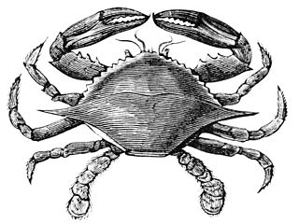

Hamman Hall of Texas Coastal Ecology

Second Floor

Marine Debris Begone
Have students research methods used to clean up tricky marine debris (think trash that has floated far out to sea or particles so small they can’t be caught in a net). After choosing a method to focus on or brainstorming one of their own, have students create a story about the problem of pollution. They could have villains, superheros, double-crossers, etc. Encourage them to get creative with solving the crisis.
Bonus: Team up with another class to share stories.

Salinity
Review the concept of salinity with students. Remind them that, in the exhibit, they read about hypersalinity as well as brackish water. Explain that different spots in the ocean may have different concentrations of salt (the ocean is not homogenous), and that these concentrations can be so different that they actually form distinct layers in the water.
You will need: large beaker or clear glass, small glass, spoon, water, salt, food coloring for each group of students
Fill the large beaker about 1/3 full of water. Add in salt, stirring to dissolve the salt in the water. Keep adding in salt until you can’t add any more (if you stir for 5 min. and the salt isn’t dissolved, you are there!). This is a hypersaline solution.
In the small glass filled with water, add a small quantity of salt- a spoonful should do. Add a few drops of food coloring to this glass so that this solution is clearly different.
Carefully and slowly add a small amount of the colored solution to the hypersaline solution in the large beaker. Do not stir. What happens?

Frensley Hall of African Wildlife

Second Floor

Create a Country
Students will work in groups to create a new country somewhere on Earth. Each group will select a continent where they want to place their country. Groups will need to research their continent’s climate to understand what type of ecosystem is established in their part of the world. The teacher will remind the students that one continent can have different types of environments. For example, when the students walked through the Hall of African Wildlife they saw a dry environment in northern Africa and a lush rainforest environment as they looked further south. Students should be prepared to explain several details about their country. Groups should include all of, but are not limited to, the following:

- Invent an economic system that will work for their country based on its surroundings
- Create a form of currency
- Establish a government
- Set up a capital city
- Draw a map showing the geological and ecological features

Check Out My New Animal!
While students looked at the Congo display they learned about the okapi and discovered that this animal has parts that look like several other animals. Ask the students to create a new species that could live in the Congo Basin. Students should use the parts of three different animals to create their new species. Remind the students that their animal has to be able to survive in its environment. Students should draw a picture of their new species and label all the parts that come from other animals. The teacher should create a bulletin board with a Congo Basin theme. Ask the students to place their new animals somewhere in the class Congo Basin bulletin board.

Helping Our Planet, One Rainforest at a Time!
While walking through the Hall of African Wildlife students learned that there are things consumers can do to help preserve the rainforests. As a class, ask the students to brainstorm several ways their school could help the rainforests. The teacher will list the ideas on the board for the students to review. Ask the students to choose one of the ideas listed and see if they can put a plan into action. For example, students could begin a recycling team, try to use less paper by printing fewer times when they are visiting the computer lab at school, or at home they could plant a tree. Ask the students to use a computer to write down their thoughts about their idea and the progress of the implementation of their idea.

I’d Rather Live There.
Tell the students to refer to the Ethiopian Realm section of their Knowledge Hunt to see what they wrote down in their Venn diagram. Tell the students that they are going to relocate to Africa. Inform the students that their new home will be either in the Ethiopian Realm or the West African Tropical Forest. Ask the students to choose either location and write a pro/con list for their choice. They may need to do more research of their chosen area to defend their decision. After the students have completed their own list ask them to break up into large groups based on the area they have chosen. The teacher will conduct a class debate about which area they believe is the best. After the debate, the teacher should decide which group is the winner.

The Morian Hall of Paleontology

First Floor

Fossilmania
Fossils are the remains of creatures which lived long ago. The parts of creatures that were most likely to remain as fossils were the hard parts, such as shells and bones.

Fossils are created when an animal dies and its body is covered in sand or ash. After a long time in the proper conditions, parts of its body are preserved. For example, if a volcano erupted, the ash would cover the animals. Over time, the ash would create a layer over the bones and preserve them.

Research the steps that a dinosaur goes through to become a fossil. Create a flip book to illustrate the steps and the conditions from an animal’s death to its fossilization.

Found: A New Species of Dinosaur
There are no real pictures of dinosaurs for scientists to look at as they reconstruct the models displayed in the museum. What if they are put together wrong? Ask the students to use characteristics of several different dinosaurs and construct their own version. Rename it. Describe what it ate, where and when it lived, what dinosaurs were its enemies, and how it became extinct.

Grid the Dig
Scientists know that dinosaurs are found in certain parts of the world for many reasons, including recognizing specific rock formations. When parts of a dinosaur are discovered scientists take every precaution to protect the potential paleontological site where the dinosaur may be buried. One such precaution includes making a grid using rope and stakes over the site. First, scientists identify the bone and the dinosaur to which it belongs. Afterwards, they measure out the grid based on the size of the identified dinosaur and the location of the bone in its skeleton.

Pretend you were walking in an area where dinosaurs have previously been found and you see a partially exposed bone fragment, such as a rib bone, a tail bone, jaw bone, etc. Create a grid map of the site where this dinosaur might be uncovered under rock or sandstone. Draw a grid of the area where the dinosaur is buried. Include a legend to show scale of each square and a compass rose. Label the quadrants of your grid. Research the size of the dinosaur that you think might be uncovered by digging the site so you can draw it to scale. Give the coordinates to identify where the part of your dinosaur might have been exposed above the ground.

Flight or Fight
When the students visited the Museum they saw two scenes in which a T rex was attacking another animal. In one scene, the animal was running away. In the other scene, the animal was fighting back. Split the class in two groups and have them debate the pros and cons of fighting back and running away.

What are you?
Discuss how dinosaurs are named. Explain to the class that their names come from where they lived, something unique about their body, where they were found, or the name of the person who found them.

Tell the students to cut out and bring to class five pictures of different objects from a magazine or newspaper. Collect the pictures in a container and have each student randomly select five pictures. Instruct the students to arrange and glue all five pictures on a sheet of paper to create a “new” dinosaur. Students may use markers or crayons to add any details to complete their dinosaur. Name the dinosaur according to the criteria “something unique about their body”. Display the new species of dinosaurs around the room. If available, show “Dinosaurs We’d Like to See” from The Magic School Bus: In the Time of the Dinosaurs.

Wiess Energy Hall

First Floor

Boom!
Assign the students to research different major oil discoveries around the world. Be sure to include Spindletop. Students will create a one page advertisement explaining why this is the most fascinating oil find of the ages. Create a class portfolio including every student’s ad. Let other classes decide which ad is the most creative and which ad makes them want to visit the site of the oil boom.

It’s Your “Fault”!
While in the Wiess Energy Hall students learned about faults in the Earth. Ask students to work with a partner and research different faults around the world. They should find out where the fault is located and what type of physical environment is surrounding the fault. Students should be prepared to report any geological events that have occurred due to these faults. Pairs may present their information by using PowerPoint, creating a poster board, or making a brochure.



Alternative Energy Sources
One of the most important conclusions the students may reach from their visit to the Energy Hall is that the world desperately needs to develop renewable energy sources.

In a class discussion, create a list of different kinds of energy sources. Have each student choose one from the list and research why their source would be the most efficient for the state of Texas. After gathering all of the information needed, have the students form small groups with other students who chose the same type of energy source. Have the groups continue their research and create a presentation for the class to convince them that their type of energy is the best for the state.

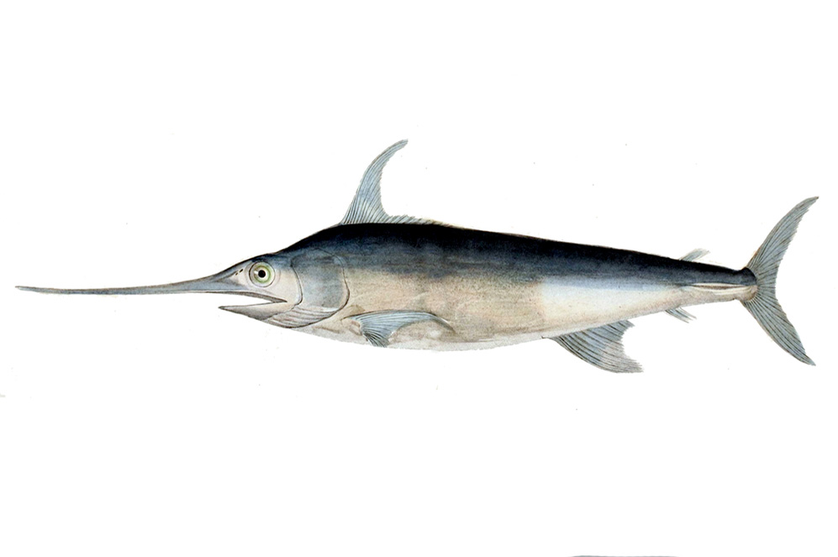
Alfred C. Glassell Jr. Hall

First Floor, Main Entrance

Marine Identification
While at the Museum, students witnessed a wide variety of marine animals. Tell them to list as many as they can remember. Work with them to create a list of about ten different marine animals.

Then, split students into groups of 3-5 and have them create a dichotomous key to help with the identification of their ten animals. Once students have created their keys, have groups swap. Provide each group with an image of one of the animals discussed and allow the groups to try and identify it through the dichotomous key.

Deep breaths
Most of the animals within the Glassell Hall were fish, but not all. One of the animals, the dusky dolphin, is a mammal and breathes through its blowhole instead of gills. Have students conduct research on the benefits and drawbacks of lungs versus gills and present their findings to the class. Students can write a persuasive speech in which they convince their classmates that one is better than the other.

Save the Ocean
Many animals within the oceans are at risk due to environmental changes and pollution. Choose one area that is associated with marine life: beaches, deep water trenches, sea anemones, sand bars. Once each student group has an area to research, tell them to investigate the biggest threats to their area. They should research the animals that call the area home, what threats those animals face, as well as ways to prevent further damage to the ecosystem.
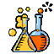

The Welch Chemistry Hall

Lower Level

Alloys
Give students a list of alloys to choose from (such as brass, steel, pewter, bronze, stainless steel, sterling silver). Tell students to research information about how it was developed and what it has been used for throughout history. A display can be created to show the class how its uses have changed over time.

Digestion
Have students research the process of digestion. While they are researching, they should create a chart of different physical and chemical changes that occur during the process. Once finished, students will work in groups to devise and test an experiment that represents these changes.

Solar System

Outside Main Entrance

Winter/Summer/Spring/Fall
Break up the class into four groups. Assign each group a different season (summer, fall, winter, spring) to research. Groups should learn about what direction the Earth is tilted in relation to the Sun during their assigned season. Ask the students to draw, on large butcher paper, the Earth as it would sit in orbit during their season. Students will report to the class what part of the Earth is in the opposite season from theirs and by showing their drawings explain why this happens. Give each group a part of the classroom wall to decorate in their season. Their drawings of the Earth’s tilt should be included on their classroom wall.

Fast Phases
As a class review, draw the phases of the moon on a sheet of paper and make several copies. Break the class up into small groups and hand them a copy of your drawing face down. Tell the groups to keep the paper face down until they are instructed to turn it over. When each group has a worksheet, tell them to flip the paper and identify each phase of the moon. Whichever group can do so quickly and the most accurately wins!



Phase Map
Teachers will provide one large blank calendar for the students to draw on. The teacher will assign a different student to look for the moon each night for one month. Each day the chosen student will draw the phase of the moon they saw the night before on the class calendar. At the end of the month assign the students a different date than the one they drew. Students will make a sketch of their moon phase in relation to the Earth and Sun.

