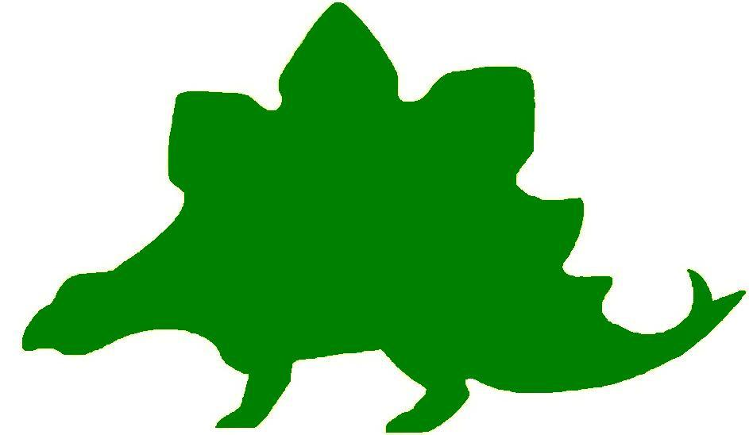
theHoustonMuseumofnaturalscience

6th Grade Extension Activities

McGovern Hall of the Americas

Third Floor

Being an Archaeologist Game
Archaeologists try to figure out how a culture lives with just a few pieces of evidence. The purpose of this game is to experience what it is like to be an archaeologist and the difficulties of determining how people lived long ago.

Materials: Old puzzles, resealable plastic bags (one for each group of four students)
- Gather several old puzzles with a variety of scenes such as plants, animals, people and buildings. Put a few pieces from each puzzle into each resealable plastic bag. To make the activity easier, have some pieces from each puzzle that fit together.
- Divide your class into several groups. Give each group a bag and tell them to put the puzzle together. Do not tell them that they will not go together. Stop the activity when they become frustrated that the pieces do not match. Have a class discussion about what it felt like to try to assemble a picture with so few pieces.
- Then, ask the students to look back at what they can see on the pieces and discuss what is revealed. If each bag contained a partial picture of a scene in the life of someone, what could they tell from the few pieces they have? What can they infer from the pieces about that imaginary person? What prior knowledge did they use? For example, if they saw a small section of the wall of a building, they inferred from past knowledge that this person lived during a time when there were structures built. They may be able to determine from plants in the picture what people ate. Write a field journal entry that includes the information that can be gained about the people from looking at their puzzle picture.


Cooking 101
While in the Hall of the Americas, students completed a flow chart about prehistoric cooking. Ask students to chose one of their favorite meals and create a flow chart about how to prepare the meal. Students must include a list of ingredients, each step needed to prepare the meal, and a drawing of each step.

Extend the activity by asking the students to trade flow charts with one another. Tell the students to try to make the dish at home by using the steps given in the flow chart. Students should then write a summary about their experience following the flow chart.

Culture Around the World
Ask students to refer to their Knowledge Hunts to remind themselves about the concepts of material culture and non-material culture. Instruct the students to come up with two forms of material and non-material cultures in regards to three different countries around the world. Ask the students to share their findings with the class. How many material/non-material cultural items did they find that are the same around the world? How many are different?



Guess Who’s Coming to Dinner?
While students visited the Hall of America’s they learned that native groups used lavishly decorated items to serve their food to guests or use during grand ceremonies. Ask the students to recall events when they used fancy or decorated dishes. Ask them to explain why everyday dishes were not used on those occasions.

Take a moment to talk to the students about the china used in the White House. When presidents are hosting special events or dinners the White House china is used to serve the meal to those in attendance. Explain to the students that these dishes have patterns and designs that represent time periods, beliefs, or leadership changes. Ask the students to conduct additional research about the White House china. Students should find answers to the following questions:

- What makes each plate different?
- What reasons do you think the president may have had for choosing the designs?
- What does the design say about our leader?
- Can you tell what causes they may have fought for?
- Do you think heads of foreign nations would have noticed the designs?
- Can you guess what time period the dish is from?

An example to share with the student would be President Johnson’s china which represents issues that were important to him. President Johnson’s plate has an eagle holding an olive branch in the center with a border of wildflowers representing his wife’s love of Texas wildflowers.

What Does Your Totem Say About You?
Remind students that they saw a totem pole in the Hall of the Americas. They learned that totem poles could explain the story of a particular family. Read to the class the Totem Tale: A Tall Story from Alaska by Deb Vanasse. Give each student a toilet paper roll, a set of totem symbols (you may use clip art to choose your animals), and a symbol definition worksheet (see web site below). Tell the students to choose three to four symbols to color and place on their totem pole. Then, instruct the students to write a story about the animal arrangement on their totem pole. When the students have completed their stories ask them to roll it up and place it inside their totem pole. Ask the students to share their “totem tale” with the class.
Web Site:
www.gullitotempoles.com/TotemPoleSymbols.html

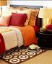

Your Room Speaks for You
Ask the students to refer to their Knowledge Hunts to re-read the quote by a Pueblo man. One interpretation of the quote could be that the place where someone lives tells a story about them. Ask the students to think about their bedrooms. What story would people tell about them if all they ever saw was their room? Ask the students to write a journal entry about the things in their room and the story they might tell.

Kachina Wishes
The students learned that kachina dolls were created to help the Hopi address their needs. Some dolls were created to ask for rain or abundant crops. Ask the students to think of a wish they would like granted. Tell the students to draw their own kachina doll and explain its powers. Their kachina should have some sort of representation of the wish that is being made.

What Did You Say?
Remind the students that the Mississippian people never developed a writing system, instead they learned to communicate through symbols. Ask the students to create a way to communicate the sentence below. They may not use any letters of the alphabet.

On the 4th of July we ate hotdogs and watched fireworks.

Ask the students to create more sentences using symbols and trade them with a partner to see if they can figure out what the symbols say.

A New Twist to an Ancient Design
Ask the students to refer to their Knowledge Hunts to look at the houses they sketched for the Caddo and the Cherokee. Tell the students to choose one of those sketches and draw a new “modern” design. They should be sure to use the same type of materials that would have been used to create these houses. Have the students display their new designs around the room.

Tell Me a Story
Tell the student to refer to their sketch of the animal they chose from the jaguar display case. Ask the students to write a children’s fable about the animal they sketched. Instruct the students to illustrate their fable. If time allows, have a story time where volunteers can read their fables to the class.

Mascot Wars
The students learned that the Mayas used the jaguar sculpture to help protect their cacao crops. Ask the students to think about their school mascot. In most cases, a mascot is a strong and fearless being. Tell the students to write a journal entry about their school mascot. Do they think they are a good representation of the school? Why or why not? What mascot would they choose if they were allowed to pick a new one? Why? Ask them to draw their new mascot at the end of their journal entry.

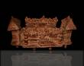

The Winner Does NOT Take All
Students saw a model of an ancient ball game in the Hall of the Americas. Tell the students that one of the rules to the game they saw was that the winners would be sacrificed. Give the students the scenario that follows:

What if you and your best friend were on opposite teams and you knew that the winners of the game were going to be sacrificed and the losers would live in disgrace.

Ask the students to write a story about how they could make a plan to save both of their lives.

Create a Country
While visiting the Hall of the Americas students learned about many different tribes of Native Americans and how they ran their societies. Tell the students that they are going to create their own country and run it as they see fit. They can work in groups or on their own to complete this project. Students will need to name their country, draw the shape of their country, name their capital, add geographical features, choose a government, form of currency, and an economic system. Students will present their country to the class using either PowerPoint® or a poster board. Students may need to conduct additional research on different forms of government so that they can pick one that best fits their style of rule. Students should be sure to explain the decisions they made to form their country.

Hall of Ancient Egypt

Third Floor

Location, Location, Location!
Use a blank map of Egypt and the European countries around it. Label Egypt, Greece, Italy, Rome, the Nile River, Lower and Upper Egypt, Alexandria, Memphis and any other place of importance that you learned about while viewing the maps in the exhibit. Include a compass rose so that you can tell north from south. After viewing your completed map write a short essay as to why you think it may have been so easy for Alexander the Great to take over Egypt. Are there any other countries that might have had an easy time taking over Egypt? Why?

Reading and Writing: The Ultimate Form of Communication
While visiting the museum you learned that only a select group of boys were allowed to go to scribal school. This would mean that almost all girls were illiterate (they could not read or write). Have a class discussion about what it would be like if you could not read or write. Think about all the things that you read each day. Warnings, school books, comic strips. What about all the things you write down like notes to friends or family, birthday cards, and even a grocery list. What are some things you would miss if you could not read or write?

Pyramids
During the Old Kingdom the Great Pyramids of Giza were built. Do research on the pyramids. You should research who they were built for, what might have been included inside, how they were structured and who built the pyramids. Give a short report to your class about what you have discovered.

Strake Hall of Malacology

Second Floor

A New Kind of Cephalopod
Ask students to refer to their Knowledge Hunt to discover the pros and cons of one particular part of a cephalopod’s defense. Tell the students that they are to create a new cephalopod species. They should incorporate the feature they chose to write their pros/cons list about, or if they think they can come up with a better defense they can incorporate that element. Students should be prepared to show a drawing or computer generated picture of their new species.

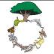

Don’t Go, We Need You!
At the Museum, students completed a food chain that included squid. Ask the students to write a journal entry about what they think would happen if squids were eliminated. How would this change the environment around us? What would the sea creatures have to do in order to survive?

What Are These?
The Australian Trumpet Snail the students saw in the Hall of Malacology belongs to a very large class called Gastropoda. There are three sub-classes of Gastropoda. Ask the students to form three groups. Each group should be assigned to one sub-class (Prosobranchia, Opisthobranchia, and Pulmonata). Tell the students they will research their sub-class and create an informational PowerPoint© about what they have learned. They should include some fun facts, families in the sub-class, and pictures about their sub-class.

Cullen Hall of Gems and Minerals

Second Floor

Use the picture of the mineral below to help you with the following Extension Activities.

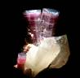

Where Can We Find It?
How many different minerals do you see in this picture? Where on Earth do you think these can be found? Make a treasure map to help others locate these minerals. Color it and include longitude and latitude, a Compass Rose, and a legend.

Formulas Rock!
The colors you see in this mineral occur naturally. Have a class discussion about how you think these colors were produced. Read the Magic School Bus: Inside the Earth to learn more about how rocks are formed. Have students research how different kinds of rocks, for example marble, shale, pumice, or limestone, are formed. Create a classroom rock collection that includes drawings of various rocks and an explanations of their formation. Students should also include a formula explaining how the rock is formed to include in their rock collection. For example:

Carbon + Pressure + Time = Diamond

Farish Hall of Texas Wildlife

Second Floor

My Life as a Bird
While visiting HMNS, the students saw a wide variety of bird species, including migratory birds. Using the information they acquired from the Museum, ask students to write a create story from the point of view of one of the migratory birds. The story should include the type of environments the bird prefers, what it eats, how its beak helps it eat, its migratory path and how it interacts with other bird species. Remind students that this is meant to be a creative story based on facts.

Animal Income
Remind students that many of the animals that were once popular in Texas are either extinct or exist in extremely limited numbers. Tell them that some of these animals were hunted for their food, pelts or sport. Some of these animals were important to the U.S. economy. Tell students that they are going to research U.S. industries that are dependent on animals. Ask the students to make a chart listing animals that are currently in Texas and which industries rely on them. Students should then explain what they think would happen to the U.S. economy if one of the animals was removed.

Bird Adaptations
Find pictures of the different types of food each bird in the Knowledge Hunt chart might eat. Divide the class into two teams. Give each group a set of cards, each card containing a different bird’s name. Show the pictures of the different foods to the class one at a time and ask the teams to choose which type of bird may have eaten that food. Students may use their charts to help them. Ask the teams to reveal their answer by showing the card they have chosen. The teams earn a point for every answer they get correct.

Levels of Organization
Remind students that ecosystems can be divided into different levels, from individual organisms to the entire biosphere. Tell them that this same system can be applied to them as well. Have them create a level of organization pyramid starting with themselves as the organism. Tell them to think about the population they belong to (their family, their class, etc.), the community as a whole, and the whole ecosystem to which they belong.
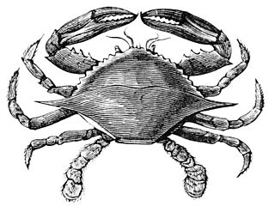

Hamman Hall of Texas Coastal Ecology

Second Floor

Marine Debris Begone
Have students research methods used to clean up tricky marine debris (think trash that has floated far out to sea or particles so small they can’t be caught in a net). After choosing a method to focus on or brainstorming one of their own, have students create a story about the problem of pollution. They could have villains, superheros, double-crossers, etc. Encourage them to get creative with solving the crisis.
Bonus: Team up with another class to share stories.

Salinity
Review the concept of salinity with students. Remind them that, in the exhibit, they read about hypersalinity as well as brackish water. Explain that different spots in the ocean may have different concentrations of salt (the ocean is not homogenous), and that these concentrations can be so different that they actually form distinct layers in the water.
You will need: large beaker or clear glass, small glass, spoon, water, salt, food coloring for each group of students
Fill the large beaker about 1/3 full of water. Add in salt, stirring to dissolve the salt in the water. Keep adding in salt until you can’t add any more (if you stir for 5 min. and the salt isn’t dissolved, you are there!). This is a hypersaline solution.
In the small glass filled with water, add a small quantity of salt- a spoonful should do. Add a few drops of food coloring to this glass so that this solution is clearly different.
Carefully and slowly add a small amount of the colored solution to the hypersaline solution in the large beaker. Do not stir. What happens?

Frensley Hall of African Wildlife

Second Floor

New Species, New Job
While visiting the Museum’s Hall of African Wildlife students learned about the Okapi. Students had the opportunity to see what an Okapi looks like in the Congo display. As they have learned, the Okapi has parts of its body that resemble other animals such as zebras, giraffes, and horses. Ask the students to create a new species of animal from head to tail using various features from other animals they have seen. They should make a drawing or 3-D model of the new species and create a name for it.

Tell the students they will play the role of curator at a press conference and present their new animal to a group of “reporters” (classmates). As curator, students should be prepared to explain their animal’s unique features. They should also be able to explain why or how these features will help their animal thrive in the wild. Students playing the role of reporters can ask questions like:
- What will the new species eat?
- Where will the new species live?
- How will the species protect itself?
- How will the species warn off predators?
- What is the average size of the new species?

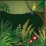

Save the Rainforests!
Ask the students to research parts of the world where rainforests can be found. Identify their locations on a map. Tell them to investigate the problem of the vanishing rainforests. On a map using two different colors outline the areas that the rainforest covered 50 years ago and the area the rainforest covers today. Display your maps around the room and have a discussion about the vanishing rainforests. Ask the students to give examples of what they can do to help save the rainforests.

Personal Traits
Ask the students to identify traits they inherited that they like or dislike. Write a journal entry to describe the trait, who they inherited it from, and why they like or dislike it.



Family Tree
Discuss the difference between inherited traits and learned behaviors. The students will create a personal family tree, using names and photos, going as far back as they can gather information. Students will choose one family member to interview and create a chart showing their inherited traits and learned behavior. See example below.
Subject: Aunt Joy
Inherited Traits – Inherited From | Learned Behavior – Learned From
Blue eyes - dad | Gardening - mom
5’ – dad | Quilting – momkin
Blonde hair – popkin | Cooking - mom
Foot size – dad | Balancing Checkbook – dad

The Morian Hall of Paleontology

First Floor

No, That’s Not How it Happened. This is the Real Scoop!
Ask the students to create their own theory about how and why dinosaurs became extinct. Tell the students to write a story explaining their theory and illustrate it. Students can be as creative as they like with their theories. If time allows, ask for volunteers to read their story to the class.

What if We Put Them Together Wrong?
There is no real picture of dinosaurs for scientists to look at as they reconstruct the dinosaurs displayed at the Museum. What if scientists put the dinosaurs together wrong? Ask students to use characteristics of several different dinosaurs and construct their own version. Students should rename it, describe what it ate, where and when it lived, what dinosaurs were its enemies, and how it became extinct.

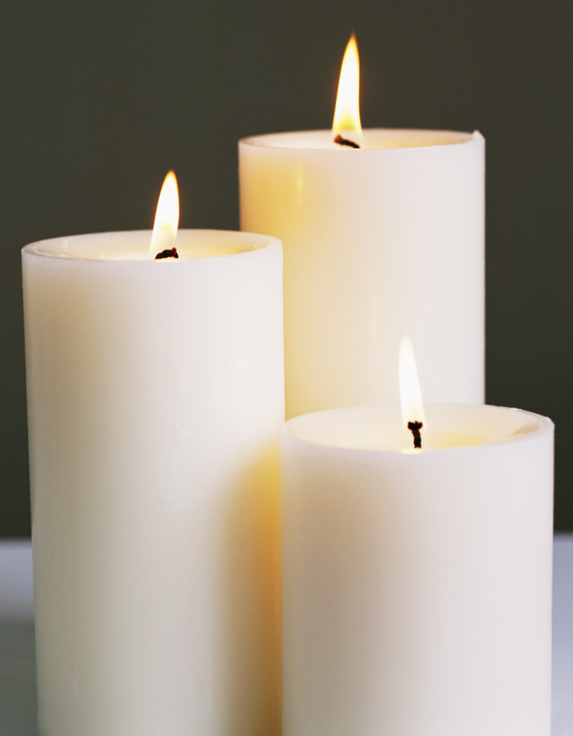

Extinguish the Flame
Remind the students about the story of the horseshoe crab on display. Remind them that as the oxygen levels lowered the horseshoe crab eventually did not have enough oxygen to live. Next demonstrate this idea by using a candle and a clear glass jar with a lid. Light the candle and show it to the students. Explain that the flame is using the oxygen in the air to stay active. Next, place the lid on the jar and show the students what happens when all of the oxygen is used up. Explain to the students that this is similar to what happened to the horseshoe crab.

Wiess Energy Hall

First Floor

As the Earth Moves
Divide the students into five groups. Give each group a different time period: Permian, Triassic, Jurassic, Cretaceous, and Present Day. Ask each group to use clay and a poster board to create a map of Earth during their assigned time period. They should make it topographical. Ask the students to label Texas, correctly, on their maps.



Map Activity
In the 1960s scientists became interested in the plate tectonics of the Afar Depression in Ethiopia. This is one of only three places on Earth where three giant plates of the Earth’s crust meet to form a giant Y.

Provide each student with an outlined map of Africa. Students will use an atlas and the internet to label the following locations:

Arabian Plate
Somali Plate (African Plate)
European Plate
Eurasian Plate
Afar depression
Ethiopia
Addis Ababa
Yemen
Great Rift Valley
Red Sea
Mediterranean Sea

Draw arrows on the map to show how the tectonic plates moved.

Energy Through Time
Discuss how petroleum affects our lives today compared to 100 years ago. How is it the same? How is it different? Create a class list of ideas. Ask the students to choose one activity from the list (i.e. cooking dinner, getting to school, or curing an illness) and write a story describing how that activity would have been done 100 years ago. Encourage them to talk to their parents about how their lives are different today than when they were the students’ ages. The next day, have some students read their stories and review what the students learned.

Alternative Energy Sources
One of the most important conclusions the students may reach from their visit to the Energy Hall is that the world desperately needs to develop renewable energy sources.

In a class discussion, create a list of different energy sources. Have each student choose two from the list and research which one they feel would be the most efficient. After gathering all of the information needed, form groups with other students who chose the same type of energy source. The groups can continue their research and create a presentation for the class to convince them their type of energy is the best.

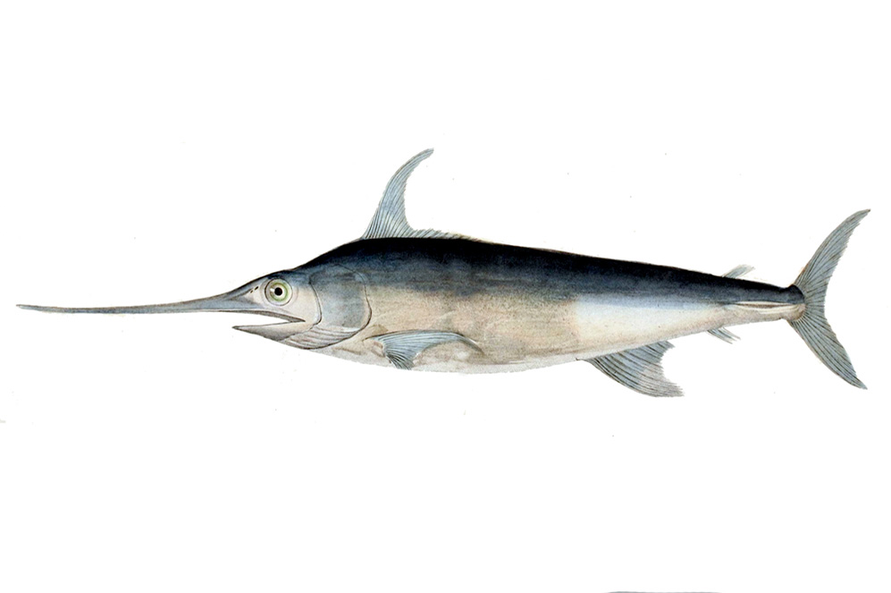
Alfred C. Glassell Jr. Hall

Main Level
Save the Ocean
Many animals within the oceans are at risk due to environmental changes and pollution. Choose one area that is associated with marine life: beaches, deep water trenches, sea anemones, sand bars. Once each student group has an area to research, tell them to investigate the biggest threats to their area. They should research the animals that call the area home, what threats those animals face, as well as ways to prevent further damage to the ecosystem.

Deep Water Exploration
Imagine that you are going on a journey to the bottom of the ocean. Working within groups, students must design a submersible vessel that will allow for survival at extreme depths and under extreme pressure. Students need to create a blueprint for their vessel that includes a method for conducting research, survival gear, and emergency plans should something go wrong.
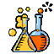

The Welch Chemistry Hall

Lower Level

Metal, Nonmetal, Metalloid
Divide students into three groups. Each group will be assigned a different classification: metal, nonmetal, metalloid. Ask each group to research their different classification and present it to the class. Information can include the type of elements found in the category, the characteristics of the elements, examples of the elements in day-to-day life, etc.

Energy Transformation
Tell students to look back at the energy transformation chart that they completed while at the Museum. Ask students to explore the classroom, looking for additional examples of energy transformation. Then, in groups, students will use poster board and other materials to illustrate and label what they think is the most important energy transformation in the room. They must explain their findings to the class.

Solar System

Outside Main Entrance

A Game, A Game!
Divide the class into small groups. Ask the groups to make a Solar System game. They will need to include the Sun, all the planets, meteorites, comets, asteroids, and moons. Groups should create a game board with playing pieces, and include a set of instructions on how to play the game. Encourage students to be as creative as they like. When all the groups have finished their game ask them to trade games with another group and play a round.

