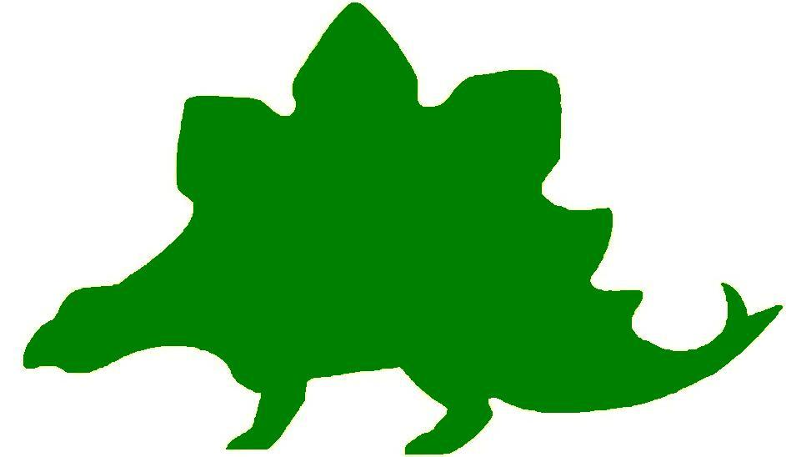
theHoustonMuseumofnaturalscience

5th Grade Knowledge Hunt
Dear Educator,
Thank you for downloading the free, online curriculum available at HMNS! We’re thrilled to see that you are including the world-renowned Houston Museum of Natural Science in your educational toolkit.
Here at HMNS our mission has always been to provide exemplary educational opportunities for the community. Providing educators like you with free, fully editable curriculum is just one of many ways we are fulfilling that mission.
Thank you again, and we hope you enjoy your field trip to HMNS!
Best,
The HMNS Staff

How to use this guide:
- Feel free to edit the questions as needed to suit your student group.
- The Knowledge Hunt is structured to begin at the top of the Museum (floor three) and work its way down to the lower level.
- Visitor services and security staff are posted around the Museum and will be happy to assist you in finding any of the locations mentioned.
- Please ensure that one chaperone is with every group of ten students at all times as they complete these activities.
- Don’t forget to download our extension activities for use in the classroom when you return from your trip!

Please direct any and all questions to curriculum@hmns.org

5th Grade TEKS Objectives
Each of the following TEKS Objectives are met as students explore the various exhibit halls and complete the Knowledge Hunt:
Science: 5.1 (A, B), 5.2 (C, E, F, G), 5.3 (C, D), 5.4 (A), 5.5 (A, D), 5.6 (A, C), 5.7 (A, B, C, D), 5.9 (A, B, C, D), 5.10 (A, B, C)
Social Studies: 5.4 (B, C, G), 5.6.(A), 5.9 (A, B, C), 5.10 (A), 5.14 (A), 5.20(B), 5.23 (C), 5.24 (E), 5.25 (A, B, C, D), 5.26 (D, E), 5.27 (A, B)

ELA: 5.9 (D), 5.10 (B, E, H, J, L), 5.11 (A, D), 5.13 (C, D, E, G), 5.14 (B, C), 5.15 (A,
C, D, E, F), 5.16 (A, B), 5.18 (A, B, C, D, E, F, G, H), 5.21 (D), 5.23 (B)
Math: 5.3 (A, C), 5.8 (B), 5.7, 5.10 (A, B, C), 5.11 (A), 5.14 (A)

McGovern Hall of the Americas

Third Floor

Vocabulary:
kiva, prehistoric, archaeologist, kachina, pueblo, extinction, ornamental, tipi, agriculture, horticulture

The Southwest
What four states meet at the area in the United States called Four Corners?
1.
2.
3.
4.

Look at the representation of a Kiva. Describe the kiva and explain what it was used for.

Look at all of the kachinas in the display and read the information that explains their importance.
What do the kachinas represent?

What is your favorite kachina? Draw or describe it.

Read about Pottery making at Zuni. What do the geometric designs on the Zuni pottery represent? Copy your favorite design.

Look at the items in the Prehistoric Pottery Case. How many years ago did the ancestral Anasazi people first paint designs on pottery?

The Plains
How did the acquisition of the horse improve the life of the Southern Plains tribes?

Look at the model of the Tipi. Give three reasons why the tipi was such a practical type of shelter.
1.
2.
3.

Read the information about The Buffalo and watch the video. About how long did the nomadic Plains culture exist?

What three things did the buffalo provide for the Native People of the Plains?
1.
2.
3.

Read the description of Counting Coup. Explain the act of counting coup.

The Southeast
Read all of the information and look at the displays about the Caddo and Cherokee tribes.
What was the historical “Trail of Tears”?

Why was the Spiro settlement so important?

Hall of Ancient Egypt

Third Floor

Vocabulary:
tandem, ancient, civilization, script, hieroglyphs, ruins, heritage

Egypt: Gift of the Nile
Why do you think the Nile flooding was useful to ancient Egyptians?

Timeline of Egyptian History
Name two things that occurred in other parts of the world during the New Kingdom.
1.
2.

According to the timeline, in what year was the Rosetta Stone created?

Egypt’s Ancient Roots
According to the text panel, when did pottery appear in the ancient Egyptian timeline?

Scripts and Writing in Egypt
Define hieratic

Why did ancient Egyptians start using the hieratic script in tandem with hieroglyphs?

Ramses II
Look at the bust of Ramses. Take notice of the slot at the brown of the crown. What do historians believe was originally in that slot?

Pharaoh: Lord of the Two Lands
Who was the most powerful person in ancient Egypt?

What did the word “Pharaoh” originally refer to?

Temples
Why do you think Egypt is “littered” with the ruins of ancient temples?

Mummification
What class of person would end up buried in the desert without any preparation?

Mallets and Masons: Egypt’s Mystic Pseudo-Heritage
What does the unfinished pyramid, on the US dollar bill, possibly mean?

Egypt in England: Chiddingstone Castle and the Collections of Denys Eyre Bower
What major event caused Denys Bower to become fascinated with Egypt?

Strake Hall of Malacology

Second Floor

Vocabulary:
mollusk, gastropod, carnivorous, marine, bivalve, cultured pearl

What are mollusks?
A large, adult squid can grow as large as 65 feet. If a young squid was found measuring 21.5 feet, how much more will it have to grow to become a giant squid?

What was designated as Texas’ official mollusk by the State Legislature in 1987?

What group of mollusks that you see displayed probably existed at the same time as dinosaurs?

What makes a bivalve a mollusk?
How many equal parts would you expect to see in a bivalve?

Gastropods and Bivalves
Identify the physical characteristics of gastropods and bivalves by checking the appropriate box.

Physical Characteristics | Gastropod | Bivalve
no head
carnivorous and herbivorous
shell, spirally coiled
head, foot, visceral mass
hatchet-shaped foot for burrowing
filter feeder/predator
eyes on head
has teeth

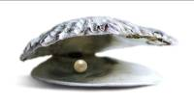

Oysters and other mollusks that make pearls
After watching the video of how cultured pearls are made, why do you think they are so expensive?

If it takes 80,000 hours to produce a pearl, how many days and weeks would that be?

Fossil Mollusks
How much would the large mollusk fossil measure in inches?



Microscopic Snail Shells
What do you think the prefix “micro” means?

Snail’s Teeth
Which snail has the most teeth, carnivore, herbivore, or omnivore? Rank them from the greatest amount of teeth to the least amount of teeth.

World’s Largest Snail Shell
The Australian Trumpet is 30 inches in length. How many feet is that?

Cullen Hall of Gems and Minerals

Second Floor

Vocabulary:
reflection, refraction, prism, surfaces, angles
Each text panel contains a number on the bottom right. These numbers will be used to identify the case.

Case #31
Look at the Quartz. How many surfaces can you count?

Case #42
Look at the Pyrite in this case and make a sketch. Use your powers of estimation and assign a reasonable length and width measurement in inches to all sides. Write the numbers on your sketch. Create a problem to figure the perimeter and the area of the object.

Now, use the formula V = s3 to figure the volume of the cube.

Case #76
Look at the Hydxorylherderite in this case. Find the two triangular surfaces on the mineral. Do you think they are congruent? Why or why not?

Case #83
What is the shape of the Elbaite? Draw a sketch of it, showing the shape and the coloration.

Refraction Touch Screen
Explain what refraction is.

Which color slows the least and which color slows the most?

What causes the spectacular color in minerals?

Attributes
As you go through the exhibit hall, identify attributes of parallel, perpendicular, and congruent parts in some of the gems and minerals.

Mineral | Case Number | Attribute

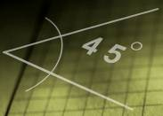

Geometric Lines and Angles
Draw an example from one of the cases of each of the following: right angle, acute angle, obtuse angle or parallel and intersecting lines. Identify the case and the name of the gem or mineral below your drawing.

Farish Hall of Texas Wildlife

Second Floor

Vocabulary:
biodiversity, niche, environment, ecosystem, species, deforestation, biome, non-sustainable, biotic, abiotic, prey, drought, predator, herbivore, reservoir, migrate, estuary, aberrant, invasive, translocation, omnivore, herbivore, predator, extinct

Aberrantly Colored Animals
Lead students to the case discussing aberrantly colored animals, just outside the main exhibit. What challenges do you think these animals faced when trying to survive?

Invasive Species
Listen to the video on invasive species. What are the different repercussions to introducing an invasive species into the ecosystem?

Introductory Video
What species, formerly extinct in Texas, now exist in stable numbers?

What species have been translocated back into Texas?

What species have disappeared from Texas forever?

Texas Ecosystems
For each of the ecosystems below, identify three defining characteristics that make it unique.
Ecosystem | Characteristic #1 | Characteristic #2 | Characteristic #3
Coastal Wetland and Marsh
High Plains
Guadalupe Mountains
Piney Woods
Rio Grande Dry Forest
Coastal Oak Motte
Coastal Prairie

Texas Predators
Draw a food web for two of the Texas predators shown in the exhibit. Put their names in the center of the web and their prey on the web strands. Can you connect them? Be sure to note which ecosystem your predator is from.

Guadalupe Mountains
Which of the animals in the Guadalupe Mountains is an omnivore, feeding on both plants and animals?

Foot Structure
For each of the following animals, examine its feet and explain how their foot structure has helped them adapt to their environment.
Animal | Foot Type  (webbed, hooved, etc.) | How it helps
Pronghorn
American Alligator
Coyote
Mottled Duck
Western Spotted Skunk
Ivory-Billed Woodpecker
Bald Eagle

Extinction Video
Take a moment to examine the extinction case and watch the video. What caused the final fate of each of the following creatures?
- Passenger Pigeon
- Red Wolf
- Carolina Parakeet

Migratory Birds
Read the text panel in front of the Coastal Oak Motte region. What human introduced factors may impact the migration of these birds between Mexico and the United States?
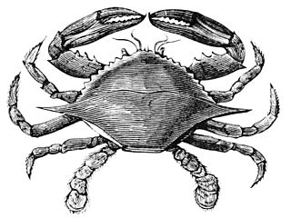

Hamman Hall of Texas Coastal Ecology

Second Floor

Vocabulary:
ecosystem, , ecology, tidal zone, population, bay, estuary, imprinting

As you enter the Hamman Hall of Texas Coastal Ecology, find Houston (Harris County) on the map of Texas. How close are we to the ocean?

What is ecology and why might coastal ecology be important to us?

Upper Coast

Oyster Reefs
Find the oyster reef display. Label everything you can see in the display as either “natural” or “man-made”. Don’t forget to include the background images!
Natural | Man-made

Middle Coast

Tides
What causes tides?

List the three tidal zones in order, beginning with the zone closest to the shore.
1.
2.
3.

Brown Pelican
Observe the series of maps that tracks Brown pelican populations over time. What do the larger circles represent?

Have Brown pelican populations in our area increased or decreased over time? What is this a result of?

Video
Watch the video at the end of the Middle Coast section from beginning to end. What is the problem here?

The narrator talks about a “never ending cycle” of picking up trash. How can we stop this cycle and protect our oceans?

Lower Coast

Texas Coast by the Numbers
What is the current human population in the 18 Texas coastal counties?
What is this population expected to be in the year 2050?
About how many more people are expected to live in the coastal counties in the next 35 years? Show your work.

Give an example of one of the laws passed to protect our bays and estuaries.

Kemp’s Ridley Sea Turtle
As you round the corner of the Lower Coast section, you will see a large turtle. Describe what she is doing.

When the baby sea turtles hatch, they will imprint, or “mark” the beach they are on as their home. In what ways do we “belong” to a certain area and call it home? Is our home always where we are born?

Frensley Hall of African Wildlife

Second Floor

Vocabulary:
aquatic, tropical, biodiversity, niche, environment, primates, ecosystem, species, deforestation, biome, non-sustainable, biotic, abiotic, prey, drought, predator, herbivore, reservoir, migrate

In the Hall of African Wildlife, find the map of Africa and label each of the regions on the map below.

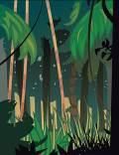

Congo – “Congo Exploration”
Why did the animals in the Congo go undisturbed until 1900?

What is community ecology?

What is biodiversity?

How would species that use different parts of the forest contribute to biodiversity?

Why does biodiversity increase in the tropics?

How much of the Earth’s surface does Africa occupy?

What is the world’s largest river?

What are the four water borders of Africa?

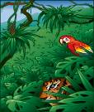

West Africa Tropical Forest – “Living Together in Harmony”
What is a niche?

What kind of environment supports the highest level of biodiversity? Why?

Serengeti – “Feast or Famine”
Animals must have what two resources to live? Give an example of each type of resource.

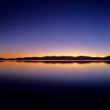

Ethiopian Realm – “Living together in Harmony”
What is an endemic species?

What is one thing you can do to help preserve the rainforest?

How many more species of birds are found in Kenya than Texas?

What happens to the balance of resources during times of drought?



Okavango – “Life Needs Water to Survive”
Compare/contrast in a Venn diagram the Okavango Delta and the Kalahari Desert.

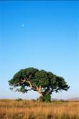

Lowveld – “What is an Ecosystem?”
What is an ecosystem?

What is the role of a producer, consumer, and scavenger in the ecosystem in the display?

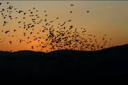

Sahara – “Perilous Migrations”
Give the main reason why migration of songbirds between Europe and sub-Saharan Africa is so great a challenge.

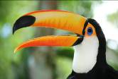

Bird beaks
Observe the birds in the Hall of African Wildlife. There is a great deal of variation among the birds in the Hall. If we look at a bird’s beak, we can often tell what it eats. Find and name a bird in the African exhibit that has the following type of beak:

Bird Name | Description | Purpose
 | Flat beak | Filters food from water
 | sharp, hooked beak | to eat other animals
 | thick short beak | to crack seeds
 | short, thin beak | to eat insects
 | long, thin beak | to get nectar from flowers
 | straight, sharp beak | to spear food
 | long, curved beak | to dig in the mud for food

Bird feet
Now, look at the birds’ feet. Feet also serve specific purposes. Find and write the name of a bird in the African exhibit that has:

Bird Name | Description | Purpose
 | webbed feet | swimming
 | large, curved claws | grasping
 | long back toe | perching

The Morian Hall of Paleontology

First Floor

Vocabulary:
fossils, extinction, predator, prey, carnivorous, herbivorous, adaptation, amphibian, terrain, food chain, fossil, inherited trait, learned trait, fossil impression

Aquarium
Watch the scenes that flow by on the aquarium screens. List four of the different adaptations you see on any of the sea creatures that float by. How do these adaptations help them to survive?

1.
2.
3.
4.

Boomerang-headed Amphibian
Look at the model of the Boomerang-headed amphibian. How do his feet help him in the water? If he is meant to stay close to the bottom, how does his head shape help him survive?

The Life of the Craddock Bone Bed
Look at the Dimetrodon in the mural. How do his feet and claws help him thrive on this type of land? How are his feet and claws similar to the Gorgons in the “Feeding Time for Gorgons” mural?

Gyrodus circularis
Look at the round wide sharp-finned Gyrodus circularis. Notice he has sharp pointy teeth. This fish thrived on coral. How do his body, his teeth, and his fins help him to thrive on a coral diet?

Stegosarus vs. Allosaurus
Compare and contrast Stegosarus and Allosaurus. Which one do you think could run faster? Based on your observation of the bone structure which one would be more adapt to muddy terrain? Which animal was a carnivore and which was an herbivore?

Compare/Contrast | Stegosarus | Allosaurus
Run Faster? Why?
Better on muddy Terrain? How do you know?
Carnivore/Herbivore. Evidence?

The Late Cretaceous
Complete the food chain using the options below:

Sun Triceratops magnolia
decay/nutrients Tyrannosaurus rex

Denversaurus vs. Tyrannosaurus rex
Study the fossils of the Denversaurus and the T-rex. Which animal do you think ran faster? What clues on his body help you determine your answer?

The Denversaurus is an herbivore. Estimate how many plants he would have to eat to survive each day.

Quetzalcoatlus
Look at the Quetzalcoatlus eggs. List three inherited traits these babies might have once they hatch. How will each trait help them survive?

1.

2.

3.

Based on the scene before you what trait might the babies have to learn from their parents in order to survive?

Maple Leaf
Look at the large maple leaf impression. How does it look similar and different than a modern maple leaf?

Eocene Maple Leaf
Modern Maple Leaf

White River Riverbank
Look at the mural of the white river riverbank and pay close attention to the environment. How do the hooves on the animals’ feet help them survive their environment?

Jurassic Bark
Stop to look at the large cross section of a sequoia tree trunk. By counting the rings in the trunk of a tree, you are supposed to be able to predict how old the tree was when it died. Look at the rings in this tree. Make a prediction as to its age when it died.

Mastodon with a Built-in Shovel: Platybelodon
What do you think these animals did with their built-in shovel?

Why do you think this species of mastodon went extinct first?

Eremotherium, Greatest of the Ground Sloth
List two reasons this large animal went extinct at the end of the ice age.
1.

2.

The Human World Mural
Find the Kenyanthropus platyops using a “tool” to grab a meal from the termite mound. Is this an inherited action or a learned action? Explain your answer.

Can you find an example of learning nearby?

Wiess Energy Hall

First Floor

Vocabulary:
energy, sedimentary, electricity, hydrocarbons, reservoirs, geologist, explorations, subsurface, seismic, borehole, molecule, consumer, nuclear, hydroelectric, conductor, current, generators, turbine, alternative, deplete, non-renewable, renewable

Formation
At the entrance to the Energy Hall, watch the movie that states that there was “a super thermal radiation of unimaginable scale”. What is this theory called?

What three elements were present that created the earth’s rock layers over millions of years?

Energy Exploration Theater
Electricity is the constant flow of ______________.

Energy that will be eventually used up over time is called _________________.

What source of energy burns clean to make heat?

As you tour the rest of the exhibit, complete the chart below with examples of renewable, nonrenewable, and alternative fuel sources.

Renewable | Nonrenewable | Alternative



Plate Tectonics
Make a sketch of how the Earth looked 200 million years ago.

Geology
Complete the geology equation.

heat + pressure = __________________

How are oil and natural gas reservoirs formed?

Sedimentation
What must be present in sedimentary rock for oil and natural gas to be produced?



Hydrocarbon Traps
What three types of rock form traps for hydrocarbons?
1.
2.
3.

Geography
Where are the world’s major oil and natural gas fields located?

How do geologists decide where to drill for oil or gas?

Drilling
What is the only way to confirm the presence of oil or natural gas in an underground formation?

How many roller cones are found on the tri-cone insert bit?

Why do you think this was more effective than the Hughes Simplex Dual Cone?

Geovator
Ride the Geovator to understand what it would be like to experience locating oil. How deep does the bit go into the Earth?

Draw a diagram of the three layers of earth over the “Pay Zone”. Label the parts.

Christmas Tree
What is the purpose of the Christmas tree?

Why do you think it was given that name?

Reservoir and Production
What does a completed well provide?

Process and Product
List five products made by transforming hydrocarbons at refineries.
1.
2.
3.
4.
5.



Transportation and Distribution
Give three ways in which energy is delivered.
1.
2.
3.

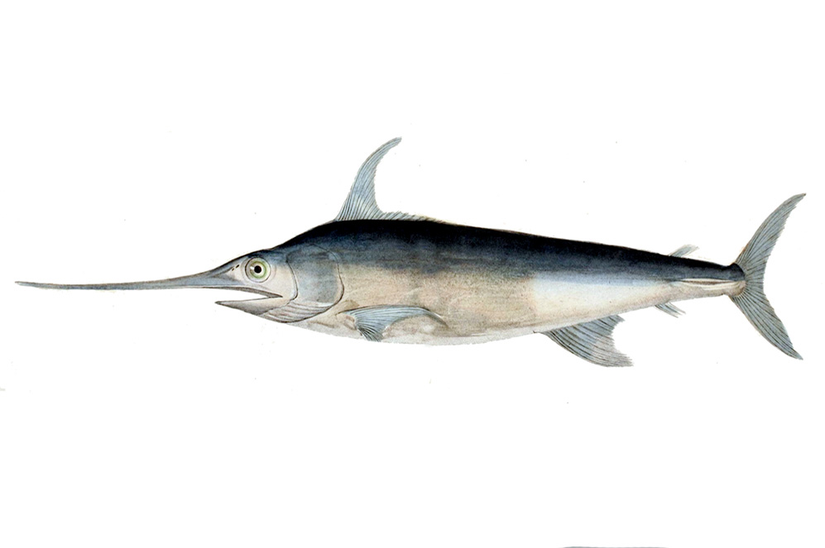
Alfred C. Glassell Jr. Hall

First Floor, Main Entrance

Vocabulary:
aquatic, biodiversity, characteristics, niche, environment, ecosystem, species, biome, non-sustainable, biotic, abiotic, prey, predator, herbivore, survival

Aquatic Environments
Within the Glassell Hall there are a variety of marine animals depicted. Identify the species listed below and choose three defining characteristics for each.
Animal | Characteristic #1 | Characteristic #2 | Characteristic #3
Black Marlin
Great Hammerhead Shark
Dusky Dolphin
African Pompano

How does each of the characteristics listed above give the animal a survival advantage?
Animal | Advantage #1 | Advantage #2 | Advantage #3
Black Marlin
Great Hammerhead Shark
Dusky Dolphin
African Pompano
There are two different marlins depicted in the hall: the blue marlin and the black marlin. In the Venn Diagram below, compare and contrast the two. Hint: The black marlin is mounted on the wall, whereas the blue one is on the ceiling.



The Welch Chemistry Hall

Lower Level

Vocabulary:
Periodic Table, elements, molecule, atom, matter, conductor, insulator, polymer, acid, base, pollutant, conductivity, superconductors, synthetic, natural, insulator, gravity, properties, surfacant

Classify Matter
For each of the items below, each available in the chemistry hall, describe its physical properties:
Item | Solid/Liquid/Gas | Physical Characteristics
Ping pong balls
Oil & Water Tube
Orange slime polymer
Copper cylinder

Physical Properties
Observe the three cylinders at the self-assembly station. Tell students that the cylinders consist of three different components: oil, water, and surfactant (soap). Tell them to fill out the following chart based on their observations:
Tube | Change in Physical Properties? (Y/N) | Explain
Tube #1: Oil & Water
Tube #2: A lot of oil, some water, a lot of surfactant
Tube #3: A lot of water, some oil, surfactant

Uses of Energy
Have students explore the Welch Chemistry Hall, identifying one object for each type of energy they are studying (mechanical, sound, electrical, light, heat/thermal). Then, for each object, explain the characteristics that make it fall under its specific category of energy, and its possible uses.
Type of Energy | Object | Characteristics | Uses
Mechanical Energy
Sound Energy
Electrical Energy
Light Energy
Heat/Thermal Energy

Solar System

Outside Main Entrance

Vocabulary:
solar system, gravity, orbit, revolve

Solar System
Draw a diagram of the solar system including the Sun, the planets, and their moons.

Saturn
Using the statistics provided, calculate how many Earths would fit between Saturn and the Sun.

Neptune
Using the length of a year on Neptune and its rotation period, find the number of hours in a year on Neptune. How many times longer is it than an Earth year?

