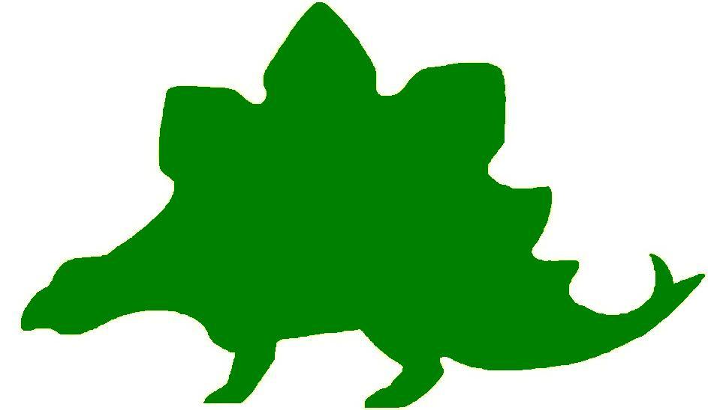
theHoustonMuseumofnaturalscience

5th Grade Extension Activities

McGovern Hall of the Americas

Third Floor

Winter Counts
A story skin or winter counts skin contains drawings of the events that happen in one year, from winter to winter. Ask students to create a story skin of events in their life for a year. Alternatively, they may pick in a special year in history. Provide brown paper grocery sacks for students to cut into skin shapes and colored markers or tempera paint to draw the pictures that create the story. After the skins are complete, have the students tell the story to the class that is illustrated on the “skin”.

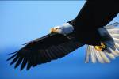

Eagle Trials
Young Indians earned eagle feathers for brave acts. Ask the students to write a story about a brave act that might have earned them an eagle feather. Cut a large feather shape from colored construction paper and one from lined paper and give them to the students to create a shaped book of their story.

Bead Art
Beautiful bead work decorated Indian clothing, pouches, vests, dresses, moccasins, and other articles that they used in their daily life. Allow students to create an original beaded design. Using graph paper and colored pencils, they may plan their design. They can replicate their design by wrapping yarn or pipe cleaners around a cardboard square. Beads can be strung on the yarn or threaded through the pipe cleaners to create the beaded design.

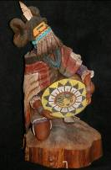

Kachina Creations
Research the importance of kachinas to the Native American Indians. Create your own kachina to represent something of importance in their culture. Use a paper towel roll, construction paper, and colored pencils or markers for your creation. Write a story to accompany your kachina.

Hall of Ancient Egypt

Third Floor


This Date in History
Choose three major historical events in U.S. history. Create a timeline showing when these events took place. Add a picture if one can be found. Next, find three things that happened in world history during the time of your original three events. Add them to your timeline. The dates do not have to line-up exactly, but they should be within the same decade. Display your timelines around the room so that everyone can see your important dates in history!

Debate: Print vs. Cursive
While visiting the Hall of Ancient Egypt you discovered that heretic was a form of cursive writing that helped the scribe write quicker than using hieroglyphs alone. Divide the class into two groups. One will debate that printing is better than writing in cursive. The other group will argue for the cursive side. The teacher will be the final decider as to whether it would be better to print or write in cursive. You should have valid arguments as this can be a very opinionated debate!

What could it mean?
While visiting the museum you had the opportunity to look closely at a one dollar bill. You learned that the unfinished pyramid on the dollar bill could represent the idea that the United States is still “unfinished”. Write an essay explaining what you think that means. How are we still unfinished? Should we complete the pyramid on the dollar bill now? Be sure to include an introduction and concluding paragraph.

Strake Hall of Malacology

Second Floor

Home Sweet Home
During their visit to the Museum, students saw an Australia Trumpet shell that measured 30 inches in length. Have them draw the shell on a large sheet of paper. Remind students that the size and shape of the shell limits the type of creatures that might live inside. Have them draw a picture of a new species of animal that they think lives inside. They will need to explain what kind of environment it might live in and everything that it would need to survive. They will name their animal and describe where the shell could be found.

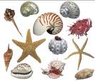

Shells for Sale
Tell the students to draw an interesting shell. They will create an advertisement offering this shell for sale as a new home for an animal. Tell them to include the size of the inside, the rooms that it contains, and any other special features.

Cullen Hall of Gems and Minerals

Second Floor

What’s Your Angle?
Ask students to use a ruler and a protractor to create angles of 90, 45, and 30 degrees. They will add details to each angle to create a new “gem”. It should be brightly colored. Ask them to tell where their gem might be found.

Museum Jewelry
Challenge students to design a piece of jewelry that incorporates one of the gems that they saw displayed during their visit to the Museum. In addition, they will create an advertisement for their creation and set a price for it. Tell them to include descriptive words and details about the gem that might help it sell.

Spelunking Fun
Tell the students to suppose they were spelunking in a cave and found one of these priceless gems. Have them write a story about what they would do next.

Colorful Light
Have students research the refraction of light and the colors it produces. Tell them to draw a gem like one they saw on their visit to the Museum. They will need to add an illustration that shows how light entering the gem would be refracted and the colors it would produce.

Convert it!
Tell the students to use the information that they gathered about the Pyrite in their Knowledge Hunt to convert the estimated measurements from inches to centimeters.

Hall of Texas Wildlife

Second Floor

Animal Invasion
Assign students one of the ecosystems they saw at HMNS to research. Have students investigate the different plants and animals that live in the region, as well as the general climate. Then, tell students to pick one animal from another region and pretend that it has moved to their ecosystem. Students should predict what will happen as a result. Will the native plants and animals suffer, or will the foreign one?
Have students make predictions in their notebooks and then write a brief story explaining what happens.
Then, challenge students to think of how the animal can adapt to its new environment. Tell them to pretend that they are the animal that has been translocated. They are to write a two week journal account of their experience, including why they left their home, where they moved to, and any changes that they were forced to undergo in order to survive in their new home.
An example of this would be a Collared Peccary, from the Rio Grande Dry Forest, being placed in the High Plains, or an alligator ending up in the Guadalupe Mountains.

Summer Vacation
Split students into groups and tell them that they are responsible for increasing tourism to specific regions of Texas. Provide them with digital and print resources and have them research an assigned ecosystem. Then, they will develop a travel brochure for the area that includes facts and pictures that would be inviting enough to bring people on vacation.

Conservation Stations
Have students research the major conservation concerns in each biome of Texas. Then, have students choose the one that interests them the most and create an action plan to solve the crisis. Encourage students to put their plan into action.

On the Wing
Ask students to read about birds of prey in Texas to find out about how their wings, eyes, beaks and talons are adapted to make them different from other types of birds. Have the students draw their bird and label its parts. Add a “text panel” to each label that gives detailed information about how each part is adapted to help the bird of prey survive.
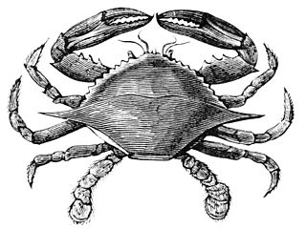

Hamman Hall of Texas Coastal Ecology

Second Floor

Stop the Cycle
In one of the videos students saw in the exhibit, the narrator talks about the “never ending cycle” of picking up trash that has ended up in the ocean. Allow time for students to research cleanup methods and/or local recycling options. Have students work as a team to design a banner that can be displayed in the hallway illustrating environmentally friendly techniques and why they are important.

Spinning a Food Web
What do we eat? Chances are students have consumed both plant and animal products, making us omnivores. Discuss with students the difference between herbivores, carnivores, omnivores, and detrivores. Divide students into groups and assign each student a role based on the diagram on the following page.
Using string or twine as a visual representation of links, have students determine what they would eat/who would eat them and link themselves in a complex food web.
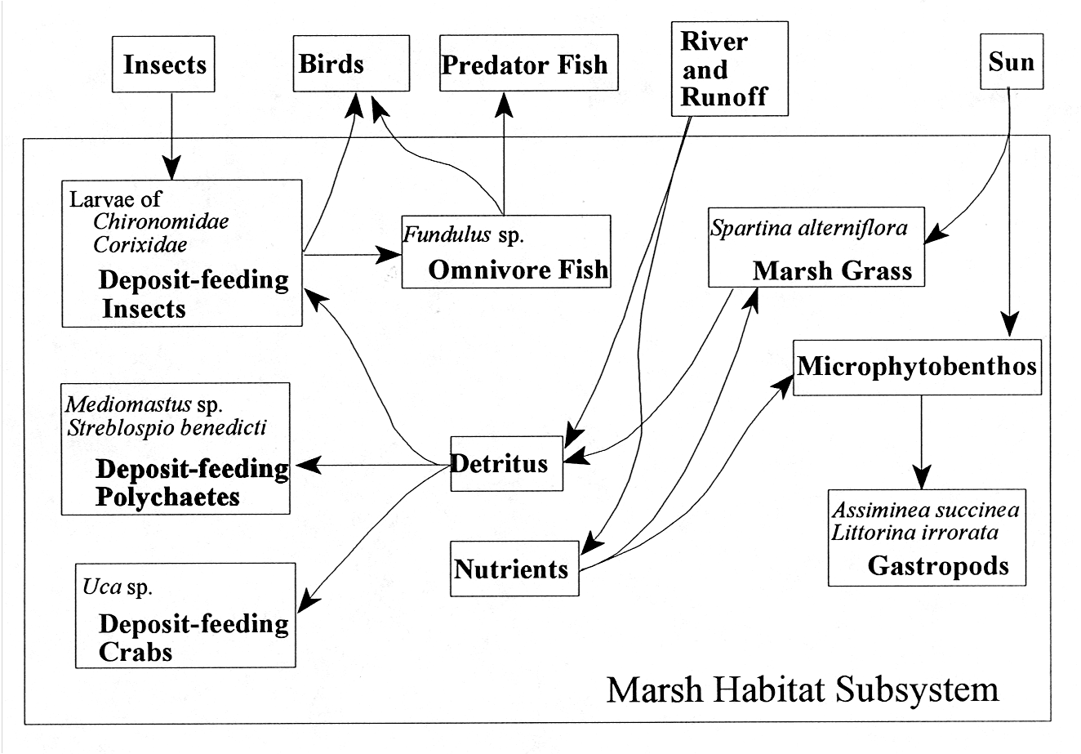
The Moon Made Me Do It!
Discuss with students the importance of gravity. What kinds of things does gravity affect? Point out that gravity affects water (pour a glass of water out- why does it fall?), and that this includes the water of the oceans around the world. It’s not just the Earth that has gravity- the Moon also exerts a force.

Frensley Hall of African Wildlife

Second Floor

Beak Trials
Provide students with forceps, chopsticks or blunt pencils, spoons, pliers, and clothespins to represent each type of beak. Display cooked rice, raisins, plastic worms, birdseed, cooked spaghetti, peanuts in shells, and water to represent the type of food birds might eat. Allow students to try to pick up each type of food with each beak representation. They should test all of the beaks with all of the foods to see which beak works best for each food. Use the chart below to record the information.

Bird Food and Beak Adaptation Observation
Food | Best Tool (beak) | Observations
Plastic worms
Cooked spaghetti
Cooked rice
Raisins
Birdseed
Peanuts in shells
Water

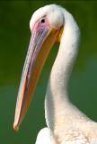

Feed the Birds
Using the information in the chart above and the description of the bird beaks from the Knowledge Hunt, help students make connections between the tool used and real beak descriptions. Have them create a booklet describing each beak type. It should explain why that beak is best for specific birds as a gathering and eating tool. They should include pictures or drawings of birds and examples of the food they eat.

Traveling to Africa
Tell students to use the information that they gathered about the regions of Africa to create a travel brochure persuading people to visit this area. They should include its name, location, the animals that live there, and a description of its environment.


Mapping the Environment
Enlarge a map of Africa and distribute copies to the students. Have them outline the regions and label them. Within each region, students should draw pictures of some of the wildlife that lives there. They will write a description of the environment, including the climate, availability of water, and the plants that exist there.

Adaptations
Tell the students to pick a region in Africa that interests them. If a penguin found itself in this environment, what adaptations would it have to make in order to survive? Tell students to write their explanation in the form of a story.

The Morian Hall of Paleontology

First Floor

Mom, Look What I Brought Home!
Ask the students to imagine that they found a dinosaur egg and took it home. After a few days, it begins to hatch. Tell students to complete the story as a book and illustrate it. Share their stories with a younger student.

Dinosaur Conversions
Tell students to choose seven dinosaurs that interest them. Ask them to create a chart that includes their name, length, height, and weight. They will add columns and convert that information into other forms of measurement.

Become a Paleontologist
Have students pretend that they are paleontologists and have a theory as to why dinosaurs became extinct. Instruct them to write a persuasive speech to try to convince their audience of their theory. Remind them to include at least five facts to support their theory.

New Discovery
Provide students with a variety of resources to research dinosaurs. They will create a new dinosaur by combining the head, body, legs, tail, and defensive attributes of at least five dinosaurs. They are to name and describe their new discovery. What does it eat? Who are its enemies? How does it defend itself?

Grid the Dig
Scientists know that dinosaurs are found in certain parts of the world for many reasons. One way that they find these fossils is by recognizing specific rock formations. When parts of a dinosaur are discovered, scientists take every precaution to protect the potential paleontological site where the dinosaur may be buried. One such precaution includes making a grid using rope and stakes over the site. First, scientists identify the bone and the dinosaur to which it belongs. Afterwards, they measure out the grid based on the size of the identified dinosaur and the location of the bone in its skeleton.

Tell students to pretend they were walking in an area where dinosaurs have previously been found when they suddenly see a partially exposed bone fragment, such as a rib bone, a tail bone, jaw bone, etc. Tell students to create a grid covering the area where the dinosaur is buried. Include a key to show the scale of each square. Label the quadrants of the grid, using letters across the top and numbers down the side. Have students research the size of the dinosaur that might be uncovered by digging the site so it can be drawn to scale. The coordinates to identify where the part of the dinosaur was exposed above the ground should be included.

Wiess Energy Hall

First Floor

Good Vibrations
This experiment shows the transfer of sound from one object to another. Create sound waves using a metal clothes hanger and two pieces of string about 24 inches long. Tie one 24 inch length of string to each corner of the clothes hanger. Tie a loop large enough to fit over a finger in the other end of each string. Slip a loop over the pointer finger of each hand. Place the fingers with strings in your ears. Gently bounce the clothes hanger off a hard object (like a desk). Allow each student to listen to the transfer of sound and write an explanation about how sound is transferred.

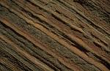

Rocky Roads
Have students research how different kinds of rocks, such as marble, shale, pumice, sandstone, or limestone, are formed. Create a classroom rock collection including a drawing of the rock and an explanation of how it is formed. Write a formula (carbon + pressure + time=diamond) explaining the rock’s formation and include in the rock collection.

Striking Oil
In a tall clear glass container, use three different colors of sand, soil, and/or rocks to show the three layers of rock that usually form on top of a pool of oil. Use a dark color of clay to represent the oil. Label the layers so they can be read on the outside of the container. Provide materials for students to create their own rock layers.

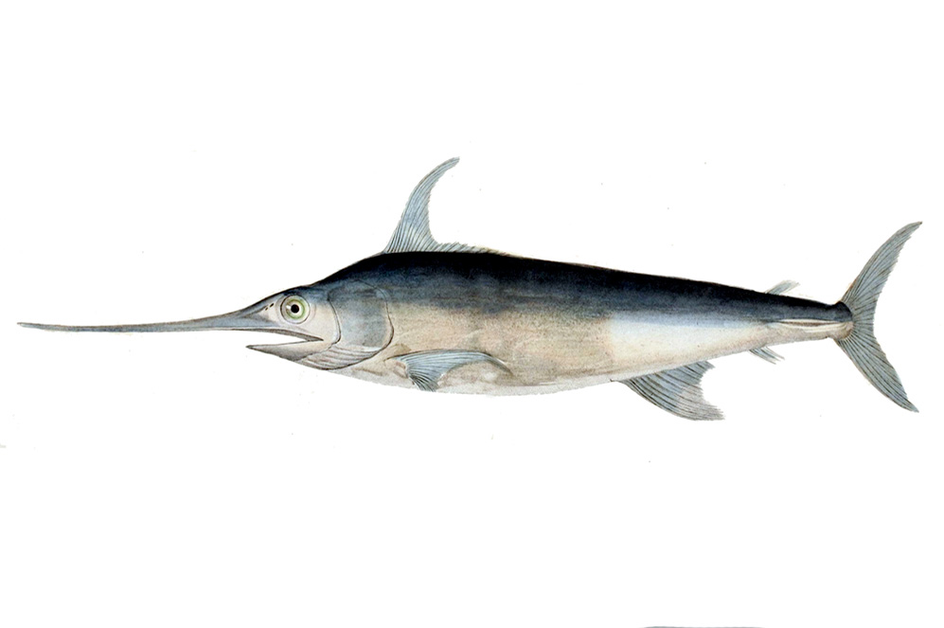
Alfred C. Glassell Jr. Hall

First Floor, Main Entrance

Our Changing Ocean
Pollution, hunting, and a changing climate are all influencing our oceans. Have students choose one of the animals seen in the Glassell Hall and research how it has been influenced by a changing environment. Then, tell them to develop a persuasive speech in which they must convince a panel of scientists and lawmakers to take action to conserve the ecosystem. The speech should provide a solution to the biggest problem, as well as the steps needed to execute the solution.

Aquatic Anatomy
Students are going to be researching three different animals that call the ocean home: the black marlin, the bottlenose dolphin and the hammerhead shark. Specifically, research the anatomy of these creatures. What similarities do they have? What differences? Guide students to create a triple Venn Diagram where you compare and contrast these three species.

Producers and Consumers
Draw a picture of the sun on the board. This is the beginning of your class food web.
Create a list of 30-40 marine organisms. Include those seen in the Glassell Hall as well as others, including algae, kelp and coral. Cut the list into strips and put the strips into a bucket. Instruct each student to pull a strip. Once each student has been assigned an organism, they must work together to organize their strips in a food web. Encourage students to use technology to research information about their organism if they are unfamiliar with it.

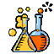

The Welch Chemistry Hall

Lower Level

Solution Solutions
Give students each a small vial full of pond water. Have them analyze its physical properties, including temperature, weight, mass, physical state, etc. If possible, repeat this experiment with a variety of different materials, including soil from the garden, tap water, and a variety of food mixtures (such as pancake batter or water and salt).

Force of Motion
Remind students that when they were at the Museum they had the opportunity to see a steam engine at work. Ask them for other examples of work, and tell them that they are responsible for designing and carrying out an experiment that will test the effect of force on an object. Once the experiments are designed, each group will be responsible for testing their experiment and recording their data and ideas for modification.

