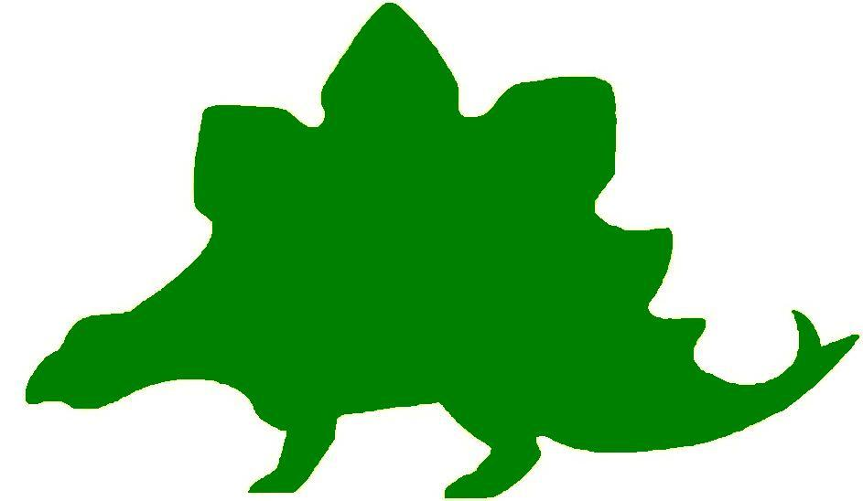
theHoustonMuseumofnaturalscience

4th Grade Knowledge Hunt
Dear Educator,
Thank you for downloading the free, online curriculum available at HMNS! We’re thrilled to see that you are including the world-renowned Houston Museum of Natural Science in your educational toolkit.
Here at HMNS our mission has always been to provide exemplary educational opportunities for the community. Providing educators like you with free, fully editable curriculum is just one of many ways we are fulfilling that mission.
Thank you again, and we hope you enjoy your field trip to HMNS!
Best,
The HMNS Staff

How to use this guide:
- Feel free to edit the questions as needed to suit your student group.
- The Knowledge Hunt is structured to begin at the top of the Museum (floor three) and work its way down to the lower level.
- Visitor services and security staff are posted around the Museum and will be happy to assist you in finding any of the locations mentioned.
- Please ensure that one chaperone is with every group of ten students at all times as they complete these activities.
- Don’t forget to download our extension activities for use in the classroom when you return from your trip!

Please direct any and all questions to curriculum@hmns.org

4th Grade TEKS Objectives

Each of the following TEKS Objectives are met as students explore the various exhibit halls and complete the Knowledge Hunt:

Science: 4.1 (A, B), 4.2 (A, B, C, D, F), 4.4 (A, D), 4.5 (A), 4.6 (A, B), 4.7 (B, C), 4.9 (A, B), 4.10 (A, B, C)

Social Studies: 4.1 (A, B), 4.4 (D), 4.9 (A, B, C), 4.10 (A), 4.22 (A, B, C), 4.23 (D, E), 4.24 (A, B)

ELA: 4.9 (B), 4.10 (A, B, F, H), 4.11 (A, C, D), 4.12 (C), 4.13 (A, C, D, E, F, G, H), 4.14 (B, C),
4.15 (A, B, C), 4.16 (A, B), 4.17 (A, B, C, D), 4.18 (A, B, C, D, E, F, G, H), 4.19 (A, B, C, D, E, F, G, H, I), 4.21 (C, D, F), 4.22 (A), 4.23 (B)

Math: 4.2 (B), 4.3 (A), 4.4 (D, E), 4.5 (B), 4.8 (A, B, C), 4.9 (B, C), 4.11 (B), 4.13 (A, B), 4.14 (D), 4.15 (A),

McGovern Hall of the Americas

Third Floor

Vocabulary:
kiva, prehistoric, archaeologist, kachina, pueblo, extinction, ornamental, tipi, agriculture, horticulture

Introduction to Archeology
What is archeology?

Look at the display showing The Wilson Leonard Site. How long ago did the Paleo-Indians live in Texas?

What was the food source of this early Indian culture?

Origins and Diversity

Cultures
What Native American culture was the most successful in developing textile weaving skills?

Sand Painting
What is the purpose of a sand painting?

The Arctic
Look at the objects displayed along the large case containing the kayak. Why do you think people in this region wore snow goggles?

How did people fish during the winter?

Look at the child’s seal gut parka displayed in the large case. How did grass help keep a child wearing a seal gut parka dry?

Inuit toys
Which of the toys do you like the best? Why?

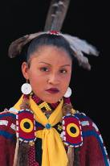

Parka and Women’s Items
Which bead was the most valuable? Why do you think that bead was more precious than beads of another color?

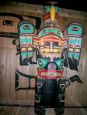

Northwest Coast

Family Crests
What was the importance of animal crests? Where were they displayed?

How did the transition mask work? Draw a picture of the two faces.

Raven House Front and House Post
List the steps in making a totem pole.

Cedar Objects
Why are cedar trees treated with respect on the Northwest Coast, even today?

Chilkat Blanket
When do you think this blanket might have been worn?

Button Robe
Why was this robe called “totem poles on cloth”?

Create a Venn diagram that compares and contrasts the Chilkat Blanket and the Button Robe.

The Southwest
What four states meet at the area in the United States called Four Corners?

Kiva
Describe the kiva and tell what it was used for.

Kachina
What do kachinas represent?

What is your favorite kachina? Draw and describe it.

Pottery Making at Zuni
What do the geometric designs on the Zuni pottery represent? Copy your favorite design.

Prehistoric Pottery
How many years ago did the ancestral Anasazi people first paint designs on pottery?

The Plains
How did the acquisition of the horse improve the life of the Southern Plains tribes?

Tipi
Give three reasons why the tipi was such a practical type of shelter.
1.
2.
3.

The Buffalo
How long did the nomadic Plains culture exist?

What three things did the buffalo provide for the Native People of the Plains?

Counting Coup
Explain the act of counting coup.

The Southwest

Caddo and Cherokee
What was the historical “Trail of Tears”?

Why was the Spiro settlement so important?

Hall of Ancient Egypt

Third Floor

Vocabulary:
ancient, sarcophagi, civilization, pharaoh, dynasty, hieroglyphic

Egypt Gift of the Nile
When did the first African civilization begin?

Timeline of Egyptian History
What time period were the pyramids constructed?

When did King Tut rule Egypt?

Which famous Queen ruled during the Ptolemaic Egypt?

Map: Egypt
Label the map with the 12 places listed below and include a compass rose. Use the text panels throughout the exhibit to help you locate the areas listed.

Lower Egypt Upper Egypt Nile River Red Sea
Mediterranean Sea Alexandria Thebes Memphis
Rome Italy Greece Jerusalem



Naming Egypt
What name did the ancient Egyptians use to identify their country?

Sarcophagus
Are all coffins sarcophagi? Why or why not?

The Rosetta Stone
Which three scripts are on the Rosetta Stone?

How did historians learn to “decode” hieroglyphics using the Rosetta Stone?

Strake Hall of Malacology

Second Floor

Vocabulary:
mollusk, gastropod, carnivorous, marine, bivalve, cultured

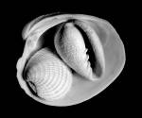

What are mollusks?
A large, adult squid can grow as large as 65 feet. How large would that be in inches?

If you collected a snail from the woods to put in your terrarium, you would have collected a _____________.

What was designated as Texas’ official mollusk by the State Legislature in 1987?

Look at the clockwise arrangement of the Texas state mollusk/shell. Why would a female snail bury one end of her egg case in the sand?

What group of mollusks that you see displayed probably existed at the same time as dinosaurs?

What makes a bivalve a mollusk?
How many equal parts would you expect to see in a bivalve?

Is a bivalve an example of symmetry? Why or why not?

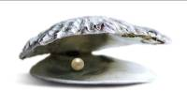

Oysters and other mollusks that make pearls
If it takes 80,000 hours to produce a pearl, how many days and weeks would that be?

Fossil Mollusks
Read the text panel to find the size of a large mollusk fossil. Use your conversion skills to figure how large it would be in inches.

Snail’s Teeth
Snails may be carnivore, herbivore, or omnivore. Give an example of one thing each type of snail might eat.

Type of Snail | What it Eats
Carnivore
Herbivore
Omnivore

World’s Largest Snail Shell
The Australian Trumpet is 30 inches in length. How many feet is that?

Cullen Hall of Gems and Minerals

Second Floor

Vocabulary:
reflection, prism, surface, angle

Mineral Symmetry
Crystals are grouped according to their shapes, called their crystal symmetry. Find four minerals in this hall that appear to be examples of symmetry. Record the case number, the name of the mineral, and draw a small sketch to show symmetry.

Case | Mineral | Sketch



Angles
Identify at least one mineral in this hall that is an example of a right, acute, and obtuse angle. Record the case number, the name of the mineral, and draw a sketch of the gem to show where the angle occurs.

Kind of Angle | Case | Mineral | Sketch
Right
Acute
Obtuse

Lines
Parallel and intersecting lines occur in minerals naturally and in the way they are cut. Find two examples of parallel and intersecting lines (including perpendicular) in the exhibit. Record the case number, the name of the mineral, and draw a sketch to show examples of the types of lines.
Kind of Line | Case | Mineral | Sketch
Parallel
Parallel
Intersecting
Intersecting

Pretend that you could take one of the minerals out of its display case and rotate it like a spinning top. What would remain constant?

Notice how the minerals are exhibited to reflect all of their sides. Explain how reflection proves symmetry of an object.

Case #42
Look at the Pyrite in this case. Does it remind you of a geometric shape?

Draw a sketch of the Pyrite as a cube. Assign a reasonable length and width in inches to your sketch. Use these numbers to write a problem to figure the perimeter and area of the Pyrite. Use the correct formulas.

Estimate the volume of the Pyrite in cubic units.

Case #41
Estimate the number of cubes that you see on the mineral Hydxorylherderite.

Farish Hall of Texas Wildlife

Second Floor

Vocabulary:
flora, fauna, ecological, niche, aquatic, ornithology, extinct, estuary

Texas Biomes
Watch the introductory video at the entrance to the Farish Hall of Texas Wildlife. Use the map below to label the different regions covered in the exhibit. Then, as you go through the exhibit, write in a characteristic of each region.

Soil Composition
As you enter the Farish Hall of Texas Wildlife, the first two regions you see are the High Plains and the Coastal Wetland & Marsh. Tell students that these two regions are in opposite corners of the state. Have them use the Venn Diagram below to compare the two regions. Then, direct them to answer discussion questions.

How is the soil in the High Plains different from the Coastal Wetland soil? Why do you think that is?

Read the text panel for the Coastal Wetland region. What is an estuary?

What do you think would happen if the High Plains received a lot of rain or if the Coastal Wetlands experienced a drought?

Survival Adaptations
For each of the items listed below, explain one of the challenges they face in their natural environment and an adaptation they have developed to cope with it.
Region | Item | Challenge | Adaptation
High Plains | Pronghorn
High Plains | Skunk
Guadalupe Mountains | Elk
Guadalupe Mountains | Bighorn Sheep
Piney Woods | Black Bear
Piney Woods | Pileted Woodpecker
Rio Grande Dry Forest | Rattlesnake
Rio Grande Dry Forest | Cactus

Extinct and Vanishing Species
Watch the brief video about extinct and vanishing species. For each of the animals below, use the chart to explain what happened to them and their current status
Animal | What Happened? | Current Status
Red Wolf
Passenger Pigeon
Carolina Parakeet

Piney Woods and Rio Grande Dry Forest
Take a few minutes to examine these two regions. How are they similar? How are they different? Point out the different flora and fauna of the two regions and have students predict why they are so different.

Coastal Oak Motte
Look at the beaks and feet of the birds in the display. How does their shape help them survive? How is the turkey’s beak different from the finch? Why do you think this is?

Read the text panel. What do you think are the primary dangers for migrating birds?

Coastal Prairie
Use the space below to make a food web, beginning with the sun. Try to include as many of the animals from this region as you can.
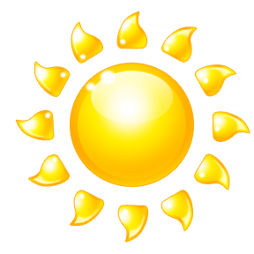

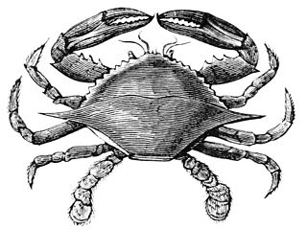

Hamman Hall of Texas Coastal Ecology

Second Floor

Vocabulary:
ecosystem, , ecology, tidal zone, population, bay, estuary, imprinting

As you enter the Hamman Hall of Texas Coastal Ecology, find Houston (Harris County) on the map of Texas. How close are we to the ocean?

What is ecology and why might coastal ecology be important to us?

Upper Coast

Oyster Reefs
Find the oyster reef display. Label everything you can see in the display as either “natural” or “man-made”. Don’t forget to include the background images!
Natural | Man-made

Middle Coast

Tides
What causes tides?

List the three tidal zones in order, beginning with the zone closest to the shore.
1.
2.
3.

Brown Pelican
Observe the series of maps that tracks Brown pelican populations over time. What do the larger circles represent?

Have Brown pelican populations in our area increased or decreased over time? What is this a result of?

Video
Watch the video at the end of the Middle Coast section from beginning to end. What is the problem here?

The narrator talks about a “never ending cycle” of picking up trash. How can we stop this cycle and protect our oceans?

Lower Coast

Texas Coast by the Numbers
What is the current human population in the 18 Texas coastal counties?
What is this population expected to be in the year 2050?
About how many more people are expected to live in the coastal counties in the next 35 years? Show your work.

Give an example of one of the laws passed to protect our bays and estuaries.

Kemp’s Ridley Sea Turtle
As you round the corner of the Lower Coast section, you will see a large turtle. Describe what she is doing.

When the baby sea turtles hatch, they will imprint, or “mark” the beach they are on as their home. In what ways do we “belong” to a certain area and call it home? Is our home always where we are born?

Frensley Hall of African Wildlife

Second Floor

Vocabulary:
aquatic, tropical, biodiversity, niche, environment, primate, ecosystem, species, deforestation, biome, non-sustainable, biotic, abiotic, prey, drought, predator, herbivore, reservoir, migrate

Survival
As you look at the animals in the African Wildlife exhibit, identify characteristics that allow members of a species to survive. For example, its color may help it blend into its surroundings or the shape of its feet might help it hold food. Create a chart of ten animals from the exhibit. Include a characteristic that helps it survive and write an explanation of how this trait contributes to its survival.
Animal | Survival Characteristics | Explanation

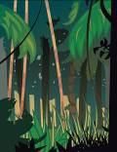

Congo – “Congo Exploration”
What is community ecology?

Define biodiversity.

How would species using different parts of the forest contribute to biodiversity?

Why does biodiversity increase in the tropics?

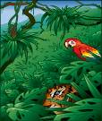

West Africa Tropical Forest – “Living Together in Harmony”
What is a niche?

What happens in an environment if a niche is disturbed or destroyed?

Serengeti – “Feast or Famine”
Animals must have what two resources to live? Give an example of each type of resource.

What happens to the balance of resources during times of drought?

Look at the environments represented in the display of the Serengeti and the Congo. Think about what exists in the Serengeti that allows the lion to thrive and tell why is it unlikely that you would find a lion living in the Congo.



Okavango – “Life Needs Water to Survive”
Compare/contrast in a Venn diagram the environment portrayed in the display of the Okavango Delta and that of the Sahara Desert.

Why would a hippopotamus not be able to live in The Sahara, when it thrives in Okavango?

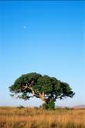

Lowveld – “What is an Ecosystem?”
What is an ecosystem?

What is the role of a producer, consumer, and scavenger in the ecosystem in the display?

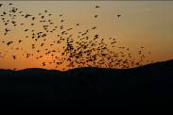

Sahara – “Perilous Migrations”
Give the main reason why the migration of songbirds between Europe and sub-Saharan Africa is so great a challenge.

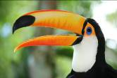

Bird beaks
Observe the birds in the Hall of African Wildlife. There is a great deal of variation among the birds in the Hall. If we look at a bird’s beak, we can often tell what it eats. Find and name a bird in the African exhibit that has the following type of beak:
Bird Name | Description | Purpose
 | Flat beak | Filters food from water
 | sharp, hooked beak | to eat other animals
 | thick short beak | to crack seeds
 | short, thin beak | to eat insects
 | long, thin beak | to get nectar from flowers
 | straight, sharp beak | to spear food
 | long, curved beak | to dig in the mud for food

Bird feet
Now, look at the birds’ feet. Feet also serve specific purposes. Find and write the name of a bird in the African exhibit that has:

Bird Name | Description | Purpose
 | webbed feet | swimming
 | large, curved claws | grasping
 | long back toe | perching

The Morian Hall of Paleontology

First Floor

Vocabulary:
extinction, predator, prey, carnivorous, herbivorous, timeline, species, inherited trait, solar panel, adaptation, environment, vegetation, climate change

Trilobite Timeline
Take a moment to look at the trilobite timeline. Notice that, even though the species changed over time, they continued to pass on inherited traits. List all the ways these trilobites are the same throughout time.

Dimetrodon
Look at the sailed-back Dimetrodon model on display. Early scientists believed the sail was used like a type of solar panel. Later, scientists predicted the sail was used as part of a warning or a mating ritual. How do you think these different uses of this adaptation help Dimetrodon survive in his environment?

Use of sail-back | How it helps…
As a solar panel
For defense
For mating

The Early Jurassic Ocean
Look at the mural titled “The Early Jurassic Ocean”. Pick one sea creature and list the different body parts that helps them not only survive, but thrive, in this underwater environment.

Late Jurassic
Choose any three dinosaurs to examine closely. List two adaptations that help them survive in their environment.

Dinosaur Name | Two Adaptations
1.

2.

1.

2.

1.

2.

Late Cretaceous Mural
Look at the magnolia trees at the bottom of the mural. What do they need to survive?

If none of the vegetation in the mural survived, what would happen to the Triceratops (herbivore)? The Tyrannosaurus rex (carnivore)?

Quetzalcoatlus
Look at the point at the base of the Quetzalcoatlus’ long head. How do you think this helps him fly through the air? Hint: Think about a rudder on a boat.

Atractosteus
After looking over the hard scales of the Atractosteus, do you think he would have been a predator or prey animal? Explain your answer.

Amber
Look at the amber on display. What types of insects do you see? Do they look like modern day insects? Have these types of insects changed very much over time?

Megalodon
Take a moment to study Megalodon and his prey. Besides the climate change on Earth, name another reason why Megalodon may have gone extinct.

Pliocene and Pleistocene
During the Pliocene and the Pleistocene, man became avid hunters. Why do you think man chose to hunt the large sloth with its huge claws instead of the saber-toothed cat?

Glyptdon
Look at this very large “armadill-o-zilla” on display. How did his large “shell” protect him in this saber toothed cat environment?

Man vs. Mastodon
Look at the three cavemen on display. Which job would you prefer to have if you had to hunt mammoths and mastodons? Why?

Foucault Pendulum

First Floor

Go to the touch screen at the Foucault Pendulum to learn more about how this amazing device works.

Count the number of pins around half of the pendulum. If all of the pins are knocked down in a 24-hour period, how long does it take for the pendulum to knock over five pins?

Wiess Energy Hall

First Floor

Vocabulary:
energy, sedimentary, deposit, electricity, hydrocarbon, reservoir, geologist, erosion, exploration, subsurface, seismic, borehole, well, porosity, permeability, molecule, petrochemical, consumer, nuclear, hydroelectric, conductor, current, generator, turbine, alternative, deplete, non-renewable, renewable

Formation
At the entrance to the Energy Hall, watch the movie that states that there was “a super thermal radiation of unimaginable scale”. What is this theory called?

What three elements were present that created the earth’s rock layers over millions of years?

Energy Exploration Theater

Electricity is the constant flow of ______________.

Energy that will be eventually used up over time is called _________________.

What source of energy burns clean to make heat?

As you tour the rest of the exhibit, complete the chart below with examples of renewable, nonrenewable, and alternative fuel sources.

Renewable | Nonrenewable | Alternative

Plate Tectonics
Make a sketch of how the Earth looked 200 million years ago.

Slowly move the cursor back from present day to the past. How many million years ago does Texas become covered with water?

Geology
Complete the geology equation.

heat + pressure = __________________

How are oil and natural gas reservoirs formed?

Sedimentation
What must be present in sedimentary rock for oil and natural gas to be produced?



Hydrocarbon Traps
What three types of rock form traps for hydrocarbons?
1.
2.
3.

Geography
Where are the world’s major oil and natural gas fields located?

How do geologists decide where to drill for oil or gas?

Drilling
What is the only way to confirm the presence of oil or natural gas in an underground formation?

How many roller cones are found on the tri-cone insert bit?

Why do you think this was more effective than the Hughes Simplex Dual Cone?

Geovator
Ride the Geovator to understand what it would be like to experience locating oil. How deep does the bit go into the Earth?

Draw a diagram of the three layers of earth over the “Pay Zone”. Label the parts.

Christmas Tree
What is the purpose of the Christmas tree?

Why do you think it was given that name?

Reservoir and Production
What does a completed well provide?

Process and Product
List five products made by transforming hydrocarbons at refineries.
1.
2.
3.
4.
5.


Transportation and Distribution
Give three ways in which energy is delivered.
1.
2.
3.
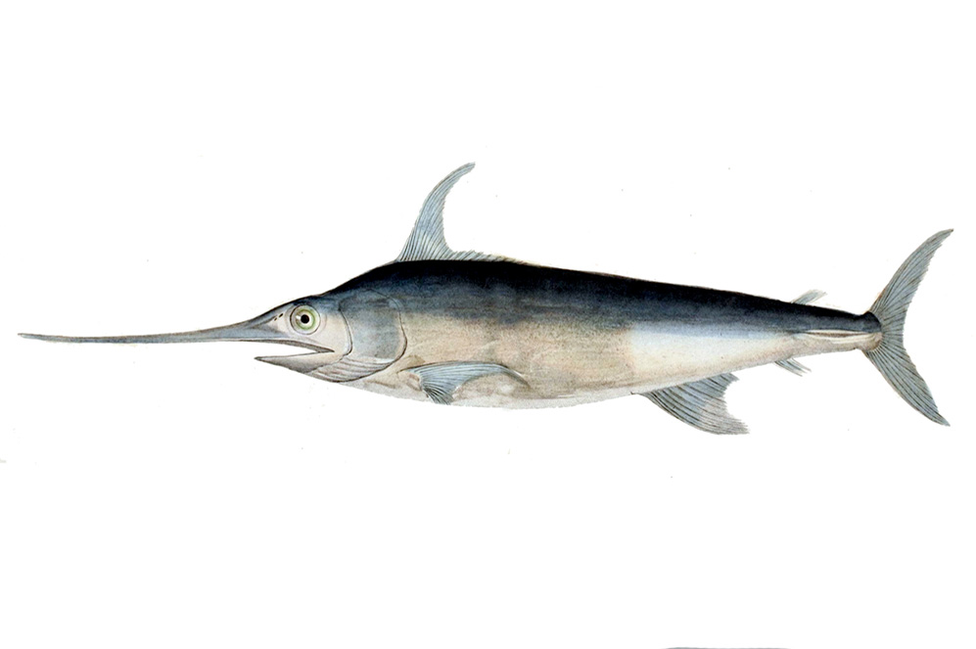
Alfred C. Glassell Jr. Hall

First Floor, Main Entrance

Vocabulary:
aquatic, adaptation, biodiversity, niche, environment, ecosystem, species, biome, biotic, abiotic, prey, predator, herbivore, marine, marlin, gills, fish, mammal, dolphin, carnivore

As you enter the Glassell Hall, examine the various examples of marine life. The biggest specimen on display is the marlin, against the far wall. Looking at the different features of the marlin, do you think it was a predator or a prey animal? Why?

Examine the animals on the ceiling. Among them are the bottlenose dolphin and the hammerhead shark. Use the Venn Diagram below to compare and contrast these two marine animals.

Many of the animals displayed here have different types of mouths. Use the chart below to sketch each animal’s mouth/jaw and briefly describe it.

Animal | Mouth/Jaw Sketch | Description

Why do you think these animals have different looking mouths?


The Welch Chemistry Hall

Lower Level

Vocabulary:
Periodic Table, elements, molecule, atom, matter, conductor, insulator, polymer, acid, base, pollutant, synthetic, natural, insulator, gravity, conductivity, super conductor, energy, thermal, electrical, oxygen, nitrogen

Energy Identification
Have students explore the Welch Chemistry Hall, identifying one object for each type of energy they are studying (mechanical, sound, electrical, light, heat/thermal). Then, for each object, explain the characteristics that make it fall under its specific category of energy.

Type of Energy | Object | Characteristics
Mechanical Energy
Sound Energy
Electrical Energy
Light Energy
Heat/Thermal Energy

Atmospheric Multiplication
Have students observe the lights on the ceiling. Tell them that they represent the particles in the air they breathe. Point out that most of the light fixtures have two bulbs of the same color. Ask students to write a word problem that will help them determine the total number of light bulbs in the ceiling.

Matter in Motion
Examine the ping pong balls at the Matter in Motion station. Explain to students that each ping pong ball represents a molecule in a solid, liquid, and gas.
- What will happen when air runs through the molecules in each tube?
- What would happen if you filled the containers with actual sand, water, and fog, respectively? Would the shape of the matter change or stay the same? How do you know?

Solar System

Outside Main Entrance

Vocabulary:
solar system, gravity, orbit, revolve

Fractions of Planets
The Earth is ¼ the size of what other planet in our Solar System?

Greatest to Least
Rank the planets in size from greatest (largest) to least (smallest).

