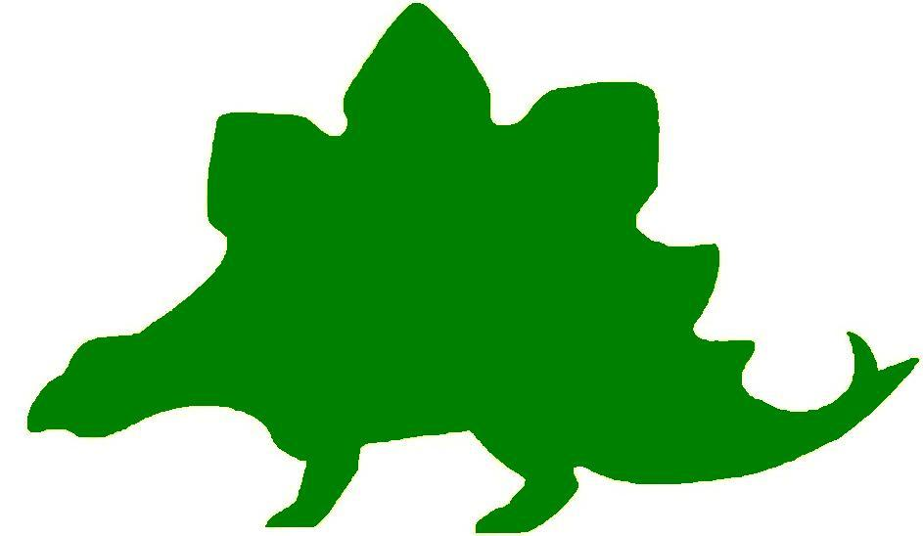
theHoustonMuseumofnaturalscience

4th Grade Extension Activities

McGovern Hall of the Americas

Third Floor
Dressing as a Native American
Ask students to create an Arapaho beaded vest or a Plains dress. They may decorate it with geometric designs, special objects, and colorful paint. The bead design may be planned on a sheet of graph paper and students may use colored pencils to color in the squares to create the design. Provide brown paper grocery bags for students to cut the shape of the vest or the dress. Using the graph paper design as a guide, students may attach real beads using drops of glue or use circles of tempera paint to represent them. They may add metal objects, buttons, shells, feathers, and colorful ribbon to complete the decoration.

Ceremonial Rattles
Have the students create a rattle that might have been used in a Native American Indian ceremony and decorate it with designs like those seen in the exhibit hall. Rattles can be made by shaping paper mache around a burned out light bulb and then tapping it on a solid surface to break the bulb inside. Students may add a handle and decorate it. Colored markers or tempera paint can be used to make colorful designs and ribbon, yarn, beads, buttons, and shells can be used for added decorations. Ask the students to write a story describing the ceremony in which the rattle is used.

Pottery Patterns
Tell the students to choose 5 geometric shapes they have studied in math. They are to create an interesting repeating pattern with the shapes by drawing them on graph paper to assure that the sizes remain consistent. Tell them to design a pot similar to one they saw displayed in the exhibit. They should decorate it with the repeating pattern they have created.

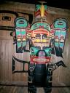
Seeing Double
Ask the students if they noticed that when they looked at the totem, the design was symmetrical. If you folded the totem in half, its design would be the same on both sides of the fold. Tell the students to think about what they learned about totems and the animals that were used to decorate them. Have students create their own totem by folding a sheet of white paper in half. They should draw half of at least four animals on the left side of the fold and trace over them with a black crayon. Have them refold the paper and press both sides together until an impression of the animals is imprinted on the clean side. Then they will trace over the impression and finish the totem by adding bright colors to the animals.

Hall of Ancient Egypt

Third Floor
The Best Ruler EVER!
Remind the students of what they learned about rulers in Ancient Egypt. Split the class in half and have each group research either King Tut or Queen Cleopatra. Have the students find out about their time as rulers of ancient Egypt. Have a debate so that each side stands up and gives information about their ruler. Then, as a class, vote on who they felt was the best ruler of ancient Egypt. Note: Each side might be biased as to their ruler so you, the teacher, are the final decision maker!

Sarcophagus Time Capsule
While visiting the Hall of Ancient Egypt, students viewed several sarcophagi. Remind them that each one was unique in its own way. The drawings and the faces painted on these sarcophagi represented the person who was placed in them. Tell the students you are going to make a school sarcophagus time capsule. Provide a nicely sealed container that the students can decorate. They should decorate it with pictures and words that represent the school and their classroom. Inside the container ask the students to bring pictures or items that they feel represent them in 4th grade and maybe something about their school. Tell students they will not see these items for a year. They can even write notes to themselves about what they predict their future might hold in a year’s time! Plan a time during their 5th grade year to get together as a class to open their sarcophagus time capsule and look at the items they buried. Ask them if they think these things are still representative of them and the school.

Strake Hall of Malacology

Second Floor
Mollusk Menu
Mollusks are a popular item on most restaurant menus. Ask the students if they saw some familiar names of mollusks while walking through the exhibit. Instruct them to create a menu with at least four mollusks as featured entrees and write a description to explain how they will be served. They should add prices and illustrations to make the menu more realistic.

Shopping for a Home
Ask the students to write a story about a hermit crab that is looking for a home. They should include some details as to the kind of house it is looking for. What kinds of places does it try before finding just the right home? Have the students publish their stories as a picture book with no words. Trade picture books to see if others can “read” the story.

Buy My House
Ask the students to write an advertisement to persuade an animal to pick one of the shells from the exhibit as their home. What does it have to offer that this animal might like to have in their perfect home? Tell the students to draw the inside of the shell showing the rooms of the house and how it is decorated. They should include the animal in the drawing.

Surprise!
Students should pretend they have found a shell and put it in their pocket after a day at the beach. Suddenly, at dinner, a hermit crab pokes its head out of their pocket. Have the students write about what happens next.

Perfectly Equal
Ask the students if they noticed that many of the mollusks exhibited in the Museum were symmetrical. Tell them to create a newly found mollusk. They should make sure that it has two parts that are perfectly symmetrical. Ask students to give their mollusk a name and describe where it was found in Texas.

Cullen Hall of Gems and Minerals

Second Floor
Angular Finds
Using right, acute, and obtuse angles, ask students to create their own valuable gem or mineral. They should use vibrant colors and combine crystal shapes to make it interesting. Ask them to name the gem and describe where in Texas it might be found.


Rocks for sale!
Tell students to create an advertisement for the gem or mineral that they discovered. Encourage them to use descriptive words to make their “rock” marketable.

Texas Hall of Wildlife

Second Floor
Soil Composition
Tell students that some soil is better for plants to grow than others. Tell them to think about the Farish Hall of Texas Wildlife. Which regions had the most plants? Which had the least?
Students will then conduct an experiment with different soil types. Each student group will be given four small cups and four plant seeds. They are going to plant a seed in each cup. The first cup will be filled with potting soil, the second will be filled with small rocks, the third will be filled with sand and the fourth will have nothing in it but the seed.
Have students make predictions in their science notebooks, take turns watering their seeds, and record the plants’ growth over time.
Conservation Web
Assign each student group a different biome that was covered in the Farish Hall of Texas Wildlife. Students will research the region and make a food web for that region.
Then, assign each student a disaster. The disaster could be natural, such as a wildfire, or man-made, such as deforestation or over-hunting. Students must revisit the food web and modify it to show the impacts of the disaster. Then, students should discuss possible solutions to restore balance to their ecosystem.
Don’t Eat Me!
Remind students that many of the animals they saw in the exhibition were predators. Review the list of adaptations that students made and talk about whether they help animals survive attacks, find food, or something else. Then, read Aesop’s fable, The Lion and the Mouse. Ask students to choose one of the Texas predator animals they saw in the exhibit and imagine it in a similar situation. Students will write a persuasive paragraph from the point of view of the animal about to be eaten to convince their captor to spare their life.
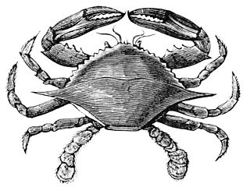

Hamman Hall of Texas Coastal Ecology

Second Floor

Stop the Cycle
In one of the videos students saw in the exhibit, the narrator talks about the “never ending cycle” of picking up trash that has ended up in the ocean. Allow time for students to research cleanup methods and/or local recycling options. Have students work as a team to design a banner that can be displayed in the hallway illustrating environmentally friendly techniques and why they are important.

Spinning a Food Web
What do we eat? Chances are students have consumed both plant and animal products, making us omnivores. Discuss with students the difference between herbivores, carnivores, omnivores, and detrivores. Divide students into groups and assign each student a role based on the diagram on the following page.
Using string or twine as a visual representation of links, have students determine what they would eat/who would eat them and link themselves in a complex food web.
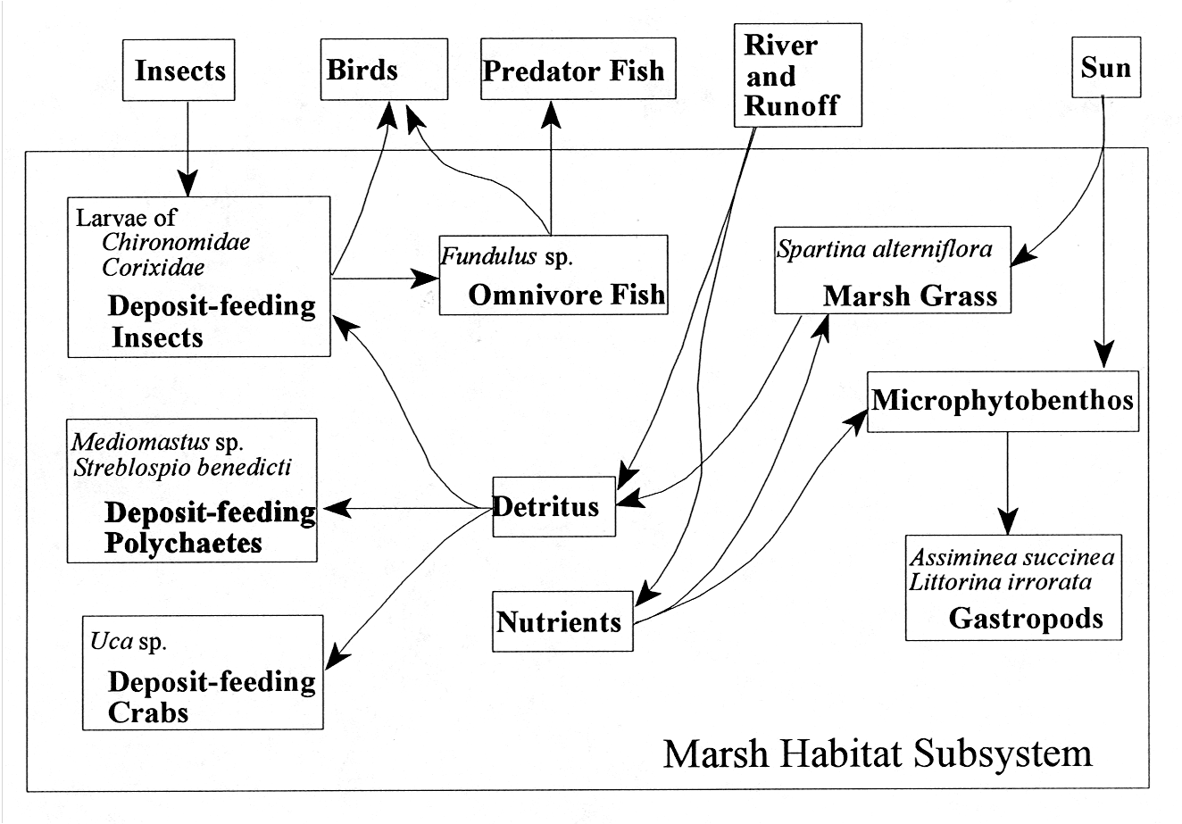
The Moon Made Me Do It!
Discuss with students the importance of gravity. What kinds of things does gravity affect? Point out that gravity affects water (pour a glass of water out- why does it fall?), and that this includes the water of the oceans around the world. It’s not just the Earth that has gravity- the Moon also exerts a force.
Illustrate this by having students sit in a circle, representing the water around the earth. One student is the “Moon” and moves around the outside of the circle. As the Moon passes students seated, they should lean in the direction of the moon (high tide). For further illustration, discuss what is happening on the side of the earth farthest from the Moon. What other forces are involved?

Frensley Hall of African Wildlife

Second Floor
Survival of the Fittest
Discuss with students the characteristics that help animals survive in their environment. Ask them to think back to their visit to the Museum, and how the animals were depicted. What natural attributes did nature equip the animals with in order to hide or escape from their enemies, defend themselves, and find food? Divide the students into groups of 3 or 4 and instruct them to draw a mural to illustrate the ideas generated in the discussion. Groups may be assigned different environments in Africa so that all of the ecosystems that exist on the continent will be represented.

Watch My Feet!
Tell students to use the information in the bird feet description chart to make three examples of feet using pipe cleaners. They should create an environment in which the feet might be found. The display should demonstrate how the shape of the feet helps the bird to survive. Have them write a “text panel” to explain their display.

Help! I Have Lost My Ecosystem!
Write the name of each of the regions of Africa (Congo, West Africa Tropical Forest, Serengeti, Okavango, Lowveld, Sahara, and Ethiopian Realm) on a large sheet of mural paper. Divide the class into seven groups and ask them to draw the environment of each region using information gained from the exhibit and additional research. Bring the class back together and ask them to write the name of one of the animals or birds they saw anywhere in the exhibit. Collect the names and distribute them randomly over the environment murals. Ask the students to return to their murals and look at the animals that have now landed in that environment. Students will draw the animals. If they naturally belong in the environment, they should be placed there. If they do not naturally belong, students must decide how the animal can be adapted to survive in the new environment. They might change their size,
In Danger
Many of the animals in Africa are threatened because of loss of habitat, human disturbance, predator changes, illegal hunting, etc. Ask students to work in groups and create a class chart of animals that are endangered, threatened, rare, or extinct. Under each category, include the name of the animal, cause of problem, and a proposed solution.

The Morian Hall of Paleontology

First Floor

Meet the Press
Give the students a list of the kinds of scientists that work at a dinosaur dig. Some suggestions are geologist, paleontologist, paleolife artist, paleobotanist, geochemist, mapping expert, etc. After researching one of these scientists, ask students to write a job description of that scientist and tell why they are important to the dig. Next, students will present their scientist to the class. They may dress as the scientist and carry objects related to their field of study that might be necessary on the dig. Students should be prepared to field questions as if they are being interviewed by the press.

Interview a Dinosaur
Ask students to choose any dinosaur they wish to research. Using the facts they have learned, they will write an interview between a paleontologist and a dinosaur. In the interview, the dinosaur should answer questions about what its name means, what it looks like, its prey, its enemies, what era it lived in, what part of the Earth it roamed, an interesting fact, etc.

Era in a Box
Discuss how plants are clues to the age when specific dinosaurs lived. Students should pick an era and research the plants that might have grown at that time. They will create a 3D environment using a box by drawing or painting the background and adding 3D objects. They should include prehistoric animals, volcanoes, swamps, trees, plants, rocks, and anything else that might have existed in that era.

I’m Bigger than You Are!
Ask the students to research the size of prehistoric creatures that might have lived in Texas. There were at least four displayed in the Museum. Using the information, they will create a bar graph showing the size of various prehistoric inhabitants of Texas and decorate it with drawings of the creatures.

What are you?
Discuss how dinosaurs are named. Explain to the class that their names come from where they lived, something unique about their body, where they were found, or the name of the person who found them. Instruct students to cut out five pictures of different objects from magazines or flyers. Collect the pictures in a container and have each student randomly select five pictures. Instruct the students to arrange and glue all five pictures on a sheet of paper to create a “new” dinosaur. Students may use markers or crayons to add any details to complete their dinosaur. They should name the dinosaur according to the criteria “something unique about their body”. Display the new species of dinosaurs in a collection entitled “Dinosaurs We’d Like to See”.

Wiess Energy Hall

First Floor

Make Mine Plastic
Allow students to research products produced from petroleum. Instruct students to create a collage using items cut from magazines and newspapers showing the many, varied products that result from petrochemical processing.

Energy Options
Energy comes from power created by a variety of sources. Create a chart of energy sources including gasoline, battery, wind, sun, water, nuclear etc. Allow students to draw or find pictures of objects that run on one of the sources of energy and place it in a column under the appropriate source. Have a class discussion as to what energy source seems to be used the most.

Pick Me! Pick Me!
Assign teams of students a type of energy. It could be renewable, nonrenewable, or alternative. Have each team research their type of energy and present to the class the reasons why their type of energy is the best for future use. After all energy sources are presented, have the class vote on their choice for the best energy source of the future.

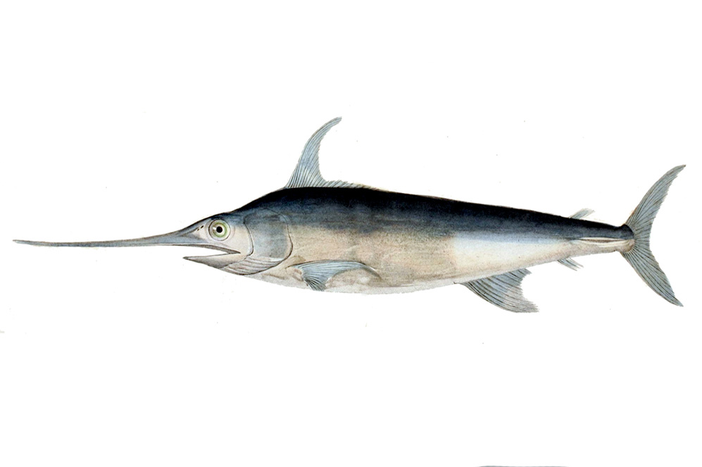
Alfred C. Glassell Jr. Hall

First Floor, Main Entrance

Species Spotlight
Within this hall, you witnessed a wide variety of marine species. Now you are going to be creating a brochure for one of these animals, highlighting its different characteristics. Pick your favorite and research the following: appearance, diet, habitat, predators, and defense mechanisms. Create a tri-fold brochure teaching your classmates about your animal.

Class Aquarium
You are going to be turning your classroom into a giant aquarium. Split students into groups and assign each group a different category: marine mammals, predatory fish, coral, mollusks. Each group will use a large shoe box or cardboard box to create a habitat for their category, including everything needed for survival.
Once complete, display the aquariums around the room and lead a discussion on how elements of each category should be similar throughout all the groups.

Ocean Conservation
The ocean is in danger, and so are the species that call it home. Assign student groups a different conservation problem to solve and have them brainstorm possible solutions. Then, as a class, choose the best solution and put it into action.

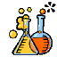

The Welch Chemistry Hall

Lower Level
Mixtures and Solutions
Students will be experimenting with different mixtures and solutions. Give student groups five different cups of water. Tell them that something new will be added to each cup and they must determine whether it forms a solution or not. Give each student group the following materials to mix into their cups: sand, salt, sugar, lemon juice, cocoa powder. When they put the material into the glass tell them to stir thoroughly and then watch what happens.

Energy Identification
Remind students of the different energy sources they identified in the Chemistry Hall at the Museum. Split students into groups and have each group focus on a different kind of energy: mechanical, sound, electrical, light, and heat/thermal. Each group is responsible for finding as many examples of their type of energy as possible and presenting it to the class as a whole, along with why their type of energy is the most important.

