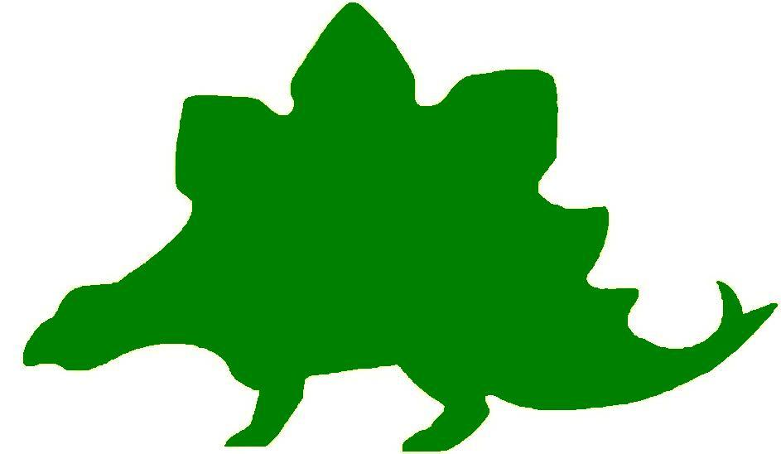
theHoustonMuseumofnaturalscience

3rd Grade Knowledge Hunt
Dear Educator,
Thank you for downloading the free, online curriculum available at HMNS! We’re thrilled to see that you are including the world-renowned Houston Museum of Natural Science in your educational toolkit.
Here at HMNS our mission has always been to provide exemplary educational opportunities for the community. Providing educators like you with free, fully editable curriculum is just one of many ways we are fulfilling that mission.
Thank you again, and we hope you enjoy your field trip to HMNS!
Best,
The HMNS Staff

How to use this guide:
- Feel free to edit the questions as needed to suit your student group.
- The Knowledge Hunt is structured to begin at the top of the Museum (floor three) and work its way down to the lower level.
- Visitor services and security staff are posted around the Museum and will be happy to assist you in finding any of the locations mentioned.
- Please ensure that one chaperone is with every group of ten students at all times as they complete these activities.
- Don’t forget to download our extension activities for use in the classroom when you return from your trip!

Please direct any and all questions to curriculum@hmns.org

3rd Grade TEKS Objectives

Each of the following TEKS Objectives are met as students explore the various exhibit halls and complete the Knowledge Hunt:

Science: 3.1 (A, B), 3.2 (C, F), 3.3 (A), 3.4 (A), 3.5 (B, C, D), 3.6 (A, B, C), 3.7 (C, D), 3.9 (A, C), 3.10 (A, B, C)
Social Studies: 3.1 (A), 3.2 (A, B), 3.3 (A, B, C), 3.4 (A,B,D), 3.5 (A,B,C,D),
3.7 (A,B,C), 3.9(A,B), 3.12 (B), 3.14 (A,B), 3.15 (B), 3.16 (A,B,C,E), 3.18 (A,B)

ELA: 3.4 (A,B,C), 3.7 (C), 3.8 (B,C), 3.9 (A,B,C,E,F,I,J),
3.10 (B,C), 3.11 (A), 3.12 (A,D,E,G,H,J), 3.13 (A),
3.14 (A,B,C,D), 3.15 (A,B), 3.16 (H), 3.17 (A,B,C,D,E),
3.18 (A,B,C,D,E,F), 3.19 (A,B,C,D,E), 3.20 (B,C,D)
Math: 3.2 (B,C), 3.3 (A,B), 3.4 (A), 3.8, 3.9 (A,B,C), 3.11 (A,B,C,D), 3.13 (A,C), 3.14 (A,B,C), 3.15 (A)

McGovern Hall of the Americas

Third Floor

Vocabulary:
climate, resources, ritual, heritage, environment, survival, invention, traditional ceremonies, ancient, ancestor, feasting ceremonies, images, family crest, kiva, constructed, plaza, courtyard, kachina, patriotic, tipi, mural, symbolize

Introduction to Archaeology
From looking at the stone tools in the case, what do you think archaeologists learned about the community that used them?

Draw one of these ancient tools.

Do you think any community still uses tools like these in the present? Explain your answer.

Clothing and Culture
The type of clothing people wear depends on their climate and resources. Look at #4, Woman’s Parka, in the case. What can you tell about the climate where this parka is worn? How do you know?

Ritual and Religion
Masks have been used for 2,000 years so the audience watching a dance will think of the dancer as something different than a person. In Mexico today, these mask dances connect the heritage of the past with that of the present. Look at the masks. What animal do you think is represented by masks #3 and #6?

The Arctic
Look at the display with the kayak. The people of the Arctic depend on hunting for their food, clothing, and tools. What role do you think the environment plays in their survival?

How do you think the invention of the snowmobile affected the life of the people of the Arctic?

Inuit Children
Why do you think children in the Arctic received small versions of objects they would need to know about when they were older?

Name three small versions of things you see in the case that they would need to know how to use later in life.
1.
2.
3.

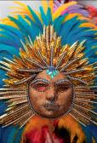

Masks
These objects were used in traditional ceremonies. Why do you think modern Yup’ik, who live in Alaska, are still performing the ancient ceremonies of their ancestors?

Ivory
Ivory carving has been an important activity for 1,000 years. Why do you think people in the Arctic carved things out of ivory instead of wood?

Why do you think wood was scarce in the Arctic?

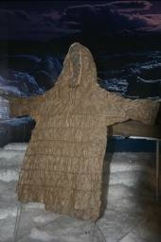

Parka and Women’s Items
How did the native people in Alaska and Canada use the resources of the area to make their clothes?

Feasting Traditions
List five foods that the people of the Northwest Coast eat during their feasting ceremonies.
1.
2.
3.
4.
5.

Why do you think the handles of tools and cooking items were decorated with animal images?

The Potlatch
The potlatch is a Northwest Coast ceremony to celebrate marriage, birth, and death, or when someone receives an honor or moves into a new house. There are speeches, feasts, dances, and the display of a family’s crest. A family’s crest is decorated with animals that symbolize things that are important to a family. What three animals do you see in the Kumugwe’ Mask shown here?
1.
2.
3.
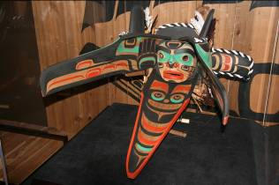

Transformation Mask
Do you see two animal images in this one mask? Explain how the transformation mask works.

Totem Poles or House Posts
The totem pole or house post contains the animals in the family crest. It is placed at the back of the house. What animals do you see in this family crest?

Chilkat Blanket
Read the text panel to find out what the Chilkat Blanket is made from. What were the two materials? Why do you think those materials were used?
1.
2.

The Southwest
Compare and contrast the environment of the Southwest to the environment of the Arctic. Think of how the houses were constructed, the clothing they wore, and the materials they used to make other artifacts in the exhibit.
Southwest | Arctic

Kiva
How did the stone and mud plaster walls help people who lived in the Southwest stay cool in the hot summers and warm in the cold winters?

Why do you think the communities of New Mexico and Arizona were built around an open plaza?

Homes in this area in 1250 AD consisted of rectangular rooms, a small courtyard, and a kiva. Draw a sketch of how this might have looked.

How would these types of homes been different from our homes today?

Read the quote below from the exhibit and answer the question that follows:
“Being a Pueblo person, I wonder if the people who lived at Sand Canyon Pueblo would have left so many things in view if they had known that 700 years later strangers (archaeologists) would be visiting their home.”
-Peter Pino. Pueblo Zia

Make a list of at least four things you see in the kiva.
1.
2.
3.
4.

Identify the four states you see on the map that come together in the Mesa Verde Region of the United States.
1.
2.
3.
4.

Why do you think this area is called “Four Corners”?

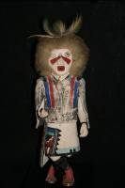

Hopi Kachinas
Kachinas are spirit beings that represent everything in the Hopi Universe. Which one in this case is your favorite? Draw, name, and describe it.

Zuni Pottery
List five animals that you see as decorations on the Zuni pottery.
1.
2.
3.
4.
5.

Draw an example of Pueblo pottery and Zuni pottery in the space below.

Pueblo Pottery
Look at the pottery in the Zuni case and the Pueblo case. Write three reasons they are alike and three reasons they are different.

The Plains
Why do you think great herds of buffalo were able to live in the Plains?

Horse Culture
Why were the Southern Plains tribes able to control the horse trade?

Beading
What patriotic symbol do you see on one of the vests?

Tipi
Why was the tipi a practical type of shelter?

The Southeast
If the Mississippians had no writing system, how do you think they were able to keep records?

Ancient Traders
Why was the location of Spiro important to its success as a trading center?

The Aztecs
Look at the mural of the Aztec city of Tenochtitlan. Today it is Mexico City. Think of four ways that it looks the same as a present day city and four ways it looks different.
Same Different
1. 1.
2. 2.
3. 3.
4. 4.

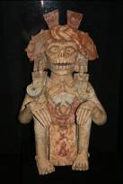

Skeletal Deity
Look at this object and think about how it might have been used to teach children to behave.

Maya
The Mayans are one of the oldest people that still exist. Look at the jaguar statue. The jaguar is the largest native land animal in Mesoamerica. Why do you think the Mayans picked the jaguar to protect their cacao orchards?

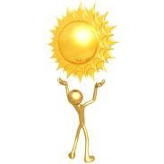

Andes
The people who lived in the Andes chose gold to symbolize the creator of their world, the sun. Give two reasons why you think gold was a good choice to symbolize the sun.
1.
2.

Hall of Ancient Egypt

Third Floor

Vocabulary:
civilization, century, decade, ancient, floodplain, climate, hieroglyphic, pharaoh, invasion

Egypt Gift of the Nile
What two natural occurrences helped establish Egyptian civilization over 5000 years ago?
1.
2.

What type of “government” ruled Egypt?

Timeline of Egyptian History
Approximately how many centuries did the Ptolemaic Egypt last?

Look at the timeline, how many centuries are represented? How many decades?

Egypt’s Ancient Roots
What two things laid the foundation of what came to be known as ancient Egyptian civilization?
1.
2.

What event encouraged ancient people to leave the dry desert land for the Nile floodplain?

Map: Egypt
Label the map with the 12 places listed below and include a compass rose. Use the text panels throughout the exhibit to help you locate the areas listed.

Lower Egypt Upper Egypt Nile River Red Sea
Mediterranean Sea Alexandria Thebes Memphis
Rome Italy Greece Jerusalem



Scripts and Writing in Egypt
Define hieroglyphic

Pharaoh Lord of the Two Lands
Who was the most powerful person in ancient Egypt?

What were the king’s responsibilities to his people?

Strake Hall of Malacology

Second Floor

Vocabulary:
gastropod, mollusk, bivalve, octopus, tessellate, fossil, microscope, microscopic, carnivore, herbivore, omnivore

Class Gastropoda
What would you find in your garden that is a part of this very large class of creatures?

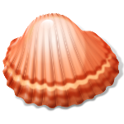

Marine Mollusks of Padre Island, Texas
Bivalves have two flattened parts that are connected by a hinge and held closed by teeth along the edge. Look at the mural of Padre Island, Texas. Name three marine mollusks that you would find that are bivalves.
1.
2.
3.

Find a bivalve in one of the cases to sketch.

Draw a mollusk that you might find if you were walking along the beach in Galveston.

Class Cephalopoda
Look at the model of the octopus in the case. What do you see that would allow it to attach to hard and soft surfaces?



Family Conidae (Cones)
Find #10, Tessellate Cone, on the numbered placement text panel. The word “tessellate” means to form a square pattern. Now look at the cone shell with that name. Do you think it is a good name for that cone shell? Why or why not? Draw a sketch of the shell and write where it may be found.

Family Cypraeidae (Cowries)
Find a cowrie shell with an animal name on the numbered placement text panel. Look at the corresponding shell in the case and give a reason why you think it was named after that animal.

Shell name:
Where found:
Reason for name:

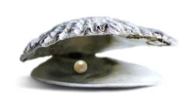

Oysters and other Mollusks that Make Shells
Using the shells displayed in the case as an example, draw a shell and the pearl it might produce.

Fossil Mollusks
In the mural to the left of the fossil mollusks, identify two creatures that lived 144-213 million years ago that are similar to creatures that live today.
1.
2.

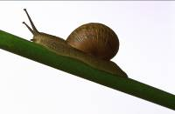

Microscopic Snail Shells
Why do you think scientists must use a microscope to see micro-mollusks? What part of the word “micro-mollusks” helps you know that?

Family Cypraeidae (Cawries)
At one time, cowrie shells were used as money. Use the numbered placement text panel to find the cowrie that has money in its name. If cowries were still being used for money, how much do you think this shell would be worth? Think about its size and color when you are assigning it a value.

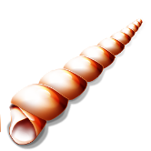

Family Xenophoridae (Carrier Shells)
If you were searching for this type of shell, what state would you need to visit in order to find it?
Write the name of the shell, the state where it could be found, and make a sketch of it.

Using the information in the numbered placement text panel, is it more likely, less likely, or equally likely that you would find carrier shells in another state? Circle your answer choice and explain.

Family Ranellidae and Personidae (Tritons)
Use the numbered placement text panel to help you find a shell you might see on the beaches in Panama. Write the name of the shell and make a sketch of it.



Family Volutidae (Volutes)
Use the numbered placement text panel to find Sowerby’s Volute and Hunter’s Volute. Estimate the length of each. Pretend that you found these two shells while vacationing in Australia. Write an addition or subtraction story problem that uses this information.

Rarites and Classics
Look at the shells in each of these cases and find one in each case that you might like to find on a beach. Draw a sketch of the shell, write its name, and tell where it might be found.
Rarities Classics

Snail’s Teeth
Look at the magnifications of snail’s teeth. Why do you think a carnivore would need fewer teeth than an herbivore or omnivore?

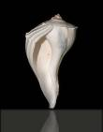

World’s Largest Snail
The Australian Trumpet measures 30 inches. If you found one that was ½ that size, how large would it be?

Family Pleurotomariidae
Use the numbered placement text panel to locate the Candelabrum Whelk that was found in Port Isabel, Texas. How many inches long do you think it is? Walk around the case and look at all sides. Do you see the piece that might have been the “door” for the creature that lived there to come in and out?

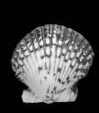

Family Pectinidae (Scallops)
Look at all of the scallops displayed in the case. Can you find one that is an example of symmetry? Draw it. Look on the numbered placement text panel to find its name and where it can be located.

Cullen Hall of Gems and Minerals

Second Floor

Vocabulary:
two–dimensional, three-dimensional, symmetry, triangle, rectangle, area, perimeter, cube, congruent

Gold “Dragon”
When you first come into the Hall, look for a gold shape in a case. Someone looked at its shape and thought it resembled a dragon. What do you think? Do you see a head, tail, arms, etc.? Write five details about the shape and make a sketch that you will use later in an extension activity.
1.
2.
3.
4.
5.

Case 16-Galena on dolomite
Look at the large rectangular shaped galena. If the length of two sides is 3 inches and the length of the other two sides is 4 inches, write a problem to figure out its area. Remember that the equation for area is length X width = area. (l x w = A)

Case 26-Cerussite
This mineral is nicknamed “Japan Law Twins”. Can you think of a mathematical reason why it was given this nickname?

Case 33-Cerussite
Look at the cerussite. What does its shape remind you of? Make a sketch to use in an extension activity when you return to class.

Case 31-Quartz
Count the number of triangles and rectangles you see on this shape. Be sure to walk all around the case to see it from all sides.
Triangles _________
Rectangles ________

Case 42-Pyrite
Look at the large rectangular shape of pyrite. If the sides all measure 3 inches, can you find the perimeter? Use the formula length + width + length + width = perimeter to find your answer. Show your work below.

Case 41-Fluorapophyllite on stilbite
Estimate the number of cube shapes you see in the cluster. Walk all around the case and look at the mineral’s reflection in the glass to make sure you do not miss some of them.

Case 54-Mesolite
Look carefully at the mesolite in the case. As you look at it, use your imagination and think of what animal it reminds you of. Draw a picture of it. Add facial features, legs, tail, etc. to make it look like the animal.

Case 76-Hydroxylherderite
Find the two triangle shapes on the face of the mineral. Do you think they are congruent? Give evidence to prove your opinion.

Case 83-Elbaite
Look at the elbaite in this case. What geometric shape is it? What does it remind you of? Draw a sketch of the mineral and make a note on the sketch of the colors.

Farish Hall of Texas Wildlife

Second Floor

Vocabulary:
environment, protected, sanctuary, predator, prey, adapted

Coastal Wetland and Marsh
Point out the diverse bird species that exist in this region. Have students use the chart to draw how the body parts are different from one bird to the next. Then, ask students why they think the adaptations are helpful to the birds.
Animal | Legs & Feet | Beak | Feathers
Bald Eagle
Mottled Duck
Heron
Osprey
Egret

Ask students what would happen if the Osprey suddenly had webbed feet instead of clawed talons. What if the duck had a sharp, curved beak? How would their survival be impacted?
High Plains
Explain to students that this region is very different from the Coastal Wetlands and Marsh, though some similar species are present. Have students complete a Venn Diagram comparing and contrasting the High Plains to the Coastal Wetland and Marsh.

Guadalupe Mountains
Have students point out the different predator and prey animals. Then, ask them what would happen if you removed the Mountain Lion from the ecosystem. What about the Porcupine?

Piney Woods
Ask students if they have ever been in an area like this while outside. Have them describe what they see and explain how each of the following features helps its animals survive.
Feature | Helps Survival
Tall trees
Ferns
Lots of rain

Rio Grande Dry Forest
Tell students to spend some time observing the animals in this region. Ask them how many different predators they can find, and how many prey animals. Remind them that some animals might be predators and prey.
Ask students to describe the niche in which these creatures live. What physical characteristics of the niche allow creatures to survive there? Ask students to come up with four different examples.

Point out the cacti and explain that this region sees relatively little rainfall compared to many other regions in Texas. Ask students what they think would happen if there was a lot of rain.

Coastal Oak Motte
Read the text panel to the students. Explain that many birds migrate from Mexico to this region of Texas, and that it is a very dangerous journey. Ask students to predict what would happen if one of the two regions it migrates to was no longer habitable. Then, have students use the table below to list the different challenges they think the birds face and potential solutions
Migratory Problem | Possible Solution

Coastal Prairie
Look at the baby American Bison and its mother. Use the Venn Diagram below to compare and contrast the features of the adult and its offspring.

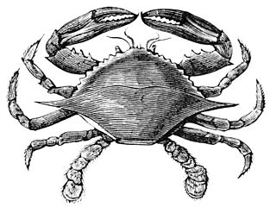

Hamman Hall of Texas Coastal Ecology

Second Floor

Vocabulary:
ecosystem, , ecology, tidal zone, population, bay, estuary, imprinting

As you enter the Hamman Hall of Texas Coastal Ecology, find Houston (Harris County) on the map of Texas. How close are we to the ocean?

What is ecology and why might coastal ecology be important to us?

Upper Coast

Oyster Reefs
Find the oyster reef display. Label everything you can see in the display as either “natural” or “man-made”. Don’t forget to include the background images!
Natural | Man-made

Middle Coast

Tides
What causes tides?

List the three tidal zones in order, beginning with the zone closest to the shore.
1.
2.
3.

Brown Pelican
Observe the series of maps that tracks Brown pelican populations over time. What do the larger circles represent?

Have Brown pelican populations in our area increased or decreased over time? What is this a result of?

Video
Watch the video at the end of the Middle Coast section from beginning to end. What is the problem here?

The narrator talks about a “never ending cycle” of picking up trash. How can we stop this cycle and protect our oceans?

Lower Coast

Texas Coast by the Numbers
What is the current human population in the 18 Texas coastal counties?
What is this population expected to be in the year 2050?
About how many more people are expected to live in the coastal counties in the next 35 years? Show your work.

Give an example of one of the laws passed to protect our bays and estuaries.

Kemp’s Ridley Sea Turtle
As you round the corner of the Lower Coast section, you will see a large turtle. Describe what she is doing.

When the baby sea turtles hatch, they will imprint, or “mark” the beach they are on as their home. In what ways do we “belong” to a certain area and call it home? Is our home always where we are born?

Frensley Hall of African Wildlife

Second Floor

Vocabulary:
desert, tropical rainforest, landscape, niche, ecosystem, diversity, species, extinction, realm, hooves, producer, consumer, scavenger, archaeologist, community

Africa Map
Look at the large map of Africa. You can see that the top of the continent is now a desert. Did you know that it was once a tropical rainforest? What do you think happened to the animals that once lived there?

Make a prediction as to what caused the change in Africa’s landscape.

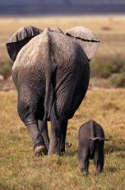

Living Together in Harmony
What is a niche?

Draw and label a picture that gives two examples of a niche.

Congo Exploration
What kind of ecosystem would you see if you explored the Congo?

Look at the okapi in the exhibit. Look carefully at its head, body, legs, and tail. It looks like a combination of what three animals. Name each animal and tell what part of the okapi came from that animal.

Animal Name | Animal Part

Equatorial Diversity
Why do you think species diversity is higher in the tropics than in any other kind of ecosystem?

Rainforest-A Threatened Resource
List three things you might do as a consumer to protect the tropical rainforest.

The Land of Sky-High Endemism
What fraction of Ethiopia’s animal species is threatened with extinction?

Ethiopian Realm
Create a Venn diagram to compare and contrast the Ethiopian Realm with the tropical rainforest.

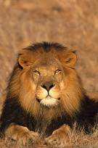

Serengeti – Feast or Famine
Aquatic species must live in or near water for what four reasons?
1.
2.
3.
4.

Look at the colors in the Serengeti and the tropical rainforest. Make a list of the most prominent colors that you see in each ecosystem.

Serengeti Tropical Rainforest
1. 1.
2. 2.
3. 3.
4. 4.

Sahara
Look at the exhibit. Write four things you see that are common in a desert ecosystem.

Compare/contrast the hooves of the Oryx to the paws of the lion. How are the hooves of the Oryx adapted to its life in the dessert and the lion’s paws adapted to its life in the savannah?

Lowveld
What role do plants play in the ecosystem of producers, consumers, and scavengers? What would happen to the ecosystem if the plants died?

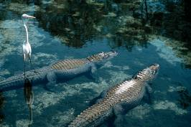

Okavango
What three animals in this exhibit are not seen in any of the other regions of Africa?
1.
2.
3.

What exists in this ecosystem that allows them to live in Okavango?

The Morian Hall of Paleontology

First Floor

Vocabulary:
vegetarian, learned trait, inherited trait, era, cast model, adaptations, landforms, extinct, carnivore, herbivore

Devonian Trilobites
As trilobites adapted to their changing environment, their inherited traits changed. Head over to the Devonian time period. Find the case of trilobites that contains six specimens, four of which are Drotops armatus. Describe the difference between the early Devonian and the late Devonian trilobites. Give a theory as to why they look different. Hint: think environment and predator/prey.

The Life of the Craddock Bone Bed
Take a moment to look at the environment these reptiles lived in. List the landforms you see.

Look at the animals that are depicted in the mural. List a few body features that worked perfectly with the environment. Describe the environment they live in.

A Triassic Pond in the Dockum Age
Look at the giant archosaur in the mural. He looks a lot like a modern day crocodile. Explain how his coloring blends in with his environment and discuss why that would be important.

Double Penguins: The Speedy Plesiosaurs
Look at the cast of the plesiosaur on display. In what type of environment would this creature live? Which adaptation do you see that helped you make your decision? Explain your answer.

The Dinosaur “Sitz-Bone” and the Pelvic Pounding
There are two major theories about the use of the pubic boot on the Tyrannosaurus rex. One theory is the bone was used so the t.-rex would not have to bend his knees down too far, he could “sit” on the bone. If he felt the need to spring up and run he could do so quickly. The second theory is that the bone was used to crush this enemy. Look at the three different T-rex specimens on display and chose the theory you agree with. Give two reasons defending the theory you chose.

Archelon
Look at one of the largest turtles in history, the Archelon. The Archelon could weigh as much as two tons and has large flippers to help him swim quickly in the ocean. Do you think this large turtle would have been comfortable living on land? Why or why not?

End Cretaceous: Death of the Dinosaurs
For many years scientists believed that a large meteorite crashed into the Earth’s surface setting off a chain of events that led to darkened skies, cooler temperatures and acid rain. Many scientists believe this is why the dinosaurs became extinct. With this disruption of the food chain dinosaurs lost their source of survival. However, several species of the time period continued to thrive. This puzzled scientists and a new theory was presented that possibly an invasion of a foreign species, which became pests, may have forced the dinosaurs to extinction. Think about these two theories and the fragile ecosystem. Which theory do you think best fits the “Death of the Dinosaurs’? Defend your answer.

Giant Bull: Mammut americanum
While they existed, early humans hunted mammoths and mastodons. Why do you think humans would have spent more time hunting these large woolly creatures over hunting animals like the saber tooth cats?

What would they have used the mammoth or mastodon for other than as a food source? List as many answers as possible.

Foucault Pendulum

First Floor

Watch the pendulum swing for a few minutes. The pendulum’s swing advances between two adjacent star points every four hours. There are 18 pegs between each of the star points. If the pendulum swings for eight hours, how many pegs will be knocked down? Write an equation below to show your work.

Create a new word problem using the information about the pendulum from the paragraph above or from the information touch screen at the rail surrounding the pendulum.

What keeps the pendulum swinging in a straight line?

Wiess Energy Hall

First Floor

Vocabulary:
plate tectonics, alternative, energy

Formation
At the entrance to the Energy Hall, watch the movie. What do you think happened to cause the Earth to change?

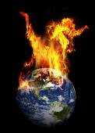

Energy Exploration Theater
Watch this fun video about energy. Energy that will be used up over a long period of time is called _______________________.

Energy that burns clean to make heat is called __________________.

Plate Tectonics
Using the touch screen, start in present day. Find Texas. Slowly move the curser back in time until you get to 86 million years ago in the Cenozoic era. Where is Texas now?

In general, oil is formed under water when microscopic marine animals and plants decay. Look back at the screen. Do you remember where Texas was during the Cenozoic era? Why do you think there is so much oil in Texas?

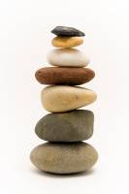

Rock Wall
Use the touch screen to view the layers of the rock wall. List three kinds of rock you see.
1.
2.
3.

Sources of Energy
As you tour the exhibit, complete the chart below with examples of renewable, nonrenewable, and alternative fuel sources.
Renewable | Nonrenewable | Alternative

Drilling
What is the difference between the tri-cone insert bit and the Hughes Simplex Dual Cone?

Energy Excursion Theater
Watch the video to find answers to the following questions:
What kind of power does a dam like Hoover Dam provide?

Offshore platforms help us get _________ and __________________ from deep under the seabed.

Splitting atoms creates what kind of energy?

____________ creates half of the electrical energy in the world.

Solar energy comes from the _______________.

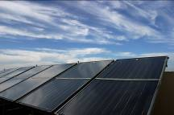

Alternative Energy Sources
Why are alternative energy sources important?

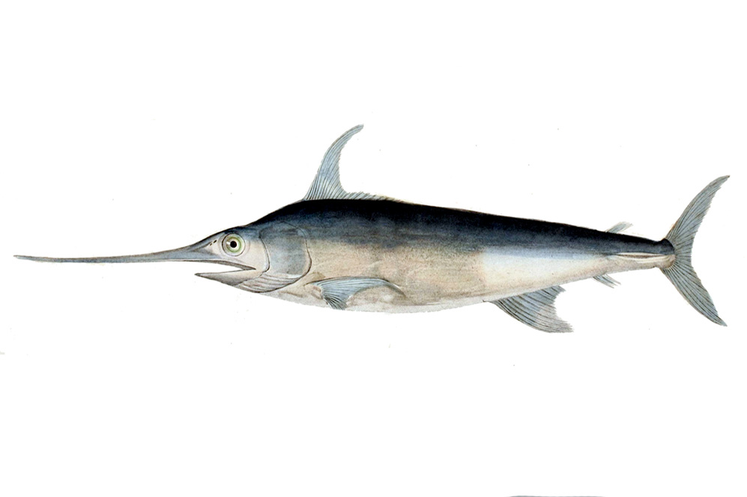
Alfred C. Glassell Jr. Hall

First Floor, Main Entrance

Vocabulary:
Adapt, aquatic, characteristics, environment, marine, niche, protected, predator, prey
As you enter the main hall, look at the ceiling. All of these animals are aquatic. You can identify them by looking at the text panel on the large pillar. Use the text panel and the chart below to find the animal on the ceiling and to identify the animal’s primary distinguishing characteristic:
Animal | Distinguishing Characteristic | Found? (Y/N)

Today our oceans are at risk. Use the touch screen by the stairs to learn about how oceans are being threatened. Then respond to the following questions:
What do you think is the biggest risk to marine animals?

How are humans trying to combat pollution in the oceans?

What do you think will happen to the animals on the ceiling if there is too much pollution? Why?

Go over to the big marlin on the wall. This marlin is a predator – it eats smaller fish. What do you think would happen if all of a sudden all of the marlins disappeared?

For each of the body parts listed below, indicate how the marlin uses it to survive:
Body Part | Use
Tail
Gills
Teeth
Spear

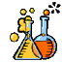

The Welch Chemistry Hall

Lower Level

Vocabulary:
matter, atmosphere, oxygen, gravity, mixture, density

Light Source
Explain to students that the air we breathe is made up of many tiny particles, and each of the lights in the ceiling represents a different particle. Have them identify the different colors of lights and fill out the chart below.

Light Color | Number of Lights

Once students have completed their chart, have them work together to create a two-step word problem in the box provided.

Creating Mixtures
Observe the self-assembly station. Tell students that each tube contains different materials and invite them to watch the materials interact by turning the tubes. Have them explain whether each tube contains a mixture or not, and explain why.
Tube | Mixture? Y/N | Explain
Tube #1: Oil & Water
Tube #2:a lot of oil,some water, a lot of soap (surfactant)
Tube #3: a lot of water, some oil, surfacant

Heavy Metal
Bring students to the Heavy Metal station. Have them take turns describing the metal cylinders. Instruct them to pay particular attention to color, shine, the way the light hits it, etc. Have students predict what will happen when they lift the lever. Why is it better to use a lever than lift the whole thing by yourself?

Gravity Slime
Bring students over to the slime polymer station. Have students predict what will happen when you turn the tube upside down. After you turn the tubes, have students come up with possible explanations for what happened. How does gravity work on each item? What is different about them? What is similar?

Solar System

Outside Main Entrance

Vocabulary:
alignment, planets

Go outside the museum and find the solar system on the sidewalk in front. Look at where the sun is located in relation to the alignment of the planets. Read the information about the sun. How many Earths would it take to make a sun?

How many planets are between the Earth and the sun in their alignment?

List all of the planets in their order from the sun. Complete the chart with information about each planet.
Name of Planet | Diameter | Distance from Sun

