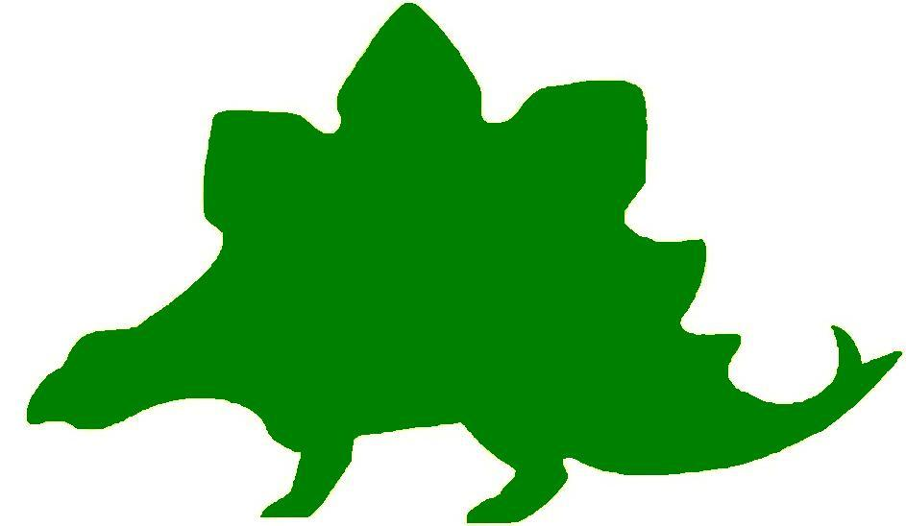
theHoustonMuseumofnaturalscience

3rd Grade Extension Activities

McGovern Hall of the Americas

Third Floor
Tool Time
Have students look at the drawings they made on their Knowledge Hunt of ancient tools discovered by archaeologists. Ask them to make two more drawings to show how this tool evolved over time to the form it is in today. Then ask them to create one more drawing of what they think this same tool will look like in the future.

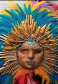
New Rituals
Give students a paper plate, a piece of yarn, and a variety of pieces of colored paper. Ask the students to create their own mask that might be used in a special celebration. They should show how the mask is worn and explain the celebration in which it would be worn.

When I Grow Up
Talk to the students about why Inuits might have given their children toy versions of things they were going to need to know how to use in real life. Ask the students to think about what they might like to do when they grow up. Have them create a toy that might be related to what they plan to do when they grow up. When they present them to the class, have students explain how this toy will help them “learn” about their adult occupation.

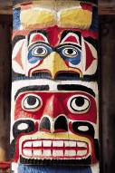
Family Totems
Allow students to research totem poles. If possible, have them find the significance of the animals that are carved into the pole. Give each student a toilet paper tube. Allow them to draw, color, and cut out animals to glue on the pole to represent their personal qualities or strengths. Students should think about the order their animals will be arranged and what story they will tell. Display the totem poles with explanations of the significance of the animals.

My Own Kiva
Next to the kiva in the exhibit is a text panel with the following quote from Peter Pino of Pueblo Zia.
“Being a Pueblo person, I wonder if the people who lived at Sand Canyon Pueblo would have left so many things in view if they had known that, 700 years later, strangers (archaeologists) would be visiting their home.”
Ask the students to think of their room at home. Have them draw their room as a kiva. Have the students write a story explaining how many things in their room would mystify archaeologists if they were to discover it 200 years later and attach it to the picture.

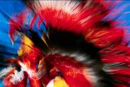
Childhood Challenge
Ask students if they recall reading the text panel about Counting Coup. Young men were considered brave if they were able to ride up to their enemy and touch them without harming them. Ask the students to think of something they might be able to do that would show they were brave. Have them write a story about the act of bravery and draw a picture to illustrate it.

Guardian Angel?
Ask the students to think about the large Standing Jaguar that was thought to be the guardian of the cacao orchards in Guatemala. The orchards were considered valuable because the chocolate made from cacao was considered valuable. Conduct a class discussion about why the Jaguar was a good animal to choose to guard something of value. Give students clay to use to make their own guardian figure. When showing the figures to the class, have students explain what their figure would guard and why it is valuable.

The Tin Deity
Remind students that the people who lived in the Andes chose gold to symbolize the creator of their world, the sun. Tell students to pretend that they used silver to honor the moon. Give each student a large square of heavy tin foil. Allow them to create something to honor the moon made of “silver”.

Hall of Ancient Egypt

Third Floor
You Can’t Get Me!
While visiting the Museum the students learned that the hot dry desert protected the ancient Egyptians from invasion. Have a class discussion about what other natural land forms might prevent areas of the world from being attacked. They should think about large bodies of water or even mountains. See if the group can come up with example by looking at world maps or globes for inspiration.
Has it been a Decade?
Remind the students of the timeline they saw in the Hall of Ancient Egypt. Remind them that so many things happened over time – even in short spurts of decades. Tell the students to think about what they might be doing in a decade. They will be 18 or 19 years old in about 10 years. Ask the students to write themselves a letter about what life is like for them today in 3rd grade. They should mention their favorite things to do, eat, study, and play. Before closing their letter they should mention what they hope they are doing at this moment ten years from now. Seal the notes in an envelope and send them home to parents. Ask the parents to save these letters. In 10 years, or one decade, they should give the letter to their children.
I’ve got Map Skills!
Give the students a labeled map of Egypt. Be sure the map includes a compass rose and a scale. Ask the students to use the scale to find out distances between Egypt and other countries shown on the map. Choose some of the locations that they labeled on their map at the Museum but also choose other areas of the world so that students can gain an understanding of not only how to use a scale, but of where Egypt is relative to other countries.
What does that Mean?
Students learned what a hieroglyphic was while visiting the Museum’s Hall of Ancient Egypt. Remind them that ancient Egyptians used this form of writing for many years. See if the students can come up with their own simple “hieroglyphic” words and symbols to create sentences. See an example below:
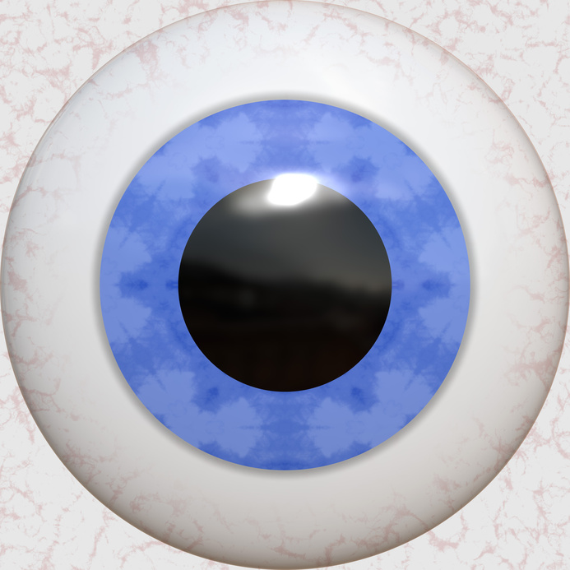

I Love You!

Strake Hall of Malacology

Second Floor

Shell Collections
Tell the students to look at the sketches they made of the shells they saw at the Museum. Have them draw a beach scene. On the beach, they should draw at least ten of the shells they sketched from the exhibit.

It’s Magic
Tell the students to look at their sketches and find their favorite shell. Ask them to draw the shell where it might be found. What if they found this shell walking on a beach one morning? Tell them that when they pick the shell up, a creature crawls out and tells them they will be granted three wishes. Have the students write a story about the events that happen after they find the shell. Include a description of the shell, the creature, and the three wishes in the story. Ask students to illustrate their stories.

Squeeze Me In
In The Mitten by Jan Brett, a large animal finds a mitten in the snow and tries to move in. Several other animals try to join him. Read the book to the class. Have the students write another version of the story using the shell as the house the creatures want to move into. Students should illustrate their story.

Same Sides
Ask students to look at their sketches of shells that illustrate symmetry. Ask students to draw and color some original shells that illustrate symmetry. Create a “Wall of Symmetry” to display the drawings. Ask the students to name their shells.

At Sea
Tell the students to pretend that they are walking on the beach one day when they suddenly began to shrink. The longer they walk, the smaller they become. Seagulls start swooping down, looking for dinner so they must look for shelter. They are small enough to fit into a shell, so they crawl in and fall asleep. Ask the students to write the story of their adventure.

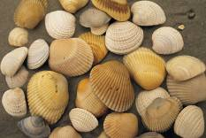
If You Build It
Tell students to pretend that many of our natural resources have been used up and that shells are now being used as building materials. Have students design and draw a building made completely out of shells. They should use some of the shapes from their Knowledge Hunt in their drawing.

Cullen Hall of Gems and Minerals

Second Floor

No Snowflake Twins
Instruct the students to look at the sketch of the mineral in case 29 from their Knowledge Hunt. Ask them if it reminds them of a snowflake. Are there any geometric shapes in their sketch? Remind students that no snowflake is alike, so their sketches will not be alike either. Ask the students to create a new mineral shaped like a snowflake that includes as many geometric shapes as possible.

Student Sparkles
Ask the students to look at their Knowledge Hunt and review the sketches they made of some of the gems and minerals displayed there. Tell the students to design a piece of jewelry that incorporates this mineral. Create a class jewelry store by displaying the drawings around the classroom. Allow students to write a description of their piece and assign it a price.

Let me have it!
Tell students to suppose they are spelunking and found one of the minerals that they saw while visiting the Museum. They reach to take it and realize there is a bat guarding it. Have the students write a persuasive speech they would give to the bat that includes five reasons why it should allow the mineral to be yours.

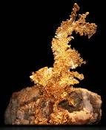
Gold Dragon
Ask the students to look at the details they wrote in their Knowledge Hunt that describe the piece of gold displayed at the front of the Hall called The Gold Dragon. Tell the students that they own the Gold Dragon. One day they take it out to dust it, and it suddenly comes alive. Ask the students to write a story about their adventure with their gold dragon.

Here’s My Opinion
Ask the students to look at their sketches and notes from the Knowledge Hunt. Have them pick the mineral that is their favorite. On a sheet of paper, ask the students to draw and color a picture of their favorite gem. Below the picture, have them write five facts and five opinions about their mineral.

Gem Geometry
Review with the students all the geometric shapes they are required to identify. Show examples or draw them on the board. Ask the students to create their own minerals to demonstrate their knowledge of geometric shapes.

Farish Hall of Texas Wildlife

Second Floor

Animal Encyclopedia
Split students into groups and assign each group a different region of Texas. Then, within the group, have each student pick a different animal to research. Students should research the animal’s physical characteristics, diet, defense mechanisms, etc. Each student will create an informational card about their animal. Then, as a group, they will create a poster about their region and put their animal cards on the poster. Posters will be presented to the class.
I-Spy
Tell students that one major adaptation animals have is camouflage. Ask them how animals would adapt to be camouflaged to the classroom. Give students construction paper and have them create animals that are adapted to survive in the classroom environment. The next day, have their animals taped around the room and see how many students can find.
Habitat Change
Split students into groups and give each group a sign that says a different region of Texas. Ask students to list as many animals as they can that live in the region. You may want to provide students with images of the animals. Then, take the sign and pass it to another group. Have students predict what would happen to each of the animals on their list in the new ecosystem. Would they survive? Would they have to adapt? How? Continue with each region.
Vanishing Species
Tell students that some of the animals they saw in the exhibit, like the jaguar, are no longer in Texas. Assign students different animals that have either gone completely extinct in Texas or are severely threatened. Have students research these animals and what happened to make them leave Texas. Then, have students create a plan for bringing the animals back to the state.
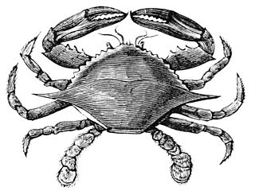

Hamman Hall of Texas Coastal Ecology

Second Floor

Stop the Cycle
In one of the videos students saw in the exhibit, the narrator talks about the “never ending cycle” of picking up trash that has ended up in the ocean. Allow time for students to research cleanup methods and/or local recycling options. Have students work as a team to design a banner that can be displayed in the hallway illustrating environmentally friendly techniques and why they are important.

Spinning a Food Web
What do we eat? Chances are students have consumed both plant and animal products, making us omnivores. Discuss with students the difference between herbivores, carnivores, omnivores, and detrivores. Divide students into groups and assign each student a role based on the diagram on the following page.
Using string or twine as a visual representation of links, have students determine what they would eat/who would eat them and link themselves in a complex food web.
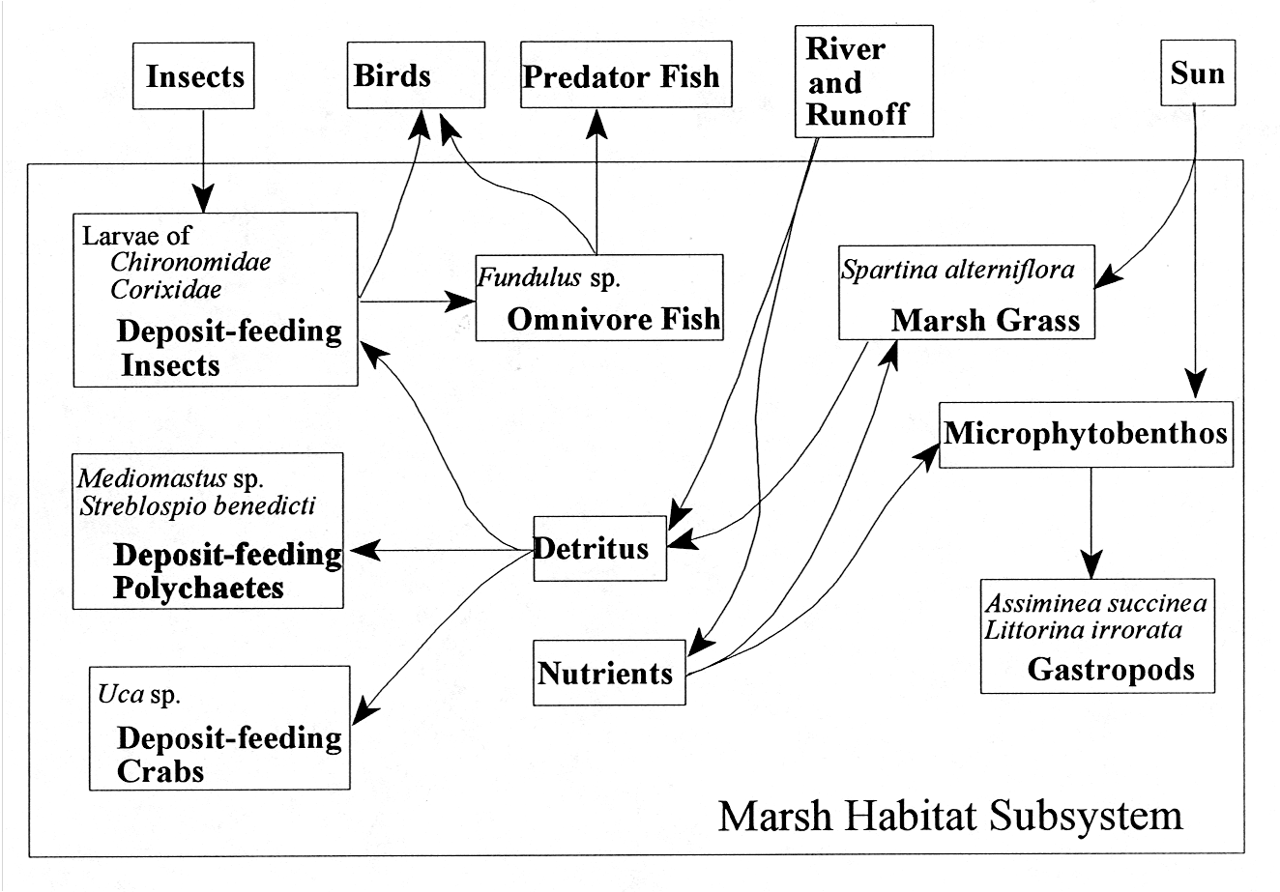

The Moon Made Me Do It!
Discuss with students the importance of gravity. What kinds of things does gravity affect? Point out that gravity affects water (pour a glass of water out- why does it fall?), and that this includes the water of the oceans around the world. It’s not just the Earth that has gravity- the Moon also exerts a force.
Illustrate this by having students sit in a circle, representing the water around the earth. One student is the “Moon” and moves around the outside of the circle. As the Moon passes students seated, they should lean in the direction of the moon (high tide). For further illustration, discuss what is happening on the side of the earth farthest from the Moon. What other forces are involved?

Frensley Hall of African Wildlife

Second Floor
Can you find me?
Provide a variety of pictures of environments. Find a desert, a forest, a farm, a swamp, etc. Try to find environments that are free of people and animals. Discuss with the students how all of the elements of the environment are necessary for an animal to live and reproduce. Use one of the pictures to talk about the details of the environment and the kinds of animals that might live there and why other animals can not. Let a small group of students pick one of the environments. On the back, they may list or draw all of the animals they can think of that would live there. Allow each group to present their environment and its animals to the class. The class can judge the animals as appropriately placed or not.

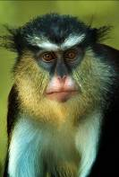
Who Am I?
Allow the students to brainstorm animals and birds they saw in the exhibit. They may refer to their Knowledge Hunt. Add more animals that live in Africa that might not have been in the exhibit. Write all the animals on a slip of paper and give each student one animal or bird to research. Ask them to find what kind of environment they live in, physical characteristics, prey, predators, etc. They can make animal cards with the information listed on them along with a picture.

What Happened?
Ask the students to brainstorm what they know about tropical rainforests. Make a list on the board. Then ask them to brainstorm all they know about desert regions. Make a separate list next to the rainforest. Remind students that the top portion of Africa that was once a rainforest is now a desert. Have students pretend to travel back to the time when Africa was a rainforest and draw how it must have looked. On the back of the drawing, have the students write their prediction of what might have happened to turn a rainforest into a desert.

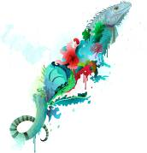
Girzehorse
Ask the students to look at their Knowledge Hunt to find the three animals that students believe make up the okapi. Allow the students to create their own “rare” animal for a class zoo. They may use as many animal combinations as they would like. A label should accompany each animal with its name and the country where it can be found.

Hidden in Plain Sight
Ask students to look in their Knowledge Hunt for the predominate colors in the Serengeti and the Tropical Rainforest exhibits. Have the students work in small groups to find five animals that might live in each environment based only on color. Each group will present their animals to the group and explain why that animal would fit into the environment. The group will vote the animal in or out of the environment.

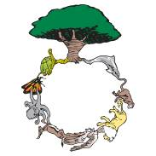
Circle of Life
Give students a sheet of paper and have them fold it in half. On one side, ask students to illustrate the role of producers, consumers, and scavengers, including plants as a producer. Then ask students to illustrate what would happen if one part of the circle was broken on the other side. They should write an explanation to accompany their drawings.

The Morian Hall of Paleontology

First Floor

Under the Sea
When the students first enter the exhibit hall, the display cases contain examples of trilobites. Have students draw the animal as it looked when it was alive.

Do they measure up?
Ask the students to research the estimated weight, height, and length of at least seven dinosaurs. They might be dinosaurs that students saw at the Museum or dinosaurs they are interested in learning more about. Have students create three bar graphs showing this information. Each graph should include a title and labels for the x-axis and the y-axis. Students should write three math problems to accompany their graphs.

Dinosaurs in the City
While visiting the Museum, students found prehistoric animals that lived in the Houston area, such as mammoths and mastodons and the giant armadillo. Tell them to think about what modern life would be like if these animals were still here. Let them talk about the problems that might exist. Review with the students the concept of cause and effect. Ask students to draw a picture of a modern city such as Houston with prehistoric creatures like the ones in the exhibit roaming freely in the city. Ask the students to write five cause/effect scenarios from their picture.

Where Did They Go?
Remind the students that they saw an explanation in the exhibit hall of one of the theories explaining what happened to the dinosaurs. Review the theory of a meteorite hitting the Earth’s surface. Ask the students to draw their own theory of the fate of the dinosaurs. If they can not think of an original theory, they may illustrate the one presented in the Museum.

Dinosaur Trading Cards
Allow students time to research dinosaurs using the internet and nonfiction books. Let the students pick seven dinosaurs that interest them. Make a list of the information students should look for such as size, weight, length, herbivore or carnivore, physical characteristics, etc. Tell students to gather this information as they read about the dinosaurs. Give each student a 3 X 5 blank index card. They will draw their dinosaur on the front and write its name on the bottom. On the back, they will put all of the facts they gathered. Students may keep their cards or trade them with their friends.

A Rural Mural
Remind the students that the world looked very different during the Mesozoic Era, the time when dinosaurs lived. Allow the students to pick one of the dinosaurs they have researched. Tell them to find other species that might have lived at the same time and the kind of plants that might have been found in that time period. Remind the students that they saw many plant fossils when they visited the Museum. Instruct the students to draw a mural that includes the dinosaur, other species, and plants that inhabited the Earth during that era. Label the mural with the names of the plants and animals. Use a sentence strip to create a “text panel” that identifies the period and the dates within the Mesozoic Era the mural represents.

What’s for dinner?
Talk to the class about the difference in the teeth of the Diplodocus, Tyrannosaurus rex, and Triceratops they saw at the Museum. Talk about why the teeth are different. Write the words “herbivore” and “carnivore” on the board. Talk about the characteristics of both kinds of animals. Allow the students to work in small groups to create a menu for two kinds of dinosaurs, “meatasaurs” and “veggiesaurs”. They should include appetizers, entrees, beverages, etc. on their menu. They should design the cover and decorate each section.

Wiess Energy Hall

First Floor

How did it happen?
Remind the students that they saw a movie called Formation at the entrance to Wiess Energy Hall. It states there was “a super thermal radiation of unimaginable scale” that impacted the Earth. It is also presented in the Hall of Paleontology as a theory of what caused the dinosaurs to disappear. Ask the students to draw what they think the Earth looked like when this event happened.

Sing it! Sell it!
Ask the students if they remember the song from the Energy Exploration Theater. Explain that the singer was trying to get a message about energy use across in a “cool” way. Ask the students if they would rather listen to an advertisement with singing or with just words. Tell the students that they are going to create their own energy ad for one of the energy sources they learned about at the museum. It can renewable, nonrenewable, or alternative. The ad must be creative and may use elements of song, rhyme, dance, or rap as well as words to convey the message. They will perform their ad for the rest of the group.

Nowhere but Texas
Remind the students that Texas was under water 86 million years ago. Ask them what would have happened to Texas if the continents had not continued to drift. In small groups, allow the students to list all of the things the world would have to do without if Texas had not emerged from under the water over time. Let each small group report their findings to the class and create a list on the board of things unique to Texas. Allow the class to create a mural to show their findings.

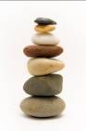
Rock Wall
Review with the students what they saw on the rock wall in the exhibit. Remind them of the three kinds of rock, the salt dome, and the trapped oil. Help them remember the order of the rock layers. Use multicolored sand, small rocks, fish tank gravel, or other materials in a clear container to create a sand art illustration of the geology associated with oil exploration.

One drilling cone, please!
Write two names of drill cones that students saw in the exhibit on the board: Hughes Simples Dual Cone and tri-cone insert bit. Ask the students if they know what dual means. Then ask them what the prefix “tri” means. Ask the students to give suggestions of prefixes that mean numbers. List the prefixes on the board. Tell the students that they have been asked to create a new, more efficient drill bit. They must draw it and name it using one of the number prefixes.

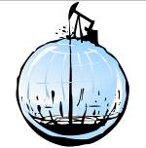
Don’t cry over spilled oil!
Remind students that they learned that oil is trapped in the tiny holes in porous rock. Tell them that only 1/3 of the oil is removed from the ground when it is first discovered. To illustrate this, measure 1 cup of water into a shallow bowl or pan. Using a new sponge, soak up as much water from the shallow dish as possible. Squeeze the water from the sponge into a measuring cup. Record the amount. See if the students can determine how much water (oil) remains in the sponge (porous rock).

Tired or Just No Energy?
As a homework assignment, ask the students to tour their house or apartment and make a list of everything that runs on electricity. Remind them to add things that run on batteries as they are a source of electricity. The next day, ask them to draw a picture of their house or apartment showing as many things from their list as possible, even though they might not actually be in the same room. Then ask the students to redraw their picture without everything that runs on electricity. Have a class discussion of the importance of electricity in our lives.


Alternative Alternatives
Using the pictures from the previous activity, ask the students to pick one item from their home that works on electricity and create a new way to make it work. It can be a sequence of events that causes the action to occur or an alternative form of energy. Encourage them to be creative.

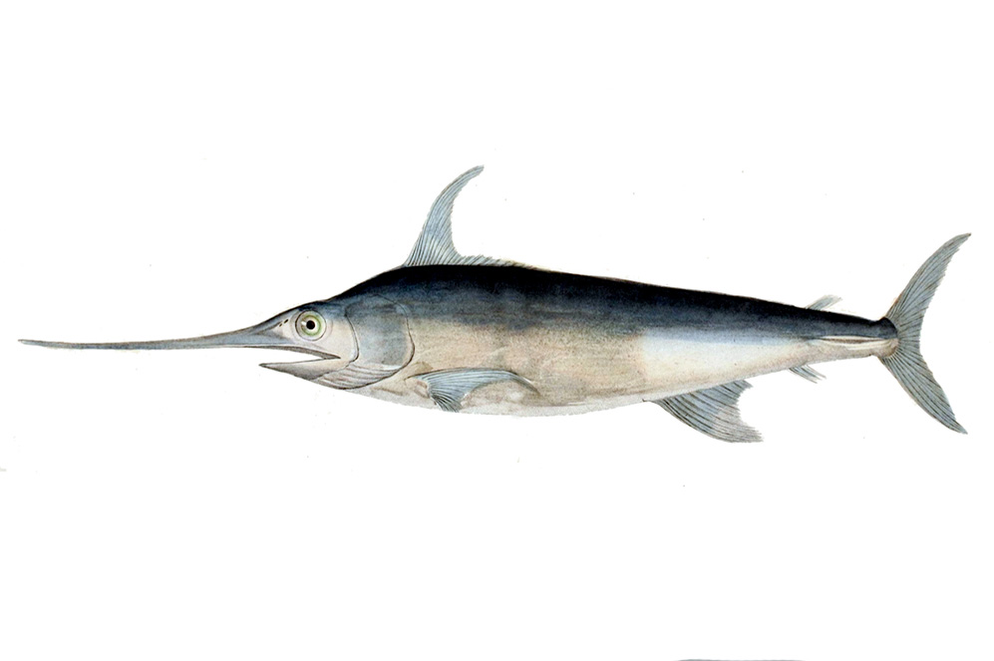
Alfred C. Glassell Jr. Hall

First Floor, Main Entrance

Adaptation Station
While at the museum, students examined the marlin and how it used its various body parts to survive. Now they are going to create their own predatory fish. Tell them that it must be able to do each of the following:
- Move through the water with ease
- Hunt food
- Hide from or fight predators
Give students blank paper or craft supplies and have them create their fish. Then, students will write a brief paragraph explaining how their fish is unique and how it survives.

Lunchtime
Give each student a picture of a different marine animal. Be sure to include predatory animals, like sharks and orca whales, and prey animals, like plankton.
Have students take their animal pictures to the wall, the board, or a piece of butcher paper with arrows pointing to which animal eats which.
Once all of the students agree on the order of the food web, discuss how the prey animals may defend themselves so that they survive longer, and how the predator animals are adapted to find their food.
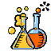

The Welch Chemistry Hall

Lower Level
Mixture Madness
Students will be responsible for creating their own variety of mixtures. Provide groups with a variety of materials, including gravel, sand, water, paperclips, sugar, oil, laundry detergent and buttons. Remind students that a mixture must contain at least two different items. Give them some time to experiment and create their own mixtures. Then, tell students that their goal is to find a way to get the oil and the water to mix together. Let them try different techniques and objects, guiding them towards the laundry detergent if they are struggling.

Energy Exploration
Students are detectives, responsible for finding as many energy sources as possible. Tell them that they must find examples of mechanical, light, sound and heat energy within the classroom. Once they have found at least two examples of each they will discuss why these energy sources are important and create a visual representation or chart.

Solar System

Outside Main Entrance

I want to be a planet!
Ask the students to conduct research to determine why Pluto is now not considered to be a planet. Using the research and facts about other planets, students will work in small groups to create a presentation persuading the audience to reinstate Pluto as one of the nine planets. Encourage students to be creative, as well as informative.


Sunshine on my Parade
Divide the class into four groups. Assign each group the name of a season. The group should research the position of the sun in relation to the Earth, the tilt of the Earth on its axis, and how the sun’s rays strike the surface of the Earth during their season. The group should then create a drawing to illustrate their findings and present them to the class.

