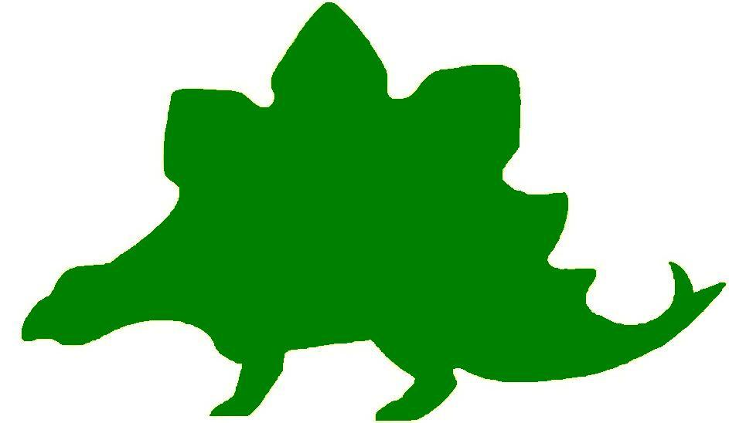
theHoustonMuseumofnaturalscience

2nd Grade Extension Activities

McGovern Hall of the Americas

Third Floor
May I Take Your Coat?
Ask the students to recall the clothing they saw in the Hall of the Americas. The seal gut parka, the woman’s parka, Plains Indian vests and moccasins, and the Chilkut blanket were all made of animal skins and natural plant fibers. Only after Europeans came to America were spun fibers used for making clothing. Until then, renewable natural resources were used. Cotton, flax, wool, leather, fleece, fur, hide, bone, plant fibers, stripped bark, and feathers are natural resources because they can be replaced over time. Tell the students that they are going to design a coat that could be made from renewable resources. Provide them with a brown grocery bag slit down the middle with the neck and arm holes cut out, paint, glue, colored paper, cotton balls, material, etc. that can be used to represent a natural material. Have a class fashion show in which the students will wear their “coat” and describe the natural resources that were used to make it. Let the class judge whether it is made from all natural resources.

Totally Tipi
Remind the students of all the objects that were displayed in the tipi they saw at the Museum. Allow the students time to discuss how the tipi looked, why it was an important form of shelter for the Plains Indians, and all of the items that would be needed to live in one comfortably. Give each student a sheet of duplicating paper. Ask them to fold it in half (hamburger style) with the fold at the top. The side facing them is to be decorated as they would like their tipi to look. When they have finished designing the inside, ask the student to turn their paper over and decorate the outside. (Be sure that they keep the fold at the top.) When the students have completed their design, bring the top two corners toward the middle and staple the ends. (Do not crease. It should be open, like a cape.) The tipi should stand up. Then make a Plains Indian village by displaying everyone’s personalized tipis.

Cultural Passport
Give each student a sheet of 6” X 9” construction paper and instruct them to fold it in half. Tell them to write Hall of the Americas on the passport cover. Students should decorate the cover with pictures of things they saw while touring the exhibit. Staple two folded sheets of white paper in the middle. Ask the students to draw some of the items that they remember from a specific culture. The title of the culture should accompany the pictures.

Artifactual
Tell the students that an anthropologist is a scientist that studies artifacts to learn more about ancient cultures. Ask the students to describe some of the artifacts that they saw while walking through the exhibit and what they learned about the culture from viewing that artifact. Tell the students to pretend that they are anthropologists and have found four artifacts they must identify and explain. Give the students four pieces of paper. On each they are to draw one of the artifacts from the exhibit, name it, and write what they would learn about the culture to which it once belonged.

Hall of Ancient Egypt

Third Floor

Birthday Timeline
Remind the students that they saw a timeline when they visited the Hall of Ancient Egypt at the Museum. Tell them that there are all sorts of timelines that historians and scientists can use. Ask the students to find out the birthdates for several members of their family. They can even ask a grandparent, aunt, uncle, or cousin. Ask the students to make a timeline and place each person in the correct order based on their birthday. They can glue or draw pictures of their family member to jazz up their Birthday Timeline!

Maps and Maps
Give the students a Map of Africa and Europe. Have them label important areas such as Egypt, the Nile River, Rome, Italy, and the Sahara Desert. Ask them to put a compass on their map so they know which is North and South.

Strake Hall of Malacology

Second Floor
My Money System
Make a large batch of claydough in several different colors using the recipe below. Remind the students that they saw cowrie shells that were once used as money. Tell the students that they are going to create their own money system. Give the students a small ball of three or four different colors. They are to make a variety of shell shapes to represent money. They should assign a value to each coin they create and a different color should be used for each value. Give each student a piece of tagboard or sentence strip. One “coin” should be glued on it with the value of the “coin” written nearby.

Claydough
1 c. white flour 1 T. vegetable oil Mix the ingredients in a pot. Cook for 5
1 c. water food coloring minutes over medium heat, stirring with a
2 t. cream of tartar waxed paper metal spoon. Dough will begin to harden on
1 c. salt containers the spoon. Pour dough on wax paper to cool.
Knead until cool. Store in airtight containers.
How Much?
After the money shells have hardened, ask the students to use them as manipulatives to write math problems using the money value as the numbers. They can write an equation by drawing two shells and adding a plus or minus sign. Ask the students to trade the problems along with their value strips from the activity above and have a classmate try to solve their problem.

Beachy Keen
Display an assortment of shells around the classroom. Ask the students to identify any they saw while visiting the Museum. Make a large batch of claydough and give the students small balls of each color. Allow the students to make several different shell shapes. Use shoe boxes to make a beach diorama. Bring in sand, if possible, to create the beach. Students will create their scene at the back of the box and place the shells on sand toward the front. Students may want to add other beach related objects to their diorama.

Shell Trade
Give the students a variety of magazines and ad flyers to cut pictures of toys or other items they might like to buy. Provide the students with shell pasta, preferably of different sizes. Allow the students to write different coin values on the pasta shells, including a dollar coin, with Sharpie pens. While the students are labeling the pasta shells, add price tags to their pictures. Give pairs of students a “bank” of money. Allow them to pick a picture and work together to find the amount of coins necessary to “buy” the item.

Cullen Hall of Gems and Minerals

Second Floor

Mining for Minerals
Review the geometric shapes that students have learned. Give the students an assortment of claydough balls of different colors. Ask them to use the claydough to create their own colorful minerals in geometric shapes. A combination of shapes can be used to create the mineral. Ask the students to name the mineral for display.

See How It Sparkles
Review with the students the attributes of two and three-dimensional geometric figures such as circles, polygons, spheres, cones, cylinders, prisms, and pyramids. Display examples and point out the vertices, faces, edges, and sides on the figures. Give the students graph paper, rulers, and colored pencils. Tell the students to create their own colorful mineral by creating two dimensional drawings similar to the minerals they saw in the exhibit. To make a mineral display, cut out the gems and glue them in the bottom of the boxes and stand the boxes on end.

Something New
Give the students die cuts of various geometric figures. Allow them to cut the figures into pieces and rearrange them to create new geometric figures. Students should identify the new figures they have created.

Mineral Mural
Divide the class into several different groups. Give each group a large sheet of paper, an assortment of brightly colored markers, and rulers. Tell the students to create a mural of the minerals they saw while visiting the Museum. Remind them to use their rulers to demonstrate their knowledge of vertices, faces, edges, and sides on their “minerals”.

Farish Hall of Texas Wildlife

Second Floor
Food Chain
Remind students that all ecosystems are dependent on a food chain. Split students into groups based on the different regions they saw while in the Farish Hall of Texas Wildlife. Then, assign each student an animal from that region. Give students three minutes to stand in the order in which they would be on the food chain. Then have students rotate to the next region. Lead a discussion about the characteristics of animals at the bottom of the food chain as opposed to the top.
Creature Creation
Assign student groups different regions and tell them that they are going to create a new animal to live in that region. In order to survive, it must be perfectly adapted to its environment. That means it will need to be able to hide, eat and reproduce.
Give students some time to come up with their animal. Allow them to draw it or use magazines to cut out images that they can combine to create their new creature. Students must determine what the animal will eat, where it finds its food, what defense mechanisms it has and how it fits into the existing food chain.
Like Mother, Like Daughter
Tell students that often baby animals look similar to their parents. Remind them of the bison in the Farish Hall of Texas Wildlife. The baby bison looked very similar to its mother.
Remind students that this is not always the case. Ask them what happens when a butterfly becomes an adult. What about a frog?
Assign student groups different animals from the Hall of Texas Wildlife and have them research the life cycle of the animal. Then, students can draw the life cycle and present it to the class.
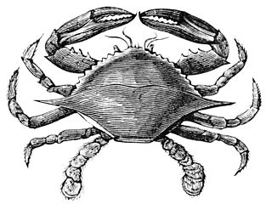

Hamman Hall of Texas Coastal Ecology

Second Floor

Trap n’ Go
Oysters, like the ones you saw in the oyster reef in the Upper Coast section, are filter feeders. This means that they bring ocean water in over their gills and “trap” small particles of yummy things that they can eat. Many creatures that live in our ocean use filter feeding to get their food. In this activity, students will create their own “filter feeders” to trap food.
You will need:
- Miscellaneous waterproof recyclables (plastic bottles, caps, pipecleaners, plastic bags, string, cloth, etc.). You may need to cut these if students require it.
- Things to hold the filter together: duct tape, binder clips, clothespins
- Tank of water big enough for a student to move their filter around
- Various sizes of particles: peas, beans, uncooked rice
- Minute timer, paper, and pen

Students should design a filter using the materials provided. Their goal is to capture as many food particles as possible in one minute. Encourage them to think about the size of their food particles and how they could be captured: Can we trap them with small enough holes? Could they be caught and held by branches on the inside of the filter?
After you have tested each filter, discuss with students how tiny pollutants released into the water might affect organisms that get their food by filter feeding.

Stop the Cycle
In one of the videos students saw in the exhibit, the narrator talks about the “never ending cycle” of picking up trash that has ended up in the ocean. Discuss with students the importance of recycling and using proper trash receptacles. Have students work as a team to design a banner that can be displayed in the hallway illustrating environmentally friendly techniques.

Frensley Hall of African Wildlife

Second Floor
Survival
Remind the students that while they were at the Museum they observed exhibits that showed what animals need to survive. Food, water, and shelter must be within a useable range for each animal to find. Have students draw a picture of where they live, including all the things they need to survive. Allow the students to label the things in their picture that are needed for survival and the items that make life more comfortable.

Favorite Colors
Remind students that when they were visiting the Museum, they saw examples of how camouflage enables animals to blend with their surroundings for protection. Some even change colors with the seasons to blend in with the white snow or the orange and brown fall leaves. Allow students to cut out a scene from a magazine or create their own. Ask the students to draw and color an animal that would be able to blend into that scene. Encourage students to be as creative and imaginative as possible.

Just Hanging Around
On the board, write the areas of Africa that the students saw on their visit to the Museum. Allow the students time to find the animals that can live in each area in books or on the internet. Make a list on the board under each area. Give each student a wire hanger and provide construction paper, tagboard, scissors, string, markers, glue, staplers, and hole punches. Allow the students to select one area of Africa for their focus. Cover the opening of the hanger with construction paper, write the title, and decorate it with the environment from that region. The students should draw pictures of the animals that live there on tagboard squares, punch holes in them, and use string to hang them from the covered hanger. As an extension, students could write a description of the animal on the back.

The Morian Hall of Paleontology

First Floor
Fly like a Pterosaur
Ask the students to make a simple paper airplane. Demonstrate how to fold the pages and fly the plane. Let the students try to see who can throw their plane the farthest. Once they have all had a turn give the students a variety of objects to add to their plane, such as pennies, clay, masking tape, and suggestions for folding more flaps. Tell the students they do not need to use all these objects but they should try to figure out which ones might help their plane fly further. Give them some time to make changes (or adaptations) to their planes. Once everyone is ready ask the students to fly their plane again. Which ones went further? Which did not fly at all? Explain to the students that as they made changes to their planes they made them more aerodynamic. Explain that this is what happened over time to the pterosaurs. Several grew sharper pointy heads, some changed the way their wings were attached to their bodies, and some added long tails to help them navigate the sky.

Extinguish the Flame
Remind the students about the story of the horseshoe crab on display. Remind them that as the oxygen levels became lower the horseshoe crab eventually did not have enough oxygen to live. Next demonstrate this idea by using a candle and a clear glass jar with a lid. Light the candle and show it to the students. Explain that the flame is using the oxygen in the air to stay active. Next place the lid on the jar and show the students what happens when all the oxygen is used up. Explain to the students that this is similar to what happened to the horseshoe crab.

Paleontology Journal
Ask the students to bring, or provide, a medium sized gift bag with handles. Cut the bottom flap and sides off the bag, leaving the handles in place. Cut five sheets of white paper to fit the size of the bag, place it inside, and staple it along the bottom. Tell the students they are to pretend they are paleontologists and these are their journals. They are to pretend they are on a dig. They must research a dinosaur to “discover” at the dig. The journal should be a five day account of their experience of finding and uncovering the dinosaur they are interested in learning more about. The journal report should include as many facts as possible about the dinosaur. Pages should include drawings or sketches to go along with their story.

Dinosaurs in a Box
Ask the students to bring in cereal boxes. They can cover the front and sides with colored or white paper. Tell the students they must find ten facts about dinosaurs in books or on the internet. At least five should be related to things they saw while visiting the Museum. They can draw pictures of a variety of dinosaurs, fossils, and other things related to the Hall of Paleontology to add to their box. Encourage the students to decorate the box with pictures and words related to paleontology.

Wiess Energy Hall

First Floor
Hooray for plastic!
Review with students that one of the big displays in the Wiess Energy Hall was of a refinery. The refinery is the place where petroleum is made into other products. One of those products is plastic. Show the students some of the things that are made in the classroom from plastic. Let the students draw their classroom and put as many plastic items in the picture as possible. Have them label the items to show how many products just in the classroom are made of plastic.

I’m a petroleum consumer.
Allow students to use magazines to cut out as many items as they can find that they think are made of plastic. Students can work together to help one another make decisions about the material the objects are made of. Give each student a large sheet of paper. Let them glue at least ten items on the paper. Beside each item, instruct students to write why that particular item is important in their lives.

Auto Alternatives
Review with students some of the alternative energy sources they saw on their Museum visit. Write solar, wind, hydroelectric, and nuclear on the board. Tell students that scientists and car manufacturers are trying to think of ways to transport people and goods without using so much gasoline since it is a nonrenewable resource. Take time to talk about why oil and gas are nonrenewable and alternative sources are renewable. Tell the students they are going to be car designers in the future. They are to design a car that will run on some kind of alternative power. After the pictures are completed, allow the students to present their design to the class and explain how it works.

Envelope Please
Have the students seal two legal sized envelopes and cut them in half. They will glue the four halves on the cover of a letter sized manila folder, and write the word “Energy”. Each envelope half should be labeled with a renewable, nonrenewable, or alternative form of energy. Give the students ten 3x5 index cards to cut in half. On each half, ask students to draw as many sources of energy as they can think of. The activity might begin with a brainstorming session to give all students some examples to draw. As the students draw their energy sources, they should sort them into the three pockets on their folder.

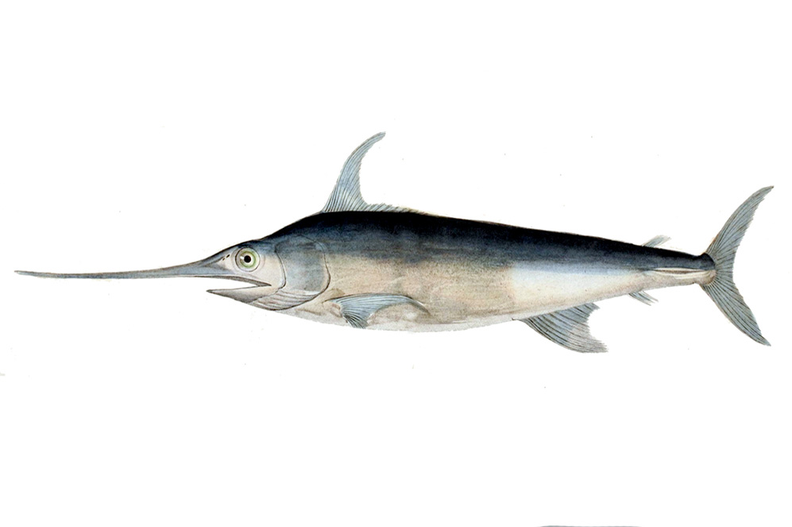
Alfred C. Glassell Jr. Hall

First Floor, Main Entrance
Adaptation Station
Tell students to look at the pictures they drew while in the museum, of their favorite aquatic species. Show students a picture of a goldfish. Then, have students compare and contrast the two species. You may want to do this as a class. Discuss what the animals have in common, and what differences they have. How might these traits aid their chosen animal’s survival?
Lunchtime
Split students into groups, and give each group pictures of the following: hammerhead shark, Tuna, Wahoo fish, plankton. You may include other species if you’d like. Tell groups that they must arrange the images in order of who eats who. Then, discuss how the prey animals may defend themselves so that they survive longer, and how the predator animals are adapted to find their food.

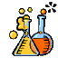

The Welch Chemistry Hall

Lower Level

Simple Machines
Remind students about the Corliss Steam Engine they saw at the Museum. Explain to them that the steam engine was once used as a way to make jobs easier. Remind them of the levers they used to lift the metal blocks. Tell them that the lever is an example of a simple machine. Give students a variety of materials, including blocks, pulleys, ramps, and levers and tell them that they are going to build their own machine (if you do not have these materials on hand, students can draw instead). Have students work in groups, and then explain what their machine does and how it makes jobs easier.

Beyond Oil and Water
At the Museum students saw that oil and water have trouble mixing. Remind students that this is because oil and water have different densities. One is more dense than the other, so they will not mix together. Have students conduct their own experiment. Split students into groups and give them each a water bottle filled a quarter of the way with water and a quarter of the way with oil. Have them turn, twist and shake the bottle to see if they can make the two mix. Have them record their results. Then, give each student group a small cup of soap or laundry detergent. Have them slowly add this to their bottle and repeat the experiment. Discuss the results.

