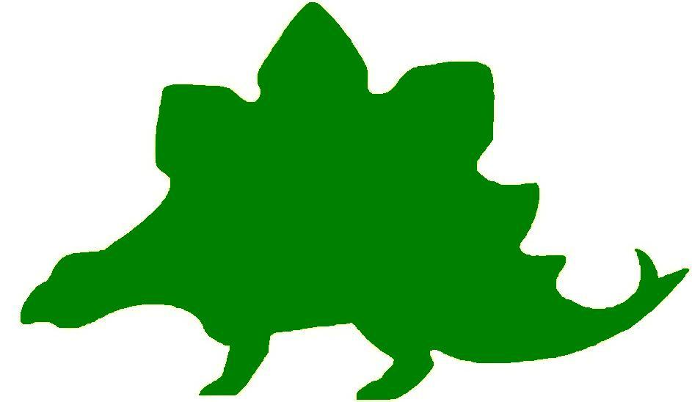
theHoustonMuseumofnaturalscience

1st Grade Knowledge Hunt
Dear Educator,
Thank you for downloading the free, online curriculum available at HMNS! We’re thrilled to see that you are including the world-renowned Houston Museum of Natural Science in your educational toolkit.
Here at HMNS our mission has always been to provide exemplary educational opportunities for the community. Providing educators like you with free, fully editable curriculum is just one of many ways we are fulfilling that mission.
Thank you again, and we hope you enjoy your field trip to HMNS!
Best,
The HMNS Staff

How to use this guide:
- Feel free to edit the questions as needed to suit your student group.
- The Knowledge Hunt is structured to begin at the top of the Museum (floor three) and work its way down to the lower level.
- Visitor services and security staff are posted around the Museum and will be happy to assist you in finding any of the locations mentioned.
- Please ensure that one chaperone is with every group of ten students at all times as they complete these activities.
- Don’t forget to download our extension activities for use in the classroom when you return from your trip!

Please direct any and all questions to curriculum@hmns.org

1st Grade TEKS Objectives

Each of the following TEKS Objectives are met as students explore the various exhibit halls and complete the Knowledge Hunt:
Science: 1.1 (A, B, C), 1.2 (A, B, C, D, E), 1.3 (B, C), 1.4 (A, B), 1.5 (A), 1.6 (A, C, D), 1.9 (A, B, C), 1.10 (A, B, C, D)
Social Studies: 1.2 (B), 1.3 (A,B), 1.4 (A), 1.5(A), 1.6 (A,B,C), 1.9(A,B), 1.11(A,B,C), 1.13(D), 1.14 (A,B), 1.15 (A), 1.16 (A,B), 1.17 (A,B,C,D), 1.18 (A,B), 1.19 (A,B)

ELA: 1.1 (B,D,E), 1.2 (A,B), 1.3 (C,D,E), 1.4 (B,C,D), 1.5 (J,K), 1.10 (A,B), 1.11 (A), 1.12 (A,B), 1.13 (D), 1.14 (D), 1.15 (A,B,C), 1.16 (A), 1.17 (G), 1.18 (C,D,E), 1.19 (A,B,C,D), 1.20 (D,E), 1.21 (A,B), 1.22 (B,C), 1.23 (A,B)
Math: 1.1 (A), 1.2 (A,B), 1.3 (A), 1.4, 1.5 (A,B), 1.6 (A,B,C,D), 1.7 (A,B,F), 1.9 (A,B), 1.10 (A)

McGovern Hall of the Americas

Third Floor

Vocabulary:
culture, ritual, ceremony, natural resources, traditions, totem, kachina, parfache, garment

Origins and Diversity

Clothing and Culture
Tell students that the type of clothing people wear is determined by the climate they live in and the natural resources available in the region. Ask the students to look at the different clothing in the case. Allow them to guess what type of climate each outfit would be worn in. Tell the students that natural resources are things that grow or live naturally in a place. Some students may be able to identify the natural resources from which articles of clothing are made; for example, the bones in the necklace, the wool of the parka, etc. Talk about how some of these clothes are worn today, keeping with that culture’s traditions.

Ritual and Religion
Draw the students’ attention to the masks. Tell them that dancers wear these masks so the audience watching a ceremony will think of them as something other than a person. Dancers may represent animals, birds, or other things in nature. Ask the students to look in the case and find the cow. Ask what animal they think mask #6 represents. Point out the muchu. Tell the students that these masks were used in ceremonies to promote healing.

The Arctic

Seal Gut Parka
Point out the child’s seal gut parka. Read the text panel to explain how it is made. Ask the students why they think this natural resource was used to make children’s clothing.

Kayak with Paddle
Tell the students that the kayak is covered with sealskin. Ask them why it was a good resource to use to make a boat. Explain that sealskin is naturally oily, so it is waterproof. Ask the students if they think this form of transportation is still used today.

Inuit Children
Show the students the toys played with by Inuit children. Explain that toys were similar to the hunting items and household items they would use in adulthood. Point out each toy and identify what it represents. Ask students if they can find two objects that might have been made just for fun.

Parka and Women’s Items
Look at the parka. It is made of sealskin because it is lightweight, warm, and dry. Other animals that were used to make clothing were caribou, polar bear, wolf, and fox.

Trade Beads
Russian traders brought glass beads to the Arctic regions to trade for furs, one of the Arctic’s natural resources. Point out the string of blue beads in the case and explain that they were considered to be the most valuable beads. Arctic people used them to decorate their clothing. Ask the students if they know of another culture that uses beads to decorate their clothing.

Northwest Coast

Feasting Traditions
Show the students the carved dishes, spoons, ladles, and other household objects displayed in the case. Point out the animals, fish, and birds that are carved on them. Explain that the carvings were the way the people of the Northwest Coast honored the animals that were important to their survival. Ask the students how they think the various objects might have been used at the house.

Transformation Mask
Show the students the transformation mask and explain how it works. See if the students can recognize the animals on the outside and inside of the mask. Tell the students that, like the masks they saw when they first walked into the Hall, these masks were designed so the dancer could start out as one animal and become another one in the middle of the dance.

House Posts
The house post is also called a totem. It was located at the back of the house. Ask the students to guess what two animals have been carved into the pole. There is a thunderbird on the top and a bear on the bottom. The thunderbird was believed to be able to produce thunder by flapping its wings and lightening by blinking its eyes. The bear was believed to have taught humans how to fish for salmon and pick berries in order to survive in the cold climate.

The Southwest

Kiva
The kiva looks like those that could be found in an ancient Pueblo in the New Mexico or Arizona desert. Roads connected the villages so they could trade with each other. Point out the ladder that leads to an opening at the top. The hole allowed the smoke from cooking fires to escape. Talk about what the kiva is made from. Ask the students what natural resource was used to make the kiva. Why was it a good place to live in the desert?

Kachina Dolls
Explain to the students that Kachina dolls were not used as toys, but were carved by the Hopi people as a way to honor the spirits that were thought to help people by making the crops grow, producing rain, making corn sweet, and by giving other blessings. Ask the students to look in the case and identify their favorite kachina and tell why that one is their favorite.

Zuni Pots
Explain to students that the pottery made by the Zuni people is functional as well as beautiful. Ask the students to give some suggestions as to how the pottery might be used. The artist had to use the natural resources available, so the clay comes from the earth. The reddish color is made from a crushed mineral while the brownish black color is made from wild spinach. The artist chewed the end of a yucca plant until the fibers separated and it looked like a paintbrush. Ask the students if they think the Zuni people still use these same methods today. Ask them to identify the animals they see on the pots. Can they predict why these specific animals were used and others were not?

Beading
Look at the beading patterns on the moccasins and the vests. Ask the students to identify one of the patterns. Ask the students if they see a patriotic symbol on any of the vests.

The Tipi
Show the students the tipi. Explain how it can be taken apart and rolled up to carry from place to place as the Plains Indians followed the buffalo herds. Tell them that it is made of buffalo hide. Show them the hole where the cook fire smoke could escape. Point out the parflache bags of many different sizes that were used to store food, supplies, and personal items. Ask the students if they could carry all of their belongings in just those bags.

The Buffalo
Buffalo hide robes were the principal outer garment of the Plains men and women. The one displayed in the case was worn by a warrior. Ask the students to guess what design is painted on the hide. The sunburst in the center denotes a person of honor. From prehistoric times to just 100 years ago, the buffalo provided food, clothing, and shelter for the native Plains people. It was the most important natural resource of the Plains people.

The Aztecs

Ball Game
Lead the students into the model of the Aztec city. Find the ceramic model of the ballgame. Explain to the students that ball games have been being played for 2,000 years. Ask the students what they see. Can they find the ball, the players, and the spectators? The ball was made of rubber, a natural resource from the rainforests where the Aztecs lived.

The Andes
Take the students inside the “temple”. Find the parrot feather poncho. The feathers were valuable, so they were used to trade for things the people needed, but could not grow or produce themselves.

Hall of Ancient Egypt

Third Floor

Vocabulary:
metropolis, civilization, shabti, mummy, overseer, ancient, culture, nomad, pharaoh

The Timeline of Egyptian History
Ask the students to look at the timeline. Ask them to place the following in the correct order of which came first. You might suggest that three different students stand by each occurrence for a better visual effect.

Turkey’s Trojan War, Roman and Byzantine Egypt, and Britain’s Stonehenge built

Egypt’s Ancient Roots
Read the text panel to your group. Ask the students to explain what factor(s) encouraged early Egyptians to roam from place to place.

Sebehnef Seated
Read the panel about Sebehnef Seated sculpture. Tell the students to study the statue and make special note of the details. Ask the students why they think this statue was done to near perfection. Read the panel to them again if they need more help. Students should be able to point out the fact that the statue is of the overseer, so of course his would be the best!

Pharaoh – Lord of the Two Lands
Read the panel to the students. Remind them that as a rule the King was responsible for his kingdom. Have the students list three things the King did as part of his “job”.

Shabti Figures – The Dead Person’s Mini-Me
In the room prior to the mummies, read the information about the shabti. Ask the students to explain in their own words what a shabti was used for. Ask them if they would like to have a shabti to do their chores at home!

The Old Kingdom (Dynasties 3 – 6, 2682 – 2181 BC)
Ask the students to study the map. Point out the city of Memphis. Explain that Memphis was once a thriving metropolis. Ask the students if they know of another city by that same name. Explain that there are several examples of Egyptian culture in the United States. They will see another example that we use in our daily lives in the last room.

The Ptolemaic Period (332 – 30 BC)
Read the panel describing the Ptolemaic period. Point out to the students that the capital during this time was named Alexandria. See if the students can figure out why the rulers of this time period chose this name for the capital. They should make the suggestion that the capital was called Alexandria after Alexander the Great who conquered Egypt.

Dollar Bill
Allow students time to study the dollar bill in the case. Do they see anything on the dollar bill that reminds them of Egypt? They should point out the unfinished pyramid and possibly the “all-seeing” eye. Explain to the students that the unfinished pyramid represents the “unfinished” United States. Explain that we are still growing and changing as a country. The pyramid and the eye are both reminders of Egypt and show that even in the United States we have been fascinated with Egypt as far back as the beginning of the nation.

Strake Hall of Malacology

Second Floor

Vocabulary:
patterns, attributes

Family Pectinidae (Scallops)
Find the case that displays scallops. Point out the scallops that are open (#8,9,10,22) and show the students that they are connected in the middle by a natural hinge that keeps it closed to protect the animal that lives inside. Encourage students to walk all the way around the display case so they can see how they look closed. Ask the students how many parts the whole is divided into when the shell is open.

Find a closed shell in the case. Point to it. Ask students to find other shells that are greater in size to this shell.

Classics
Allow students an opportunity to look at all the shells in the classics cases. Ask students what kinds of repeated patterns they can see on them (spots, colors, spines, geometric shapes, etc.).

Family Cypraeidae (Cowries)
Allow students time to look at the Cowries from both sides. Tell students these were once used as money for trading. Find #6 and tell students it is called the money cowrie. Ask them why this particular shell was used as money instead some of the others. What attributes does it have that would make it valuable?
Ask students to look at the shells and see if they can find one with attributes that might have contributed to it being called a Mouse Cowrie #17, Humpback Cowrie #22 & #28, Tiger Cowrie #27, and Eyed Cowrie #30.

Family Conidae (Cones)
Ask the students to look at the Cones. Talk about all the attributes of these shells. Using the attributes, allow the students to suggest new names for them. Ask them to explain why that would be a good name. Allow them to compare their new name with the real name printed on the text panel beside the display.

Family Conidae (Cones)
Find one of the larger Cone shells. Point it out to the students. Allow them to point to other shells to indicate shells that are less than the selected shell in size.

Cullen Hall of Gems and Minerals

Second Floor

Vocabulary:
minerals, gems

Case #16-Galena
Point out the galena in the case. Ask the students what geometric shape it reminds them of.

Case #26-Cerussite
Tell the students that often minerals form shapes that look like common objects. Allow them to suggest what this mineral might remind them of.

Case #31-Quartz
Tell the students to look at this large piece of quartz. Ask the students if they see rectangles and triangles on it. Ask one student to point them out to the rest of the group.

Case #33-Cerussite
Ask the students to suggest what this mineral looks like.

Case #42-Pyrite
Tell the students that pyrite was called “fool’s gold” at one time. Allow them to speculate why that name was given to pyrite. Ask the students to name the shape of this piece of pyrite.

Case #76-Hydxorylherderite
Ask the students if they can find two triangles on the mineral.

Case #83-Elbaite
Ask the students to name the shape of the elbaite. Ask the students if this is a three-dimensional object or a two-dimensional object. Allow one student to explain the difference in the two kinds of objects.

Farish Hall of Texas Wildlife

Second Floor

Vocabulary:
habitat, adaptation, desert, predator, prey, survival, herbivore, carnivore

High Plains
Tell students that the Pronghorn grazers are among the fastest mammals in North America. Ask students why they think Pronghorn adapted to be such fast runners. What about their habitat favors fast runners?
Ask students what color they see most. Point out the brown fur and feathers of animals within the exhibit, and then point out the ground. Ask students why they think most of the animals are this color.

Coastal Wetlands and Marsh
Point out the various plants within this region. Ask them to describe the trees, the grass, and the other features. Then have students verbally label the different parts of these plants.

Guadalupe Mountains
Remind students that all of the animals present in the exhibition are dependent on one another. As you name each animal listed below, give students time to find it within the exhibition. Then, ask students whether it is a predator, prey, or both predator and prey animal.
Animals: Elk, Gray Fox, Ringtail, Golden Eagle, Desert Bighorn Sheep, Mountain Lion, Trans-Pecos Rat Snake.

Piney Woods
Often times, animals must rely on their environment for survival. Ask students to find examples of animals using various features of the land to protect themselves.

Extinct & Vanishing Species
Bring students to the Extinct & Vanishing Species case. Ask students why they think these animals no longer exist in large numbers in Texas. Ask students if there are any other animals they know of that are endangered or extinct.

Rio Grande Dry Forest
Point out how different this region is from the Piney Woods. It is much more open, the trees are smaller and scruffier, and there are cacti instead of ferns. Ask students what characteristics animals might need to have to survive here. Point out the Western Diamondback Rattlesnake. How is it adapted to survive in this environment?

Coastal Prairie
Point out the adult American Bison with its young. Ask students to describe the similarities and the differences between the fully grown animal and its offspring.
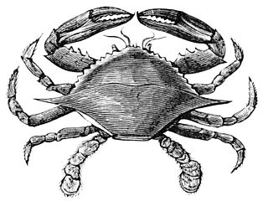

Hamman Hall of Texas Coastal Ecology

Second Floor

Vocabulary:
ecosystem, habitat, ecology, endangered, food chain, tidal, reef, bay. imprint

As you enter the Hamman Hall of Texas Coastal Ecology, adjacent to the Farish Hall of Texas Wildlife, explain that the Texas Coast is another important ecosystem in our state, important to many types of plants and animals (humans too!). Explain that ecology is the study of how organisms interact with their environment, and that a change in a habitat affecting one type of animal might affect other animals as well.

Upper Coast

Map of Coastal Region
Locate Harris County on the map of the Texas coast. Explain that this is where Houston is, where you and the students are standing at this very moment. How close are we to the ocean? Explain that Houston is part of Texas’ coastal plains. Have any of the students ever gone to the beach?

Oyster Reefs
Show students the display of an oyster reef (yes, these are real oyster shells!). Ask them what they see in the display, including any images in the background. As students describe the oyster reef in detail, have them classify each object as “natural” or “man-made”. Oysters are living creatures that can only survive in certain conditions. Discuss with students how some man-made objects, like trash or motor boats, might affect oysters.

Middle Coast

Brown Pelican
The Brown pelican was listed as an endangered species. Show students the maps of Brown pelican populations (larger circles represent larger numbers of pelicans in the area) over time. Explain that when there are very few of a type of plant/animal left, it is listed as “endangered,” or in danger of becoming extinct. Based on the maps, how has the number of Brown pelicans changed over time? Point out that pelicans are growing as a result of humans trying to preserve this amazing bird.

Video
Watch the video at the end of the Middle Coast section with your students. Have students watch the short clip from beginning to end and challenge them to estimate the number of empty milk jugs they see. How many are there? Too many to count! The narrator talks about a “never ending cycle” of picking up trash. Brainstorm with students about a way to stop this cycle and stop trash from ending up in the ocean where it harms wildlife.

Lower Coast

Kemp’s Ridley Sea Turtle
As you round the corner of the Lower Coast section, you will see a large turtle. What is she doing? How many eggs does she have? Explain that sea turtles like this will bury their eggs in the sand to protect them.
When the baby sea turtles hatch, they will imprint, or “mark” the beach they are on as their home. In what ways do we “belong” to a certain area and call it home?
Can students find the baby sea turtles in this exhibit? In what ways do they resemble their mother?

Frensley Hall of African Wildlife

Second Floor

Vocabulary:
environment, predator, prey, adaptation, characteristics, environment, consumer, producer, scavenger

Serengeti
The lion needs food, shelter, water, and space in order to survive. Ask the students to look at the exhibit. Ask them why they think the Serengeti is a good place for the lion to live. How does the tall grass help the lion survive?

Ethiopian Realm
Ask the students to walk around the display and find the animal they think is an herbivore. After pointing to it, ask the student to explain how they know.

Congo
The Congo is a rainforest. Ask the students to identify some items in the display that remind them of a rainforest. Ask them to look in the display and find an unusual animal. After they find the Okapi, ask them to identify the three animals that it looks like it is made of.

Lowveld
In this exhibit, you can see how animals depend on each other. Plants are producers because they produce food for animals such as the zebra. The zebra is a consumer because it consumes, or eats, the plant. The lion is also a consumer because it eats the zebra. The vulture and hyenas are the scavengers because they eat what is left over and clean up the environment.

Sahara
Talk to the students about the environment of the desert. It is rocky and sandy with few plants. It is very hot and dry. Point out that the animals have hooves. Ask them why this kind of foot is better for the animals that live in the desert. Would it be a good place for a lion to live? Why or why not? Point out the colors and the thinner fur of the animals and see if they can explain why these characteristics help these animals survive in the desert.

Okavango
Ask the students to find two animals in the exhibit that they have not seen in any other region of Africa. Ask the students why the hippopotamus and the crocodile can live in this environment, but can not live in one of the other regions of Africa.

The Morian Hall of Paleontology

First Floor

Vocabulary:
herbivore, carnivore, reptile, mammal, vertebrate, marine, vegetation, mastodon, mammoth, offspring, adaption

Trilobites
Allow the students to look at the trilobites on display starting with the Cambrian. They will see a lot of fossils and impressions of these life forms. Ask the students to guess if these creatures had hard or soft bodies. How can they tell? Ask them if they think this type of body protected them from predators.

While looking at the trilobites, point out that these creatures are getting smaller and, in some cases, spikier. Ask them to guess why this might be happening. Explain to the students that as more predators entered their environment the trilobites needed new ways to protect themselves.

Jurassic Oceans
Tell the students to look at the mural “The Early Jurassic Ocean”. Ask the students if they can find any food chains represented in the picture. After they have had a few minutes to discuss their ideas, point out that the sunlight helps the plants, the plants are eaten by the cephalopod and the ichthyosaur eats the cephalopod.

Diplodocus
Point out the mural featuring Stegosaurus at the foreground and Diplodocus in the background. Tell them to examine the mounted Diplodocus on display. Ask the students to explain why this dinosaur needed a long neck. Why do they think he needs a long tail? Explain that these animals reached into the trees for their food and they needed a long neck to help them. The diplodocus had a long tail for two reasons. He could use it for defense – his tail could swing as fast as 80 miles per hour! – and he needed his long tail to balance the long neck!

Late Cretaceous
Look at the mural titled “Late Cretaceous”. Point out the Triceratops and the Tyrannosaurus rex in the middle of the mural. Ask the students which animal they think would move faster. Why? Now ask the group to move to the fossil of the Triceratops and the T-rex. Do they still agree with their original answers? Why or why not? Explain that the Triceratops was a very large bulky animal that moved on four legs, while the T-rex was slender, more muscular, and ran on two legs. In all likelihood the T-rex would have been much faster. Scientists have studied the ankles of the T-rex and have concluded that his feet would easily spring off of the ground, propelling him forward.

Wide-Snouted Duck-billed Dinosaur
Look at the two duck-billed dinosaurs on display. Ask the children if they look alike. Explain that they are seeing an adult and a junior dinosaur and they would be similar in every way except for size, proving that the offspring of this dinosaur looked very much like the parent.

Danger in the Miocene Sea
Tell the students to look at the mural of the Megalodon and the mastodon. Ask the students which animal was more equipped to swim in the sea. How do they know? Which body part would help the megalodon swim faster than the mastodon? Explain that the Megalodon has large fins to help it swim quickly and cover large distances.

Megalodon Jaw
Tell the students to estimate, or guess, how many 1st graders would fit from one side of the Megalodon jaw to the other. Explain to the group that this jaw is almost 12 feet wide! When you return to school measure out 12 feet across and line up the class shoulder to shoulder to see who had the closest estimate while visiting the Museum.

Giant Bull
Point out the scene on display of the humans interacting with the mastadons. Explain that scientists have ways of deciding which creatures are carnivores and which are herbivores. Ask the students to look closely at the mastadon’s teeth. They should see large flat teeth indicating that they are herbivores. Now ask the student to think about their teeth. Are they sharp? Mostly likely they eat some sort of meat in their diet, making them carnivores. Now ask the children to take in the scene again. Ask them to guess which species is being hunted and which is doing the hunting!

Wiess Energy Hall

First Floor

Vocabulary:
alternative, renewable, nonrenewable, solar, geothermal, tidal, nuclear, biomass

Sea Creatures
Find the sea creatures to the right, immediately upon entering the exhibit. Ask the students what they think these are. Tell them they are tiny plants and animals that lived in the ocean millions of years ago. When they died, they formed a layer of rock. Under that rock is where oil is trapped in the ocean. Explain that the energy made by these creatures is called nonrenewable energy because these kinds of creatures no longer exist. Once this kind of energy is used up, it will be gone forever.

Plate Tectonics
At the touch screen, begin with the way Earth looked 200 million years ago. Ask the students if they can tell from the shapes of the continents where Texas might be located. Slowly move the curser. During the Mesozoic Era, show the students the shadow that indicates where Texas is starting to take shape, but it is still below water. Point out that during the Triassic Period, the time of the dinosaurs, the upper part of Texas is above the water, but the Houston area is below the water. Ask the students if they think we would find fossils of any of the dinosaurs from the Triassic Period in our area. Tell them that many of our early fossils were creatures that lived in the ocean. Ask if anyone can explain why.

Energy Exploration Theater
Allow students time to watch the movie about energy. After the movie, ask the students if they can name the three forms of energy. Can they give examples of renewable, nonrenewable, and alternative forms of energy that they saw in the movie?

As they move around the exhibit, another Energy Exploration Theater will be available. In this theater, watch the movie about alternative energy sources. Upon leaving the theater, ask students if they can name three forms of alternative energy.

Alternative Energy Sources
Move the students through the touch screens in this area to see how many of the alternative energy sources are converted into the energy that we use. The language will be too technical for them to completely understand, but the visual representation will be helpful for their understanding. The alternative forms of energy presented are:

Solar-Energy:
This energy comes from the sun, which is converted to electrical energy through solar panels.

Wind Energy:
Because the wind is constantly moving around the Earth, it can turn huge blades that move like a fan to generate electricity.

Geothermal Energy:
The heat inside the core of the Earth is used to create energy.

Tidal Energy:
The ocean is constantly moving. Movement is energy. This movement can be captured to produce electricity.

Nuclear Energy:
When atoms are split, it causes a burst of energy that can be used to produce electricity.

Fuel Cells:
These cells are what powers hybrid cars.

Biomass:
This type of energy is produced by living things. One example is corn that is turned into a fuel that is used to power trucks.

Ocean Thermal:
The surface of the ocean is hotter than the rest of the ocean. This heat can be used to generate electricity.

Make sure that the students are introduced to all forms of energy and understand that there are many sources of alternative fuel.

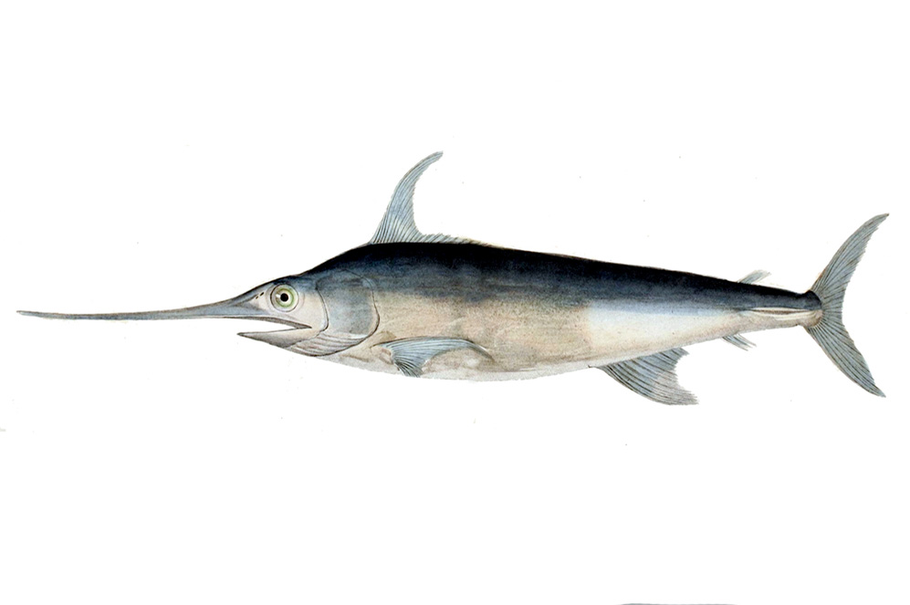
Alfred C. Glassell Jr. Hall

First Floor, Main Entrance

Vocabulary:
habitat, adaptation, marine, predator, prey, survival, herbivore, carnivore, marlin, dolphin, shark, fish, mammal, ecosystem

Lead students to the big Marlin hanging on the wall. Ask them to describe the external characteristics of the fish, including characteristics such as shape and color. Ask students:
Where do you think this fish lives?

Do you think this fish is a deep water or a shallow water fish? Why?

What do you think this fish eats?

Draw student attention to the ceiling, where a wide array of fish are hanging. Ask them if they can count the total number of fish. Tell them to try and separate the fish into different kinds based on how they look. Have them use the space below to sketch the most plentiful fish:
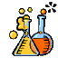
The Welch Chemistry Hall
Lower Level

Vocabulary:
matter, solid, liquid, gas, contaminated, pollution, particle

States of Matter
Encourage students to observe the ping pong balls at the Matter in Motion station. Press the buttons and allow students to observe what happens. Ask them to describe the movement of the ping pong balls (fast, slow, up and down, back and forth, etc). Have students explain why they think the ping pong balls move in this way, and why each set of ping pong balls moves differently.

Breathe In, Breathe Out
Instruct students to observe the lights in the hall and describe what they see. Explain that the air we breathe is made up of many tiny particles, and each colored light bulb represents part of that air. Have students point out which color light appears most often. Which one appears least often? Can they count the number of lights of each color (you may want to limit this to the green and pink lights)?

Like Oil and Water
Bring students over to the self-assembly station, and have them observe the tube of oil and water. Ask students to predict what will happen when you turn the tube upside down. Turn the tube and have students explain what happened. Have students predict will happen if you continue to turn the tube.

Slime Races
Show students the slime polymer station. Tell students to predict which tube of slime will go the fastest when you flip the tube upside down. When you flip the tube, have students count out loud as the slime falls to the bottom. Repeat this for each tube. Which tube of slime took the least amount of time to fall?

Solar System

Outside Main Entrance

Vocabulary:
solar system, planets

Allow the students to step on the sun and all the planets. See if the students can find the largest planet, Earth, the planet closest to the sun, and the planet Saturn.

What does Saturn have that other planets do not?

What does Earth have that other planets do not have?

